Coventry City Council

Equality Impact Assessments
End of Year Report
1st April 2025 – 31 March 2026

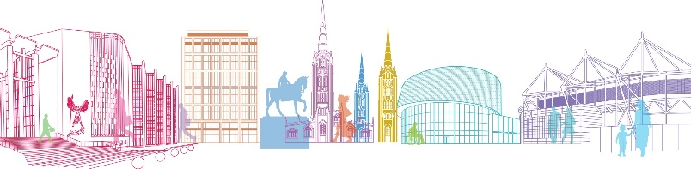

Foreword

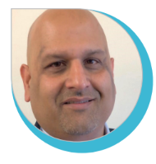

Councillor Abdul Salam Khan
Cabinet Member for Education, Skills & Equalities

I am delighted to share this Equality Impact Assessment Report for 2025 to 2026, which shows some of the work that we’ve been doing over the past year to make Coventry City Council a more inclusive, diverse and equitable organisation. The report also demonstrates the Council’s commitment to meeting its obligations under the Public Sector Equality Duty.
Coventry is a city with a rich heritage – a city that is proud to be diverse, proud to be multi-cultural and welcoming to all. We must ensure that as an organisation, we continue to advance our efforts on diversity and inclusion so that we can meet the needs of all the communities that make up our wonderful city. Our Equality Impact Assessment process is an invaluable tool for us as we work towards this aim.
As Cabinet Member with lead responsibility for Equality – I am committed to ensuring this work continues to progress at pace and that we deliver actions that match our ambitions for the Council to become a lead public sector organisation in this area.

Contents Page:

Page 4 | Introduction
Page 4 | The Equality Act 2010 - Public Sector Equality Duty
Page 5 | When should an Equality Impact Assessment be carried out
Page 6 | Coventry as a Marmot City
Page 6 | Equality Impact Assessment Training
Page 9 | Summary of the outcomes of Equality Impact Assessments – 1st April 2025 to 31st March 2026
Page 14 | Equality Impact Assessments – Analysis of outcomes
Page 14 | Summary of EIA’s by Protected Characteristics
Page 17 | Analysis of Marmot Principles
Page 20 | Budget Setting 2026 to 2027

- Introduction

This report is split into two parts and summarises:

- Part 1: Operational EIAs undertaken by the Council between 1 April 2025 and 31 March 2026, providing analysis of the equalities impact identified on different groups.

- Part 2: Specific EIAs undertaken by the Council during the budget setting process for 2026 to 2027.

The following section outlines the legislative and policy context underpinning this report, including the Council’s responsibilities under the Equality Act 2010 and the Public Sector Equality Duty

2.0 The Equality Act 2010 - Public Sector Equality Duty

The Equality Act 2010 contains the Public Sector Equality Duty, also called the general duty. This general duty means the Council must have ‘due regard’ to the need to:

- eliminate unlawful discrimination, harassment and victimisation.
- advance equality of opportunity between different groups; and
- foster good relations between different groups.
An Equality Impact Assessment (EIA) is a tool to ensure that we consider the effect of the Council’s decision-making processes on different groups of people with protected characteristics (see figure 1 below).

Protected Characteristics identified in the Equality Act 2010
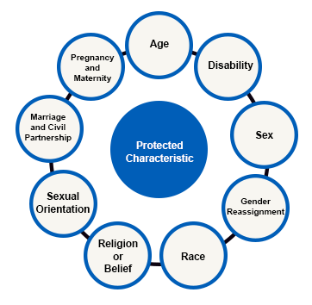
Figure 1

Coventry City Council has also prioritised the consideration of 3 additional groups within its Equality Impact Assessment process (see Figure 2).

Additional groups considered by Coventry City Council

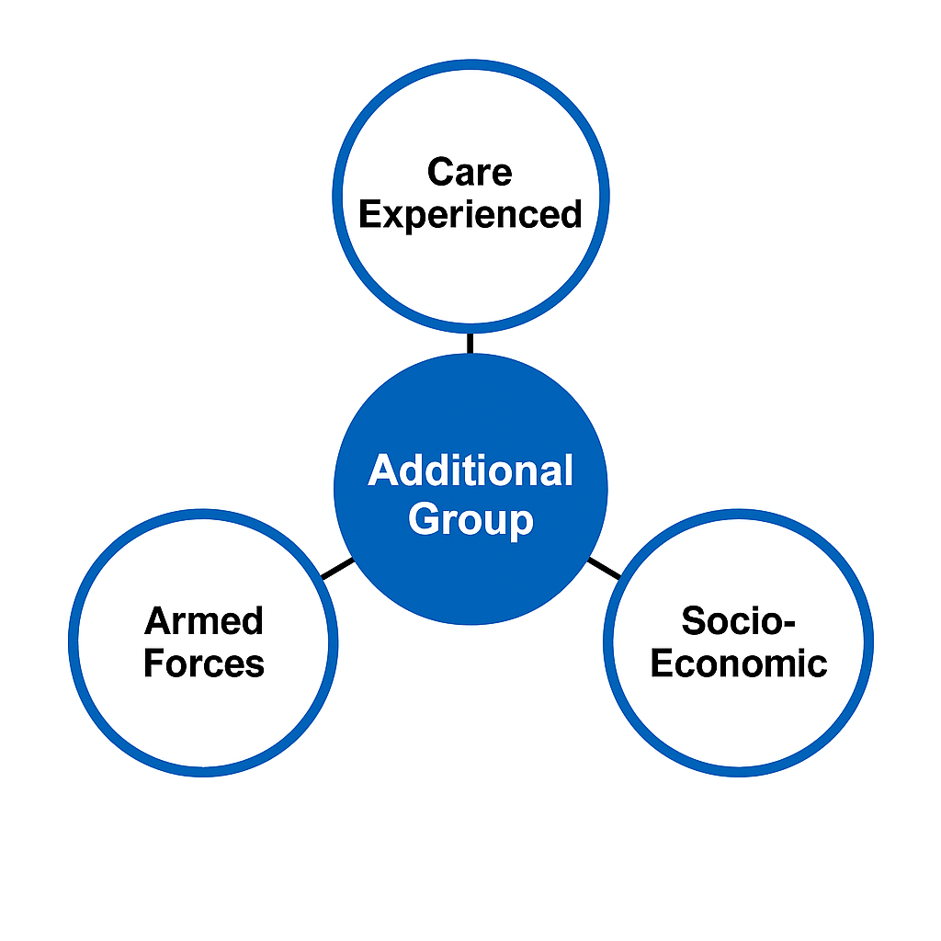Figure 2

At the start of the 2025 to 26 operational year, the Council formally adopted the Armed Forces community as an additional group for consideration. This reflects its commitment under the Armed Forces Covenant, which requires councils to recognise and include serving personnel, veterans, and their families when assessing the impact of policies, strategies, and projects.

The EIA process also includes Care Experienced as an additional group. Including this group helps ensure their unique experiences and needs are considered when making decisions. It enables the Council to identify potential impacts, avoid discrimination, and promote fair outcomes.

The Council considers Socio economic disadvantage in decision making to reduce inequalities and improve outcomes. Socio economic disadvantage refers to people living on a low income with little or no wealth, limiting their ability to access basic goods and services.

By undertaking EIAs, the Council seeks to identify any potential adverse impacts on those with protected characteristics as well as the additional groups and, wherever possible, implement appropriate mitigation measures.

3.0 When should an Equality Impact Assessment be carried out

An EIA should be carried out at the earliest opportunity in the following instances:

- Developing new:
- Strategies / Policies
- Guidelines
- Services / Functions
- Projects
- Events

- Reviewing:
- Existing Strategies / Policies
- Existing Guidelines
- Existing Services / Functions
An EIA shows how equality information and data relating to a policy/project/review has been used to understand the potential impact that the policy/project/review will have on people with protected characteristics.
The EIA process is an evidence base to show how the Council is paying due regard to the requirements of the general duty under the Public Sector Equality Duty.
4.0 Coventry as a Marmot City

Coventry City Council’s Equality Impact Assessment (EIA) process plays a central role in addressing health inequalities and supporting the city’s long-standing commitment as a Marmot City.

In 2019, the Council, working with other statutory organisations, introduced a requirement to consider the impact of decisions on health inequalities, recognising that Council decisions can significantly influence residents’ wellbeing and that adverse impacts are often disproportionately experienced by people in lower socio-economic groups.

From 1 April 2025, the EIA process was further strengthened through the formal inclusion of socio-economic groups as a distinct category alongside the core protected characteristics, reflecting the strong link between deprivation and poorer health outcomes.

The EIA form requires officers to use baseline evidence and analysis, including deprivation and demographic data, service usage patterns, and consultation with disadvantaged communities—to identify how policies, strategies, and projects may impact those most at risk of inequality and to mitigate negative impacts wherever possible.

The EIA references the Marmot Principles, requiring consideration of how decisions contribute to:

- Giving every child the best start in life
- Enabling all children, young people, and adults to maximise their capabilities and have control over their lives
- Ensuring a healthy standard of living for all
- Creating fair employment and good work for all
- Creating and developing healthy and sustainable places and communities
- Strengthening the role and impact of ill-health prevention
- Tackling racism, discrimination, and their outcomes
- Pursuing environmental sustainability and health equity

Through this evidence-led and preventative approach, the EIA process helps ensure that potential negative impacts on health and wellbeing are identified early, addressed proportionately, and do not inadvertently widen existing inequalities.

5.0 Equality Impact Assessment Training

The team continued to provide tailored training sessions during 2025 to 26 to individual staff members or departments, as required. The training sessions are held online or face to face and cover the following:

- The equality legislation -Including the Equality Duty 2010 and The Public Sector Duty
- The role of Council services in improving equality and diversity in service provision
- Benefits of completing EIA’s
- Step by step guide to completing EIA’s

Part 1

Equality Impact Assessments 2025 to 2026

6.0 Summary of the outcomes of Equality Impact Assessments – 1st April 2025 to 31st March 2026

This section presents a visual summary of the outcomes of 48 Equality Impact Assessments (EIAs) completed during the reporting period. The EIAs cover both external decisions affecting service users and internal decisions affecting the workforce.

The 3 tables below summarise impacts across all protected characteristics and additional groups. Outcomes are colour-coded to support quick interpretation:

Green Box shows a positive impact; Red Box shows a negative impact; Orange shows both positive & negative impacts; and blank boxes indicate no impact. Please note empty cells in this table represent no impact.

External EIAs – Service Provision
(Decisions impacting residents, service users, or the wider community)

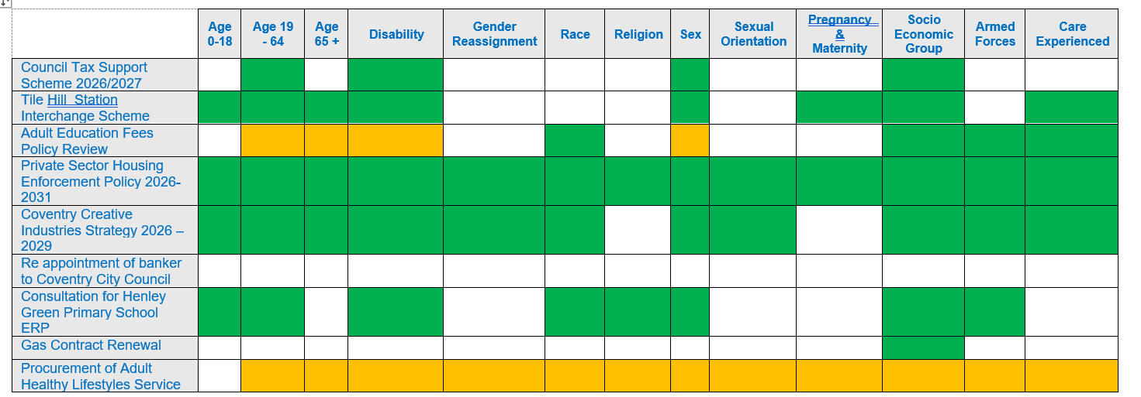

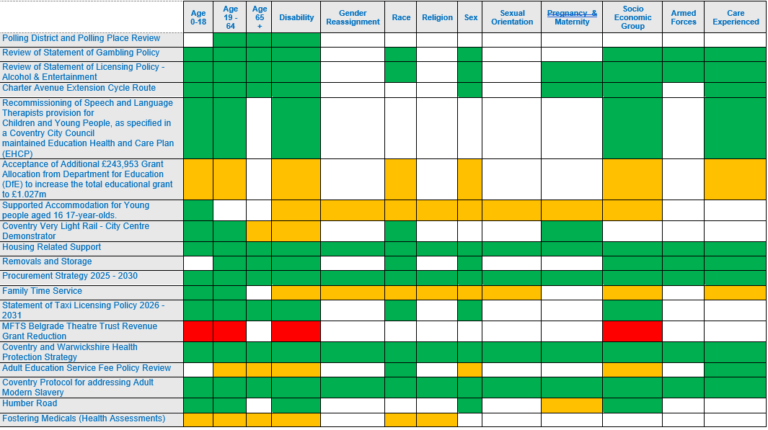

Table 1

Table 1 presents the outcomes of external EIAs relating to service provision, where decisions or policies may impact residents, service users, or the wider community. The table distinguishes impacts across all protected characteristics, in addition to socio-economic background, armed forces status, and care experience.
Overall, the majority of external EIAs recorded positive impacts across most groups. Where negative or mixed impacts were identified, mitigating actions were identified within the individual EIAs to minimise disproportionate effects and ensure continued compliance with the Public Sector Equality Duty.

Combined Internal and External EIAs
(Decisions impacting both service users and the workforce)

 | Age 0-18 | Age 19 - 64 | Age 65 + | Disability | Gender Reassignment | Race | Religion | Sex | Sexual Orientation | Pregnancy & Maternity | Socio Economic Group | Armed Forces | Care Experienced
Service Restructure - Disabled Grants
Street Enforcement Proposed Structure
The best start in life (BSiL) Strategy
2 New Complex Needs Homes
Green for All
Coventry Climate Adaptation and Resilience Plan
Coventry: City of Movement Strategy
Housing Options - Service development and redesign
Mental health VCSE accommodation with support recommissioning
Staff Consultation - AMHP Rota
Data Strategy
CovConnects Digital Unite Digital Champion Training - Inspire
Adult Social Care 5 year plan
Passenger Transport
Restructure of Commercial Property Team
Table 2

Table 2 summarises the outcomes of EIAs that relate to decisions impacting both service users and the Council’s workforce. These include strategic plans, service redesigns, and cross-cutting programmes that have internal operational impacts alongside external outcomes.
The assessments demonstrate that equality implications were considered at an early stage of policy and service development. Positive impacts were most frequently identified in relation to improved accessibility, inclusive service models, and targeted support for vulnerable groups. Where negative or mixed impacts were identified, mitigating actions were identified within the individual EIAs to minimise disproportionate effects and ensure continued compliance with the Public Sector Equality Duty.

Internal EIAs
(Organisational and workforce-related decisions)

Overall Impact
Learning Agreement Policy 2026
Review of Disciplinary Procedure
Flexi Time Policy
Digital Services - Relocation of Lockers
Online Learning Policy
Service Restructure - Digital Delivery Service

Table 3

Table 3 presents the outcomes of internal EIAs, focusing on workforce policies, restructures, and organisational processes.
Overall, internal EIAs identified either positive or both positive and negative impacts where potential negative impacts were identified, mitigations were put in place.

6.1 Analysis of Outcomes

A total of 49 Equality Impact Assessments were carried out. The graph shows that Equality Impact Assessments were most completed in relation to reviews of existing policies and strategies, which accounted for the highest number (18). This indicates a strong focus on assessing equality implications when updating or revisiting established frameworks.

Commissioning activity was the next most frequent trigger for EIAs (9), followed by reviews of services (7). New policies and strategies and new services each accounted for 6 EIAs, demonstrating that equality considerations are being applied at the development stage as well as during review. (See Figure 3)

Figure 3
Overall, this reflects a consistent and structured approach to assessing and addressing equality impacts across both strategic and operational decisions.

6.2 Summary of overall impact of EIA’s

Figure 4
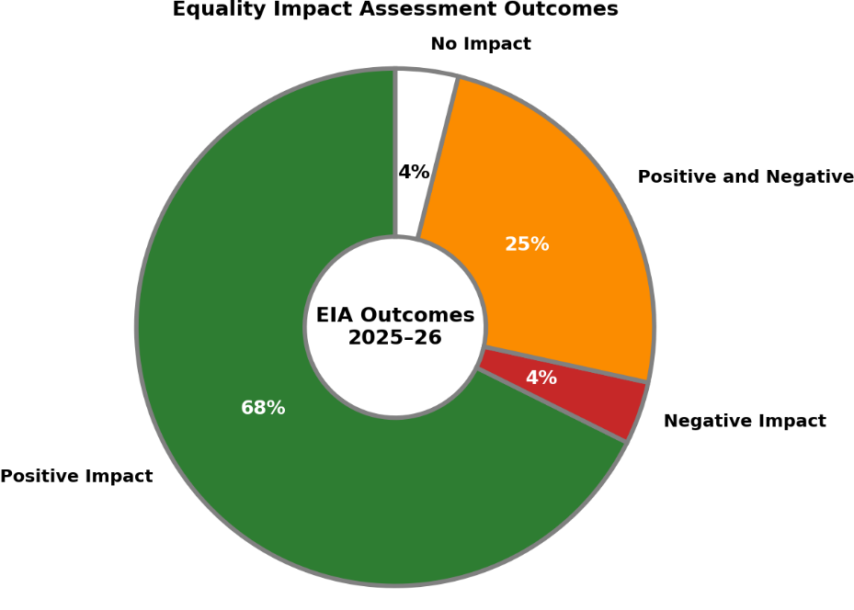

As shown in Figure 4, analysis of the 49 completed Equality Impact Assessments indicates that the majority (68%) identified a positive impact. A further 25% identified both positive and negative impacts, demonstrating that equality benefits were considered alongside potential risks. Only a small proportion of assessments identified negative impacts (4%) or no impact (4%), reflecting the proactive and embedded consideration of equality across Council decision-making.

6.3 Summary of EIA’s by Protected Characteristics as a % from EIAs received

Detailed analysis has been carried out on the potential impact on different groups, identifying those that experienced the most negative impact, the most positive impact, or no impact at all. The impact has been illustrated below.

6.3.1 Positive Impact

Of the 43 external and internal EIA’s relating to service provision and staffing completed this financial year, the most positively impacted protected characteristics are Age 19 – 64, Disability, followed by Age 0- 18 and Socio Economic Group. See Figure 5.

Figure 5 – Positive Impact as an % by Protected Characteristics

Figure 5

Examples of positive impact have included:

EIA - The Best Start in Life (BSiL) Strategy: The assessment identified significant positive impacts for children and families aged 0–18, including earlier identification of need, strengthened early years, SEND, health and learning pathways, and improved transitions into Reception, with indirect benefits for adults aged 19–64 through enhanced parental support. Further positive impacts were identified for disabled children, pregnancy and maternity, ethnic and faith communities, care-experienced families, Armed Forces families and socio-economically disadvantaged groups, through accessible Family Hub services, culturally responsive and targeted support, and action to reduce inequality.

EIA - Green for All: Green for All delivers positive impacts by improving access to green spaces, outdoor learning and nature-based activities, supporting physical and mental wellbeing and reducing inequalities, particularly in areas of high deprivation. The EIA showed inclusive, community-led approaches ensure benefits for children and young people, disabled residents, minority ethnic communities, care-experienced people, Armed Forces families and those facing socio-economic disadvantage, contributing to improved health, skills and community resilience.

6.3.2 Positive and Negative Impact

Among the 43 external EIAs related to service provision completed this financial year, disability, age 19–64 and sex were the protected characteristics most significantly impacted, both positively and negatively. Overall, 25% of the EIAs identified a combination of positive and negative impacts on these groups. See Figure 6.

Figure 6 – Positive and Negative Impact as an % by Protected Characteristics

Figure 6

Examples of both positive and negative impact are:

EIA - Supported Accommodation for Young people aged 16 - 17 year olds:

Positive impact
The supported accommodation service provides safe, stable housing for vulnerable 16–17-year-olds, including care-experienced young people, UASC and homeless young people, supporting safeguarding, wellbeing and stability. Tailored, trauma-informed support helps young people develop independence, access education, health services and positive pathways toward adulthood.

Negative impact
The EIA highlighted potential negative impacts may arise where placements do not fully meet individual needs, particularly for disabled young people, young parents, or LGBTQ+ and transgender young people. These risks are mitigated through strengthened service specifications, robust commissioning, staff training, safeguarding arrangements and ongoing quality monitoring to ensure appropriate and inclusive provision.

6.3.3 Negative Impact Only

Figure 7 shows that children and young people (0–18), working-age adults (19–64), disabled people and people from lower socio-economic groups were identified as being negatively impacted in those EIAs where the outcomes was negative.

Figure 7 – Negative Impact only as an % by Protected Characteristics

Examples of negative impact only is:

EIA - 15% reduction in the Council’s revenue grant to the Belgrade Theatre Trust: The Equality Impact Assessment identifies potential negative impacts from the proposed 15% reduction in the Council’s revenue grant to the Belgrade Theatre Trust on some groups.

These include children and young people, who may experience reduced access to schools, learning and engagement activities; working-age adults, particularly creative freelancers who benefit from skills development and employability pathways; and disabled children and young people, due to potential impacts on targeted SEN and accessible programmes.

In addition, while not a protected characteristic, a risk of negative impact on lower socio-economic groups was also identified as reduced funding may limit the Theatre’s ability to offer free or subsidised access for people from deprived or lower-income communities.

6.3.4 No Impact

Figure 8 highlights that marriage and civil partnership followed by gender reassignment, sexual orientation and religion were the least impacted protected characteristics.

Figure 8: No Impact as an % by Protected Characteristics

There are several reasons why protected characteristics might not be impacted such as:

- Relevance to the Policy or Practice: Not all policies or practices will affect every protected characteristic. For example, a policy related to physical accessibility might primarily impact individuals with disabilities.
- Scope of the Assessment: The scope of the EIA might be limited to specific areas, meaning some characteristics might not be relevant to the assessment.
- Data Availability: There might be insufficient data on certain protected characteristics, making it difficult to assess their impact accurately

7.0 Analysis of Marmot Principles

The analysis shows that activity during the reporting period was most strongly aligned with Marmot Priority 3 (Ensuring a healthy standard of living for all), which accounts for 60% of the total, reflecting a clear focus on interventions addressing income, housing, and wider living standards as key determinants of inequality. This was followed by Marmot Priority 4 (Creating fair employment and good work for all) at 56% and Marmot Priority 5 (Creating and developing healthy and sustainable places and communities) at 54%, demonstrating a substantial emphasis on employment, place-based approaches and community wellbeing.

Lower alignment is observed for Marmot Priority 2 (Enabling all people to maximise their capabilities and have control over their lives) at 35%, and Marmot Priority 8 (Pursuing environmental sustainability and health equity) at 31%, highlighting opportunities to strengthen activity in these areas.

The lowest level of alignment is seen for Marmot Priority 7 (Tackling racism, discrimination, and their outcomes) at 15%, indicating this as a key area for future development to ensure a more balanced and comprehensive approach to reducing health and social inequalities. See Figure 8

Figure 8 – Analysis of Marmot Principles

Key
- MP 1: Giving every child the best start in life
- MP 2: Enabling all children, young people, and adults to maximise their capabilities and have control over their lives
- MP 3: Ensuring a healthy standard of living for all
- MP 4: Creating fair employment and good work for all
- MP 5: Creating and developing healthy and sustainable places and communities
- MP 6: Strengthening the role and impact of ill-health prevention
- MP 7: Tackling racism, discrimination, and their outcomes
- MP 8: Pursuing environmental sustainability and health equity

Part 2

Specific EIAs for Budget-Setting 2026 to 2027

8.0 Summary of the outcomes of EIAs on the Budget proposals 2026 to 2027

21 policy proposals in the 2026 to 27 budget report had individual equality impact assessments (EIAs) carried out. The table below outlines the assessment of each proposal and some analysis to support the outcome of the EIAs.

Table 4 below presents the outcomes of 21 EIAs completed.

 | Positive Impact
Bringing the Tip to You | 
Build Your Future (EcoForce Crew)
New approach to tackle ASB
Food Waste behaviour change
Enhanced cleansing services
Plas Dol-y-Moch site refurbishment and development
Connected Futures: Bridging the Gap from Education to Employment: Focus on 14-16
Transforming Futures: A Strategic Approach to tackling NEET
Increased capacity and new approach to tackle ASB
Average Speed Enforcement
Godiva Festival & Extended Events Programme
Free to play facilities improvement scheme (War Memorial Park)
Community Grow Sites
Care leaver council tax exemption
Increasing number of 5/6 bed family large Temporary Accommodation properties
Increasing family Temporary Accommodation owned by the Council
Support for Foster Care Households
Car Park Improvement Schemes
Defect Repairs
Minor Asset Management
City Centre Red Route Enforcement

8.1 Budget Equality Impact Assessment Analysis
Of the 21 proposals, all were anticipated to have a positive impact. Overall, the anticipated impact (on service users with protected characteristics) of all the budget policy proposals taken together, was analysed as positive.

