Introduction to A Religion and Worldviews Approach to RE: EYFS
Activity 1: Who am I?
Begin by explaining to pupils that everyone has a worldview. This isn’t just about how we see the world, it is about:
- Your beliefs
- How you live
- What you think is true and real
- What really matters to you
- The things you like or don’t like doing

Spend some time talking about what these things might mean. To build an understanding of how people can think differently, you could give examples such as – ‘Do you think unicorns are real?’ Or ‘Do you prefer to go to the park or watch a movie?’.
Provide pupils with paper copy of a gingerbread man. Invite them to spend some time thinking about what makes them who they are: “What makes you, you?”. Remind them to think about their personality as well as the things listed above. If you want to make this practical, you could bake or decorate gingerbread men to show the uniqueness of each one. Alternatively, you could make paper puppets to represent themselves.
If suitable for your pupils, you could watch this BBC short about how we can be similar yet different here: What makes us special? - BBC Bitesize Explain to pupils that everybody has their own way of thinking about the world around them and different ways that they like to do things. This means we all look at the world in our own way and have our own thoughts. This can be called our ‘worldview’. Link this back to the gingerbread man- each one is unique. But what can help us to decide what our worldview might be?
Activity 2: What is my worldview and why?
Invite pupils to consider: Where do my ideas about the world come from? Have a think about the things that most influence the way you see the world and your ideas and beliefs. Think about all the people who are important to you, the things that you do at home and at school, and the places you go. Children can then draw their influences inside a magnifying glass template. As a teacher, model your thinking by drawing your family or other important people, your favourite stories or TV programs, other members of staff, any groups you belong to or particular places you like to go. As you draw, explain how these are important to you and affect the decisions you make, such as: “My mum always told me I need to be polite so I always try to remember to say please and thank you. I love reading the story of the three pigs and that has taught me that I should always work hard “(and so on).
If using persona dolls you could compare your drawing to one of their supposed drawings, adding elements of their organised worldview (religious tradition).
Note: When teaching the worldviews of others, you might like to have paper glasses for pupils to put on to remind them that are deliberately looking at the world through someone else’s worldview lenses.
Invite pupils to think about how they would answer these questions:
- What makes me happy?
- Is it important to help other people?
- How do I know what wrong and right is?
- Do I think there might be a God?
As they think about these questions and how they might answer them, invite them to try to draw their worldview in a glasses template (such as the one below). Continue by reflecting on the following:
- What is important to you?
- What do you believe?
- Who helps you answer big questions?
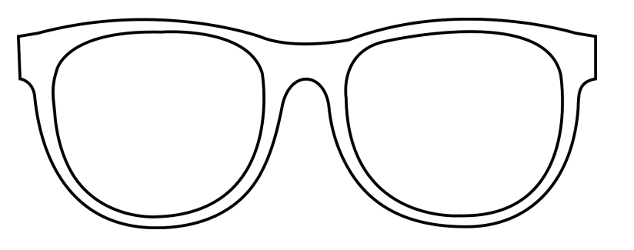
Invite pupils to consider whether their own worldview is influenced by a particular religion. Make sure they know it is fine if it is not; many people are non-religious in today’s society. 
If appropriate, you might introduce pupils to some worldviews terms: individual, communal and organised worldviews:
Individual Worldview | The worldview of a single person, including their beliefs, what they think is important and the things they do. (This may or may not align with an organised worldview like a religious tradition.)
Communal Worldview | The shared worldview of a family or a faith community (e.g. belonging to a local place of worship) where people often share some similar beliefs, ideas or actions.
Organised Worldview | A set of beliefs, ideas, rituals and practices that form a recognisable worldview with familiar characteristics. These are often taken from a sacred text or as a result of a long-held tradition (e.g. a religion) but can also be non-religious in nature (e.g. Humanism).

Remind pupils that their own worldview is called their personal worldview.

Part 3: Other People’s Worldviews
Show pupils the artwork of the Wanderer Above the Sea of Fog by German artist Caspar David Friedrich made in 1818. Invite pupils to imagine themselves as the wanderer above the fog, about to find out about some different worldviews to their own. Explain to pupils that in RE they will find out about different worldviews with different beliefs and ideas and different ways of living. Invite them to consider the question: How can we find out about how other people think or live? Guide towards asking questions, reading stories about people or sacred stories, watching videos about different festivals or the ways people worship, making visits to local places of worship or listening to what worldview visitors have to say. All these things will help us to learn in RE.
Explain to pupils that in the new RE syllabus they are going to be ‘Worldview Explorers’ like the wanderer above the sea of fog (you might even want to set up a role play area with a jacket and explorer tools similar to the character of the wanderer). If we become worldview explorers, then we will be able to understand worldviews that are different to our own. It won’t be difficult for us to understand that other people have different beliefs or ideas or that they live differently, doing things in ways we don’t do ourselves but are important for them. To help us understand other people, we need skills like:
- Curiosity
- Listening
- Thinking

Show pupils the reconciliation statue in the ruins of the old Coventry Cathedral. This provides a good visual of how we might become good worldview explorers. Invite pupils to look at the following:

- The two figures are different from each other, you could link this with each person having their own worldview which makes them unique.
- They are leaning towards each other; they want to understand the other person and get closer to them. This is like wanting to understand how someone else sees the world and what they believe. They could be saying ‘I want to understand you better’.
- They are embracing each other’s head and shoulders. This is like trying to understand and learn about other people’s worldview. This can be exciting because they see, experience and live in the world in a different way to you.

Pupils might enjoy creating a similar sculpture (using clay or playdough) to demonstrate these important skills when understanding someone else’s worldview.

So, how do we become great worldview explorers? How do we study someone else’s worldview?

Activity 4: Disciplines

Explain to pupils that to help us study religion and worldviews, we use different ways of studying and learning. If it feels appropriate for your pupils, you could use the word ‘disciplines’. These are tools and methods with different purposes so we can explore religion and worldviews in different ways. In the new syllabus, we will be developing skills as:

Theologians:  Thinking about beliefs | Theologians do theology. They explore the sacred (special) stories of religion and worldviews and study the beliefs people have. They might also look at art work and other creative activities that can represent those beliefs.
Philosophers:  Thinking about ideas | Philosophers do philosophy. Philosophy means ‘love of wisdom’, so philosophy is all about ideas and thinking. Philosophy helps us to understand why the world might be the way it is and why we might be here, as well as ideas about God and/or something beyond ourselves.
Human & Social Scientists:  Thinking about living | (Human and social scientists use sociology to explore and examine what religion and worldviews look like in society.) Human and social science is all about understanding the ways that people live together, the things people do, and the way they choose to express themselves. This might include interviewing people, looking at what they do and how they live.

Explore the different statements about what pupils will do when using these different disciplines:

Theology- Thinking About Beliefs:

- We listen carefully to sacred stories and make links with what people do and believe.
- We look for clues to try and back-up our thinking.
- We ask questions about what we read and discuss what it might mean.
- We think deeply about what sacred texts mean to us personally and what they might mean to others.
- We look carefully at religious art to discover what it might be telling us about the artist’s worldview, beliefs and ideas.

Philosophy- Thinking About Ideas:
- We think about our own opinions and ideas.
- We explain our opinions and ideas.
- We ask brave questions of our own and attempt to answer the questions of others.
- We try to help people understand our point of view through what we say.
- We think carefully about what we have learned to decide what is true and what might not be true.
- We think about issues of right and wrong, good and bad.

Human & Social Scientists- Thinking About Living

- We look for similarities and differences in the way people live together.
- We think about the reasons why people might choose to wear specific things, behave in certain ways or do particular things.
- We study diversity and lived experiences of religion using interviews, examples and observations,
- We listen carefully and think hard about what we have heard to try to understand the worldviews of others, both personal and organised, alongside our own,
- We meet real people from different religious traditions and those of no faith/religion.
- We think about issues of belonging and how we express ourselves.

The units of work from the new syllabus use at least two disciplines each time. You can see them on the ‘disciplinary doors’ at the top of the unit map and also in the starting slides of the unit resource. Share these with pupils in whichever way seems most appropriate for your pupils.

Introduce pupils to DK Drew (see separate PowerPoint). Drew is a cartoon representation of the wanderer in the fog (see art mentioned earlier) and they have a set of tools for studying religion and worldviews. If possible, have a real backpack with the items inside. When teaching the units of work, you might pull out and discuss with pupils which of DK Drew’s tools they are using and how these will help the fog to clear and make worldviews more visible and understandable. Pupils might like to make their own copy of the tools like DK Drew’s. The tools are listed below. You will probably only want to use some of them for EYFS. Choose the most appropriate ones for your pupils and edit the accompanying PowerPoint slides accordingly.

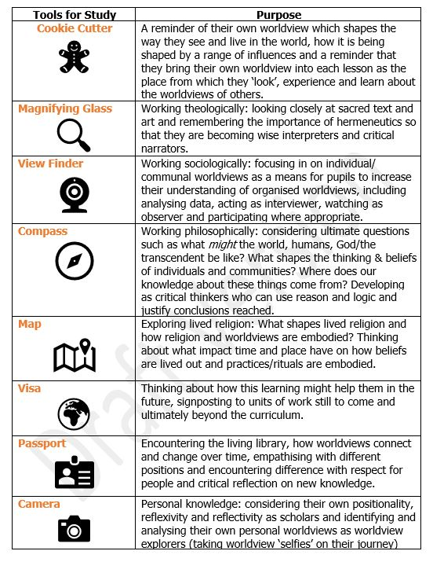

Activity 5: Concepts

The new syllabus for RE is based on seven core concepts that are relevant for understanding all worldviews. You can introduce these to pupils using the simple explanations below:
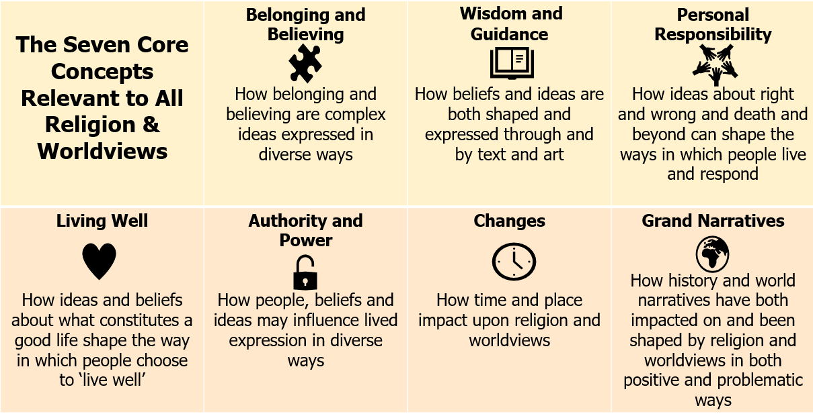

At EYFS pupils will only be encountering the first three of these (the top row). These each have an icon to help pupils recognise them. You might show pupils the icons and see if they can match these to the concepts (see below). This could be through active games or by trying to draw the symbols.

When you teach units from the new syllabus, help pupils to orientate themselves into the concept the unit is exploring.
 |  | 

Wisdom and  Guidance | Personal Responsibility | Belonging and Believing

