Introduction to A Religion and Worldviews Approach to RE: KS2
You will need the Pupil Worldview Passport for KS3 (pages 22-25 in the passport document).
Part 1: Who am I?
Begin by explaining to pupils that everyone has a worldview. This isn’t just about how we see the world, it is about the following:
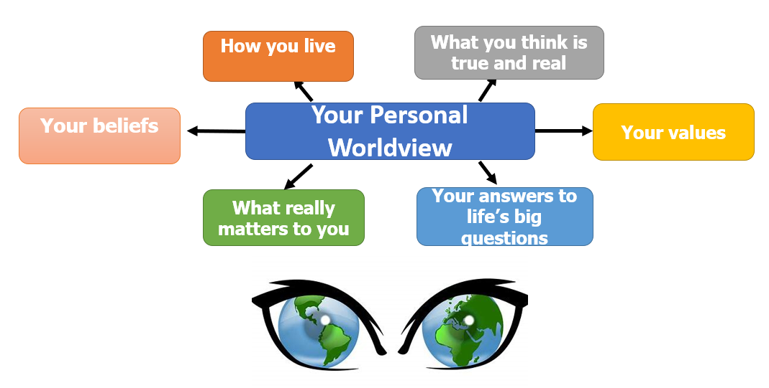
Spend some time talking about what these things might mean.
Invite students to consider the mixing desk on page 22 of the pupil passport. Are these things important for them? How important? These are some of the things that can make us different from other people, even our peers. If the mixing desk is an analogy, our personal worldviews are like our own unique melodies.

Where would they place these on the mixing desk to begin thinking about the important components of their own personal worldview? Which things would be dialled up high or faded down low? If you want to, let students cut out and construct the mixing desk or just have them write the words in the right place on the infographic:
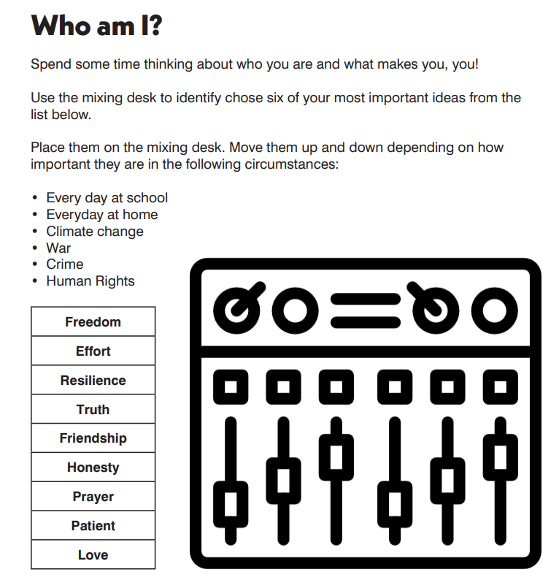
Show pupils the Nobody Stands Nowhere animation from Theos Think Tank here that explains how everybody has their own way of seeing the world from their own unique position. Remind pupils that everybody stands somewhere. This means we all look at the world from a certain position and see things from our own perspective. You could say that our worldview is like the ‘mesh’ that we look at the world through. Link this back to the gingerbread man- each one is unique. But what creates that mesh? What influences it?
This video by the Open University might also be a useful watch for pupils when considering what we mean by worldviews and how this is not a simple concept and that worldviews are messy and fluid and can’t easily be out into boxes as we might have previously tried to do (e.g. ‘All Christian believe…’, ‘All Muslims do…’ etc).

Part 2: What is my worldview and why?
Invite pupils to consider: Where do my ideas about the world come from? Have a think about the things that most influence the way you see the world and your ideas and beliefs. You might ask students to draw their influences inside a magnifying glass template (such as the one below):
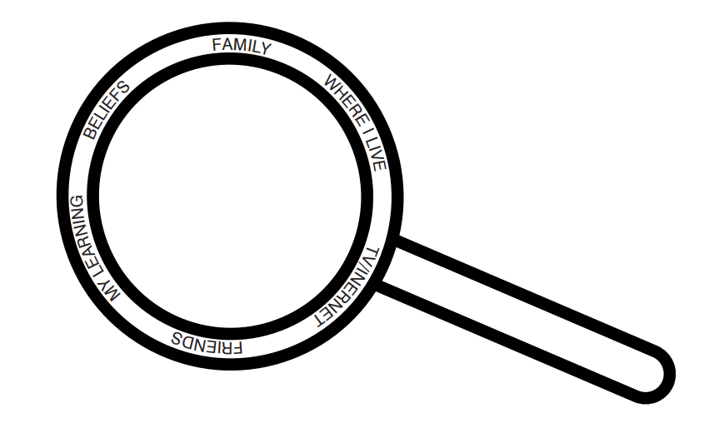
They can think about influences such as the following, or ones they themselves identify as relevant for them:
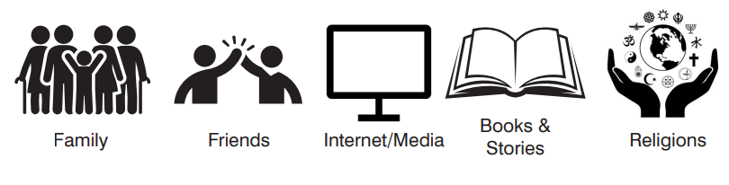
Ask pupils to think about the term ‘worldview’ and what it means. You might ask them to:
Define it:
Use it:
Link it:
Deconstruct it:
The Freya Model might provide a good framework for really becoming familiar with this word that will be key to this new way of doing RE.
Pose the question: How has your worldview changed since you were younger? You might use page 23 of the pupil passport to get pupils thinking about how their personal worldview has changed, identifying things that were part of their personal worldview when they were younger but perhaps aren’t now and more recent additions and accommodations within their worldview.
Introduce pupils to terms: individual, communal and organised worldviews:
Individual Worldview | The worldview of an individual, including their beliefs, values, philosophy for living and behaviours/actions. This may or may not align with an organised worldview like a religious tradition.
Communal Worldview | The shared worldview of a family or a faith community (e.g. belonging to a local place of worship) where individual worldviews share close characteristics with others in the group.
Organised Worldview | A set of beliefs, ideas, rituals and practices that form a recognisable worldview with familiar characteristics. These are often taken from a sacred text or as a result of a long-held tradition (e.g. a religion) but can also be non-religious in nature (e.g. Humanism).

Remind pupils that their own worldview is called their personal worldview.
The video series from the University of Nottingham here includes explanations of what we mean by these different types of worldviews.

Invite pupils to consider whether their own worldview overlaps with/aligns with an organised worldview like a religion. Would they consider themselves to have a religious identity? Is their relationship with religion more sentimental or cultural?
You might ask them to circle the diagram that best represents them or to draw their own diagram showing the relationship between their own personal worldview and any organised worldview(s). Remind them that it is perfectly fine for them to just have a personal worldview with no overlap with an organised worldview and also to describe themselves as ‘non-religious’.
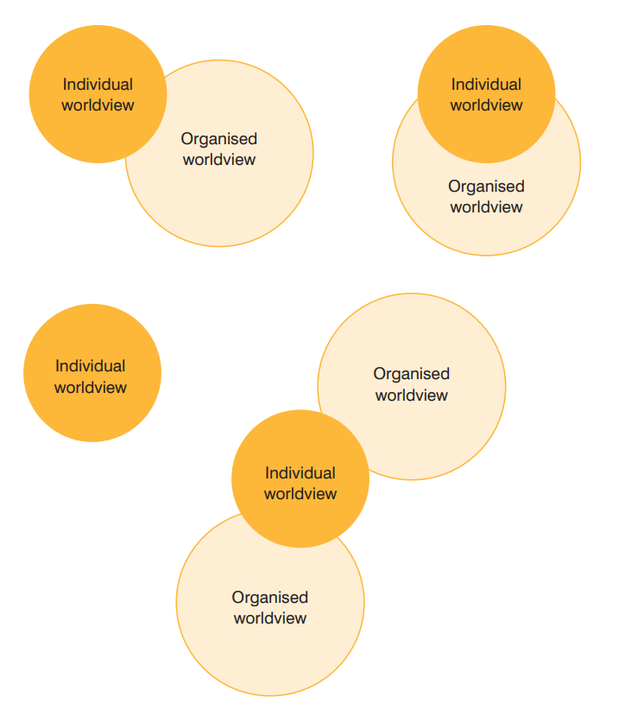
Another activity you might do with pupils is to invite them to complete a ‘Personal Worldview Snowflake’ (see below). To do this they need to read the statements in each box and place an ‘x’ on the line; closer to the box depending on how important it is for them and nearer to the middle if it is less important. They should then join all the ‘x’s up to create their own unique snowflake. Pupils might like comparing their snowflakes with those of their peers.
- Can they find a snowflake very similar to their own?
- Can they find a snowflake very different to their own?
- Choose one statement to compare with someone’s else’s snowflake.
You might create a display of the different snowflakes. Allow these to be anonymous unless pupils wish to put their names on them.
Personal Worldview Snowflake

I believe that following an organised/ institutional worldview is the best way to live
I believe that this life prepares us for a new life after death
I believe my actions can make the world a better, more peaceful place to exist
I believe there is a God or higher power beyond myself that really exists
I believe that spending time in reflection (e.g. prayer or meditation) is helpful for living well
I believe that love for all is the most important thing over everything else
I believe the world has the capacity to be a better place in the future than it is right now
I believe that finding the truth about life is a hard but worthwhile task

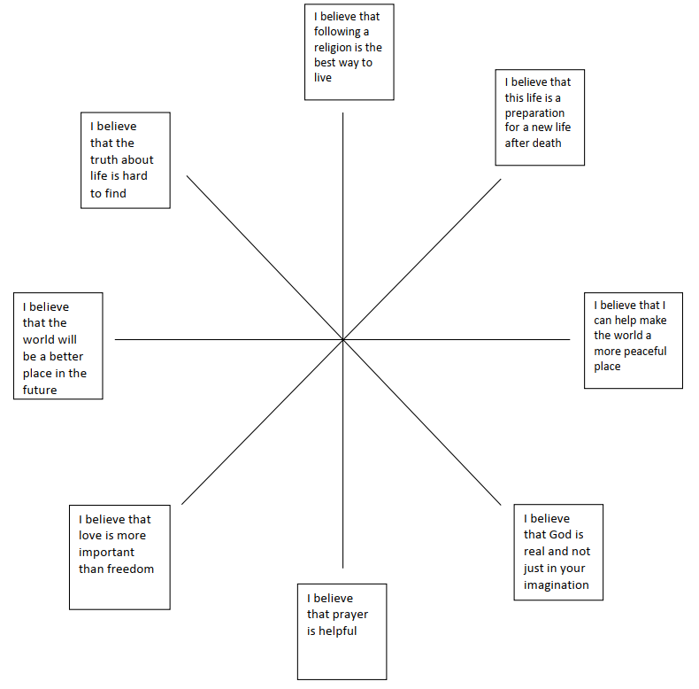

Following (or instead of) this, you might also like to invite students to do a ‘Diamond 9’ activity thinking about their own personal worldview. You could invite them to identify 9 things that might influence your world view from the list:
Food
Religion
Music
Animals
Parents
Social Media
Friends
Society
Celebrities
Nature
Money
Politics

Invite them to rank their 9 chosen things in order of what might influence their personal worldview the most. The most important factor goes at the top.
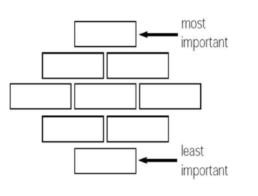
You might then invite pupils to draw their worldview, perhaps using a template such as a pair of glasses (see below). This could make a great display for the RE classroom.
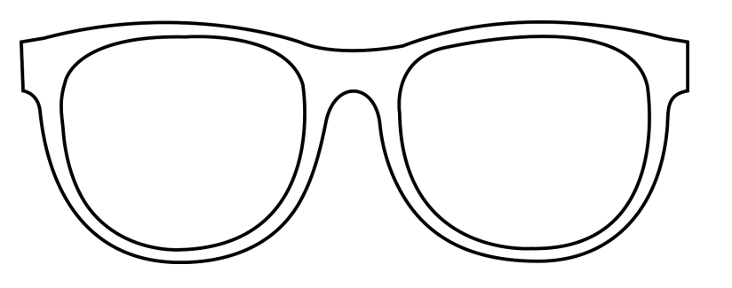
Invite pupils to consider whether their own worldview is influenced by a particular religion. Make sure they know it is fine if it is not; many people are non-religious in today’s society. They might be able to add any relevant organised worldview (such as religious tradition) to their drawing, using symbols or other means.
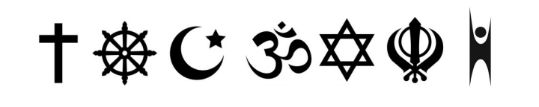
Introduce the term ‘embodied’ to students. You might see this as the physical expression of one’s worldview, identifiable through actions and observable in practice and ritual. Invite students to consider how a worldview can influence behaviour, thinking about their own personal worldview and behaviour/actions. This might lead onto discussions around advocacy and activism as a result of beliefs and philosophical ideas.
This is also a good opportunity for introducing important new skills to students:
Reflectivity: Taking time to think about your own worldview lenses and what you have read, watched, listened to, learned, encountered and are bringing into the lesson with you. What is your own worldview? Recognising there is no neutrality or absolute objectivity.
Reflexivity: Being able to identify your own experiences as a learner and a teacher, to become more conscious, open-minded, and self-critical in your own practice, asking questions about your own biases and assumptions as you take action e.g. to choose a resource, to book a speaker, to pose a question.
Positionality: Understanding one’s own position in approaching the subject matter. The social and political context that creates identity in terms of race, class, gender and sexuality is better understood by teachers, as well as how identity influences, and potentially biases, your understanding of the world, so is inherent to any worldviews approach to learning in RE.
Developing these skills will help students to better understand their own worldview.

Part 3: Other People’s Worldviews
Show pupils the artwork of the Wanderer Above the Sea of Fog by German artist Caspar David Friedrich made in 1818. Invite pupils to imagine themselves as the wanderer above the fog, about to find out about some different worldviews to their own. In RE they will find out about different worldviews with different beliefs and ideas and different ways of living. Invite them to consider the question: Which actions will help you to better understand somebody different to you? Ask them to write these actions down. Are these things they regularly do in RE?
Explain to pupils that in the new RE syllabus they are going to be ‘Worldview Explorers’ like the wanderer above the sea of fog. If we become worldview explorers, worldviews different to our own will not be such a mystery anymore; we will recognise them and understand them. It won’t be difficult for us to understand that other people have different beliefs or ideas or that they live differently, using their bodies in different ways, such as in rituals or practices we don’t do ourselves but that have great meaning for them. Often when we encounter a worldview that is different to our own, we can experience what we might call ‘Worldview Shock’ (just that initial unfamiliarity with how that person understand the world or what they believe) and we need to use our skills to overcome this. Those might be skills like:
- Curiosity
- Listening
- Empathy
- Humility

Show pupils the reconciliation statue in the ruins of the old Coventry Cathedral. This provides a good visual of how we might overcome our ‘worldview shock’ and be good worldview explorers. Invite pupils to look at the following:

- The two figures have their knees apart, providing them with a solid base. This is their own position from which they see and understand the world. You could say this represents their own worldview.
- They are leaning towards each other; they want to understand the other person’s position and connect with them. This is like the desire to understand how someone else sees the world and what they believe. There is a humility in saying ‘I want to understand you better’.
- They are embracing each other’s head and shoulders. This is like trying to understand and learn about someone else and their worldview and empathising with them because they see, experience and live in the world in a different way to you.

Pupils might enjoy creating their own sculptures (perhaps using clay, playdough or even tinfoil) to demonstrate these important skills when understanding someone else’s worldview.

So, how do we become great worldview explorers? How do we study someone else’s worldview?

Part 4: Disciplines

Explain to pupils that to help us study religion and worldviews, we use different ‘disciplines’. These are tools and methods with different purposes so we can look at religion and worldviews from different angles/through different academic lenses. In the new syllabus, we will be developing skills as:

Theologians | Theologians do theology. They explore the sacred texts of religion and worldviews and study the beliefs people have. They might also look at art work and other creative activities that can represent those beliefs.
Philosophers | Philosophers do philosophy. Philosophy means ‘love of wisdom’, so philosophy is all about ideas and thinking. Philosophers create and discuss different arguments and reasons for believing certain things. Philosophy helps us to understand why the world might be the way it is and why we might be here, as well as ideas about God and/or something beyond ourselves.
Human & Social Scientists | Human and social scientists use sociology to explore and examine what religion and worldviews look like in society. Human and social science is all about understanding how society works, how faith communities live, belong and express worldviews together and how people embody their worldview. This might include interviewing and surveying people, observing what they do and how they live or looking at data to do with religion and worldviews.
Historians | Historians look at the evidence of what life was like in the past and they explore sources to try to understand how and why things happened. History is connected to RE because we can ask questions about religion and worldviews in the past and how people lived out their beliefs and ideas.

Explore the different statements about what pupils will do when using these different disciplines:

Theology:

- We analyse sacred texts and make links with practices and beliefs.
- We look for evidence to back up our thinking.
- We make judgements based on our reading.
- We make interpretations and identify our hermeneutical lenses.
- We ask questions about what we read and discuss its meaning.
- We consider authorship and authority and the context in which sacred texts were written.
- We reflect on what sacred texts mean to us personally and what they mean to others.
- We consider what religious art might be telling us about the artist’s worldview and wider beliefs and ideas.

Philosophy:

- We explore different methods of knowing and different methods of reasoning.
- We use the ideas and thoughts of others to generate discussion and formulate our own opinions.
- We justify our opinions and ideas with evidence and examples.
- We challenge the ideas and opinions of others, known to us and not previously known.
- We ask innovative questions of our own and attempt to answer the questions of others.
- We try to be persuasive in our spoken language and in our writing.
- We think critically using reason and evidence.
- We think about why we are here and issues of right and wrong, good and bad.

Human & Social Scientists:

- We question assumptions about worldviews and religion.
- We analyse how things change in society.
- We consider the reasons for human behaviour and practices.
- We consider what behaviour and practices tell us about belief and ways of seeing the world.
- We study diversity and lived experiences of religion using interviews, case studies and observations.
- We analyse and try to understand the worldviews of others, both personal and organised, alongside our own.
- We encounter real people from different religious traditions and those of no faith/religion.
- We think about issues of belonging and identity and the interactions between these ideas.

You might invite pupils to do a matching game, sorting different methods and tools they might use in RE lessons to the correct disciplines (see below).

The units of work from the new syllabus use at least two disciplines each time. You can see them on the ‘disciplinary doors’ at the top of the unit map and also in the starting slides of the unit resource. Share these with pupils.

If appropriate (perhaps for younger students in KS3), you could introduce pupils to DK Drew (see separate PowerPoint). Drew is a cartoon representation of the wanderer in the fog (see art mentioned earlier) and they have a set of tools for studying religion and worldviews. When teaching the units of work, you might discuss with pupils which of DK Drew’s tools they are using and how these will help the fog to clear and make worldviews more visible and understandable. Pupils might like to draw or make their own tools like DK Drew’s.

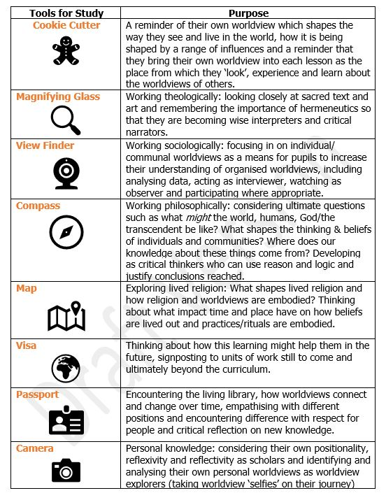

Part 5: Concepts

The new syllabus for RE is based on seven core concepts that are relevant for understanding all worldviews. You can introduce these to pupils using the simple explanations below:
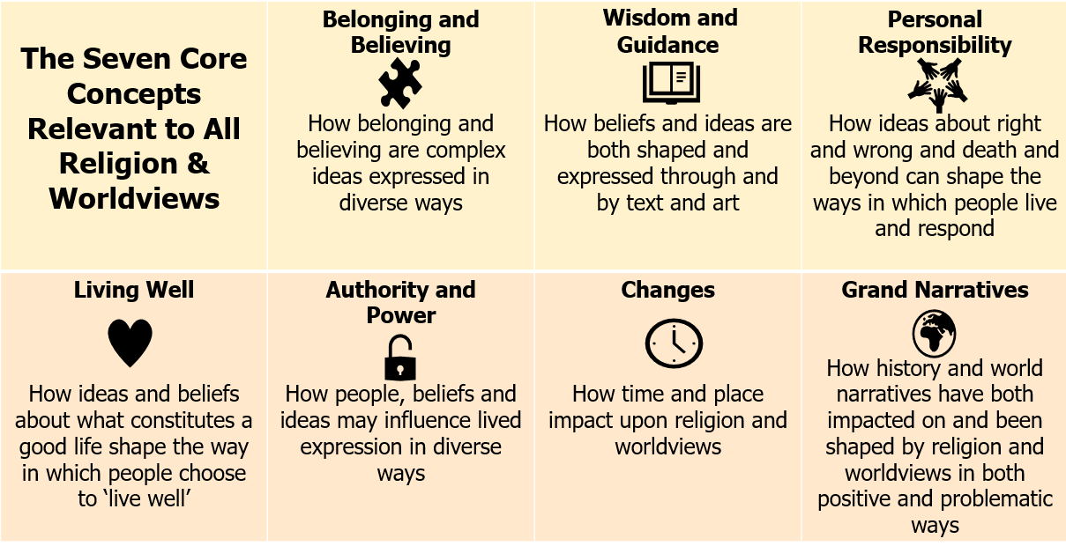

At KS3 pupils will be exploring all 7 of these. Due to the newness of the syllabus, they will not have become familiar with them at primary school so bear this in mind. These each have an icon to help pupils recognise them. You might show pupils the icons and descriptions and see if they can match these to the concepts (see below).

Explain to pupils that this syllabus is like a spiral staircase; we will keep coming back to these concepts and trying to understand them better as we look at religion and worldviews from different angles.

When you teach units from the new syllabus, help pupils to orientate themselves into the concept the unit is exploring.

Discipline | Methodology | Tools
Theology | Making surveys asking questions about religion and worldviews | Sacred texts (including different versions/translations of sacred texts)
Philosophy | Interpreting stories from sacred texts (hermeneutics) | Religious/sacred artwork
Human & Social Sciences | Making notes/highlighting (exegesis) of sacred texts | Philosophical arguments made by existing philosophers
History | Interpreting religious art | ‘Living Library’: people with different worldviews
 | Taking part in discussion & debate | Thought experiments
 | Observing what happens in a place of worship/faith community (ethnographic study) | Data about religion and worldviews
 | Coming up with reasoned arguments
 | Interviewing people with different worldviews

How ideas about right and wrong and death and beyond can shape the ways in which people live and respond | How beliefs and ideas are both shaped and expressed through and by text and art | How time and place impact upon religion and worldviews | How history and world narratives have both impacted on and been shaped by religion and worldviews in both positive and problematic ways
How people, beliefs and ideas may influence lived expression in diverse ways | How ideas and beliefs about what constitutes a good life shape the way in which people choose to ‘live well’ | How belonging and believing are complex ideas expressed in diverse ways
 |  |  | 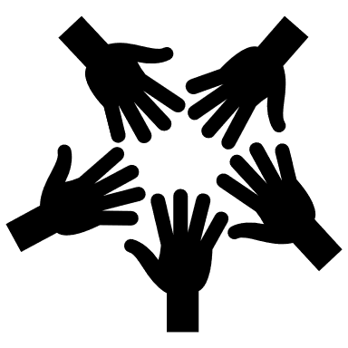
 |  | 
Wisdom and  Guidance | Living Well | Personal Responsibility | Changes
Authority and  Power | Belonging and Believing | Grand Narratives

