Moving to My New School


Name………………………………………

I am moving from Year 6 at XXXXXX School to Year 7 at XXXXXX in September.

All of my classmates from Primary school will be starting at a new school too.


My photobook will help to remind me about where I will be and how to get there.

My new school is called……………………………………
Insert photo of school

Insert school badge

My new form tutor, XXXXXXXXXXXXX, is really looking forward to seeing me in September.
Insert photo of form tutor

This is my form room where I will go every morning for the register and XXXXXXXXXX (add appropriate details)
Insert photo of form room

I need to be at school at XXXXXX (time) every morning.
This is where I will arrive at school.
Insert photo of appropriate school entrance for pupils

I will then go to the playground, my form room, nurture room, my calm space etc… (add appropriate details)
Insert appropriate photo/s to match sentence above

Lessons start at XXXX (time).
I will need to make sure that I have all the right equipment and books for each lesson.
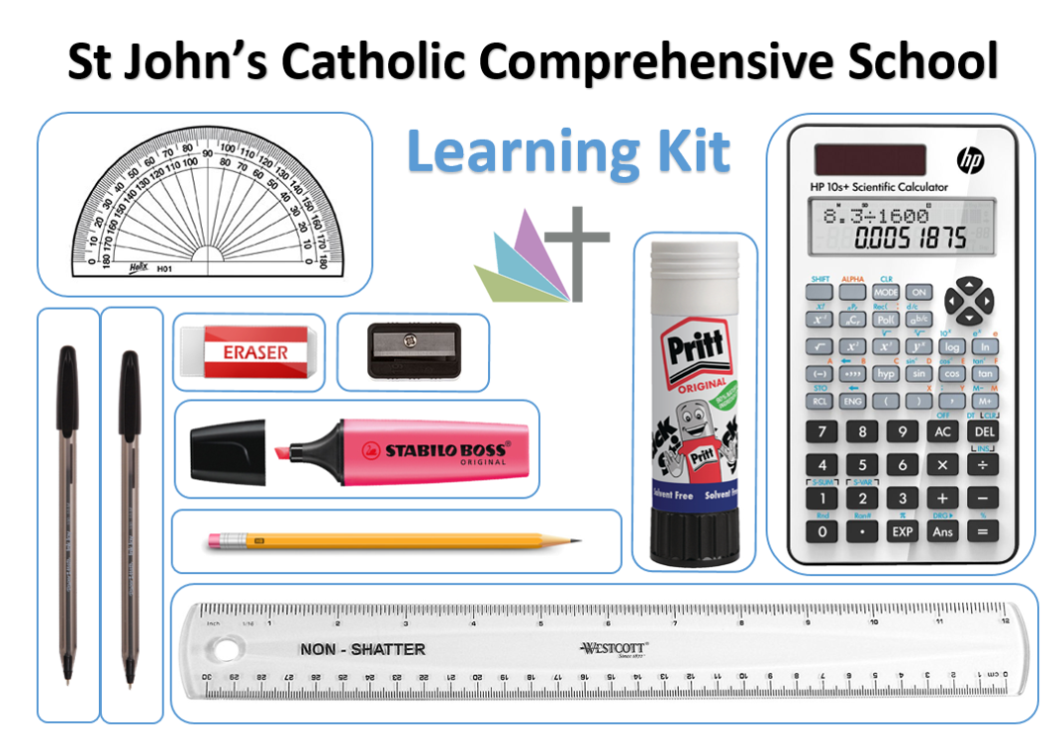
(example only above- add picture of school equipment list if available)
My timetable will help me to understand what I need each day.
Insert picture of timetable format

This is the timing of each day.

When it is breaktime I can... (go onto the playground, visit the nurture room, sit quietly in the library…add appropriate detail)

Add necessary photographs

At lunchtime, xxxxx (explain how lunchtime will be organised and what is available and where)
Insert photos of lunch facilities

The school day ends at XXXXX.
I will leave the school site using the XXXXXX
(add appropriate details and photos if needed).

People who will be important to me at my new school. (change as appropriate)
Identified key person
SENDCo

Learning Support Assistant/ TA
Pastoral staff

Headteacher
Head of year

I will have a new school uniform. This is what I will need to wear:
Insert photo of uniform

In PE lessons I will wear a PE kit.
Insert photo of PE kit

