Moving to My New School


Name XXXXXXXXXXXXXXX

I am moving from Year 6 at Green Street Primary School to Year 7 at Blue Drive Secondary School in September.

All of my classmates from Primary school will be starting at a new school too.


My photobook will help to remind me about where I will be and what happens there.


My new school is called Blue Drive Secondary School


This is the school badge.

My new form tutor, Mr History, is really looking forward to getting to know me better in September.


This is my form room where I will go every morning at the start of the day to be registered. Mr History will tell us about any school news or events.
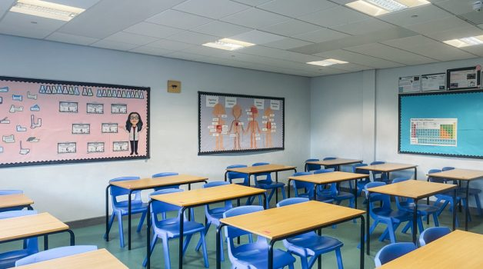

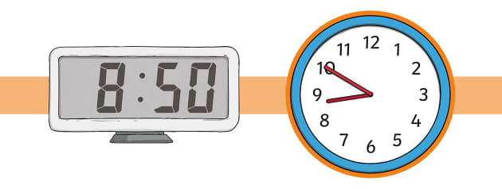
I need to be at school by 8.50am every morning.
This is where I will arrive at school.
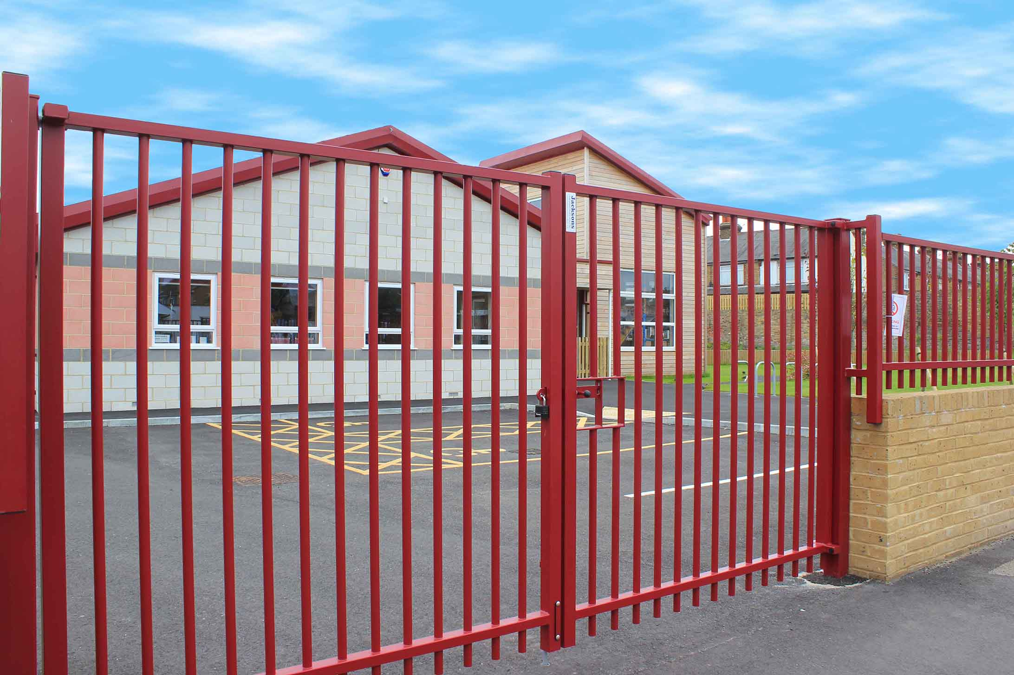

I can go onto the playground if I feel able or to The Hub where it is calm. I will go to my tutor room when the bell goes at 8.50am.
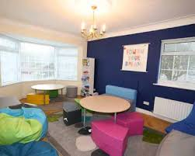
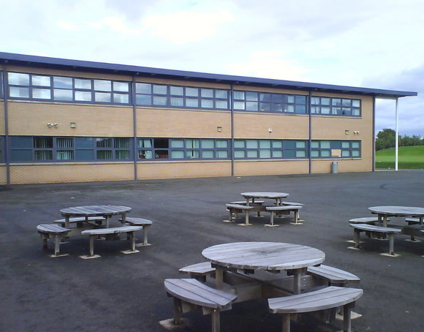

Lessons start at 9.10am.
I will need to make sure that I have all the right equipment and books for each lesson.
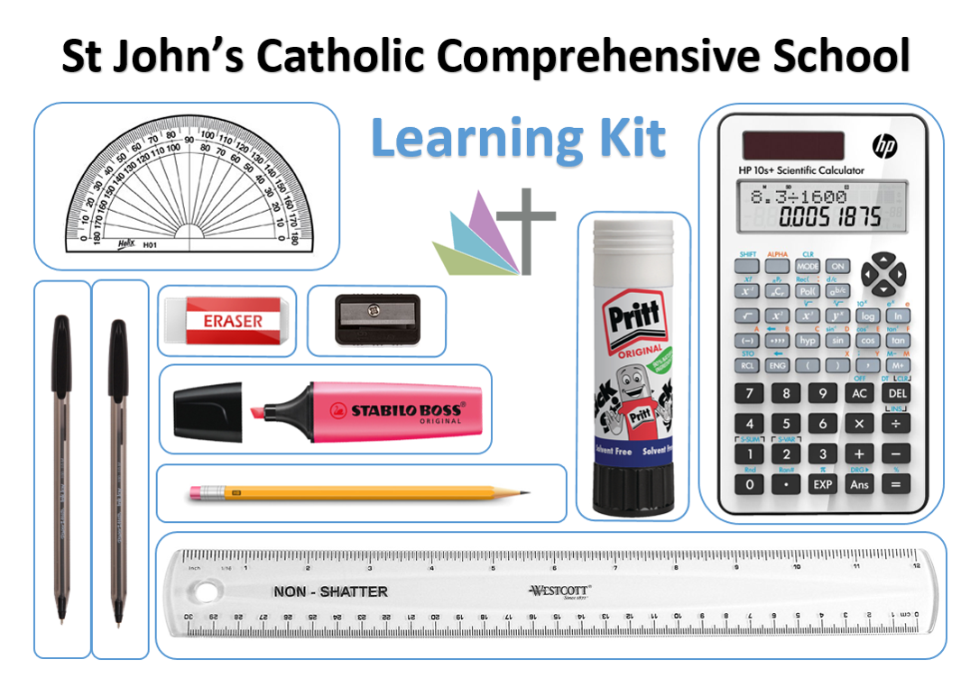
My timetable will help me to understand what I need each day.
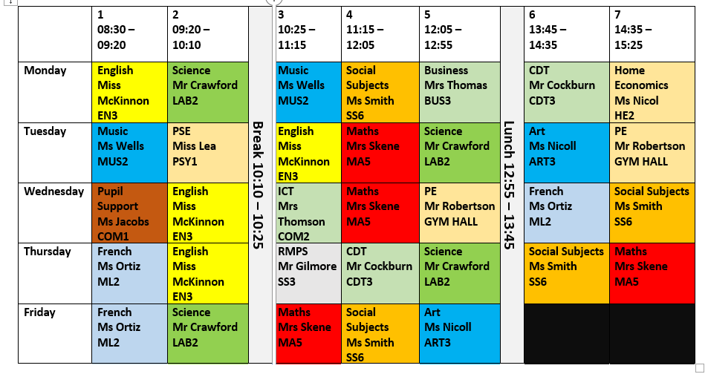

This is the timing of each day.
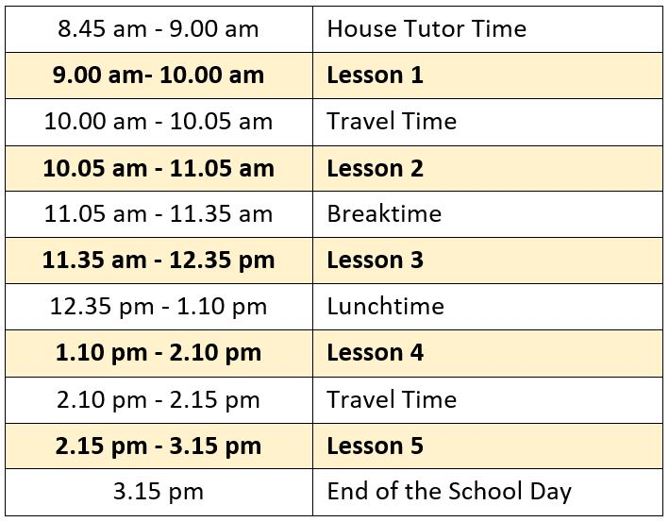

When it is breaktime I can go onto the playground if I feel able or I can sit calmly and quietly in The Hub or the library.
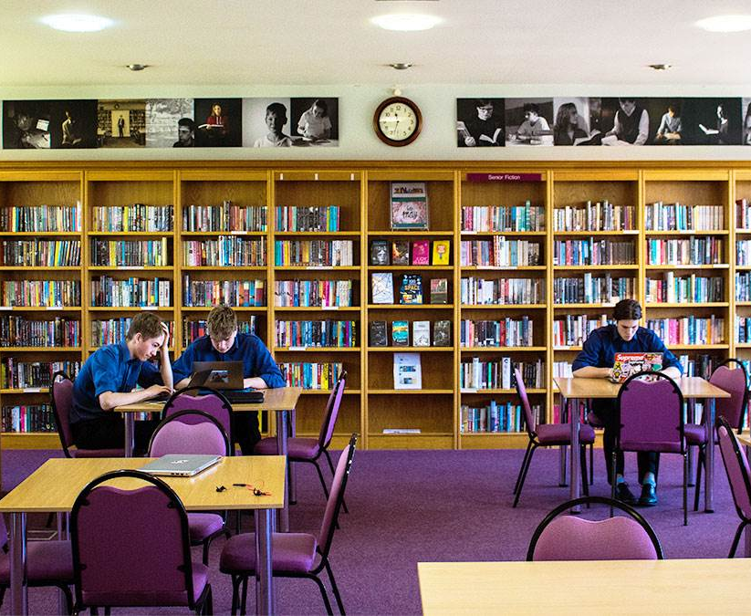

We have two lunch breaks: 11.30am to 12.30pm and 1pm to 2pm.

I can buy my meal or bring a packed lunch.


I can eat my lunch in the canteen or go to the Year 7 playground, the library, The Hub or attend a club.
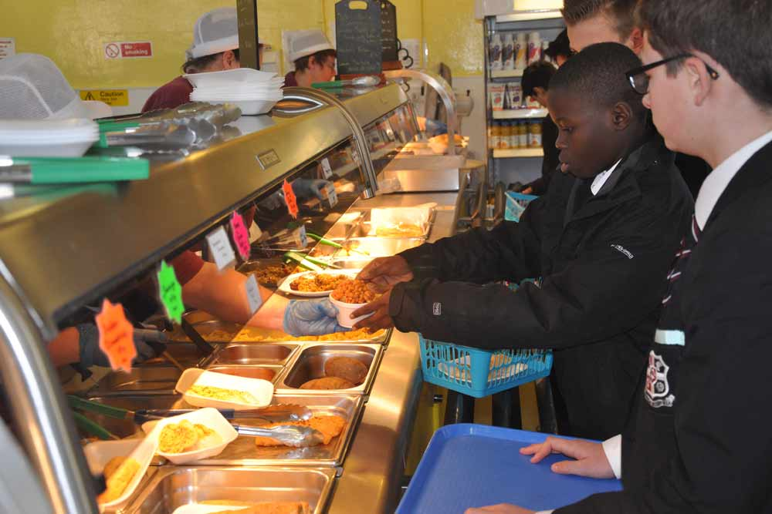

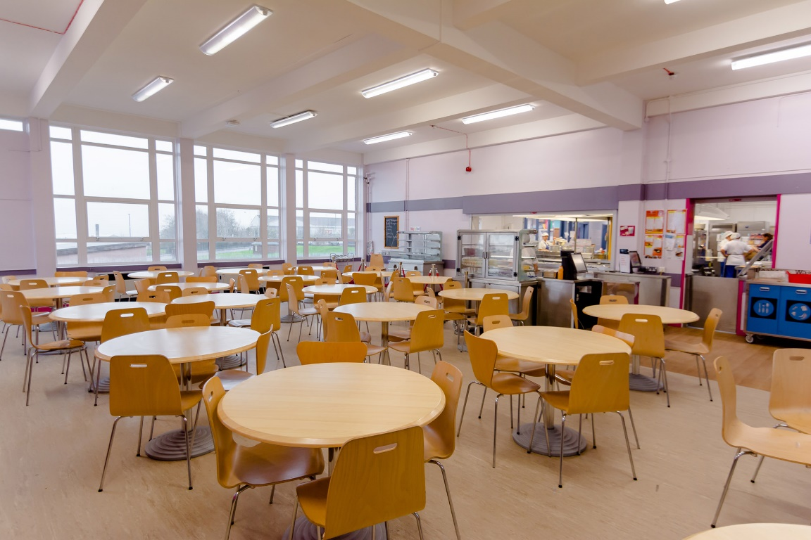



The school day ends at 3.15pm.

I will leave the school site using the main entrance.

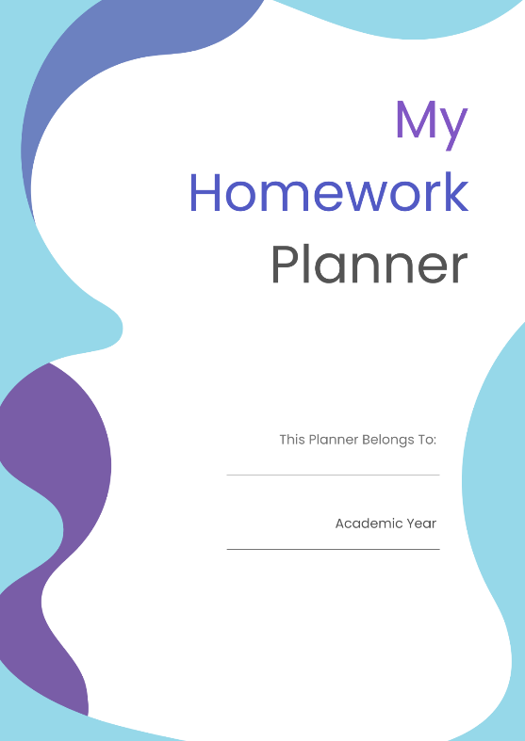
I will walk home.

I will need to check my homework diary when I get home and complete my homework.


People who will be important to me at my new school.

Mrs Helpful- SENDCO
Mr Science- My Key Person




Miss Patience- The Hub Leader
Mr Caring- My Learning Support Assistant


Mrs Head is the Headteacher at Blue Drive Secondary School.


Mr Leader is the Head of Year 7.

I will have a new school uniform. This is what I will need to wear:


In PE lessons I will wear this PE kit.


I will soon get used to all these new things at my new school.

It is ok to feel a little worried.
My friends will feel this way too.
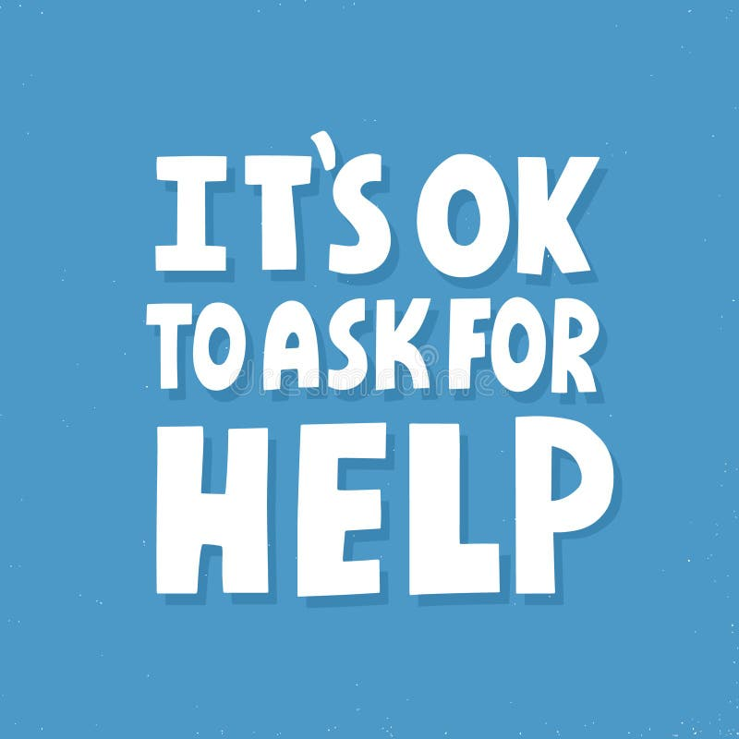

I know who can help me and I need to remember to ask for help if I need it.

