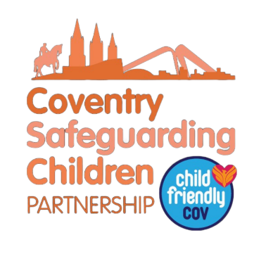
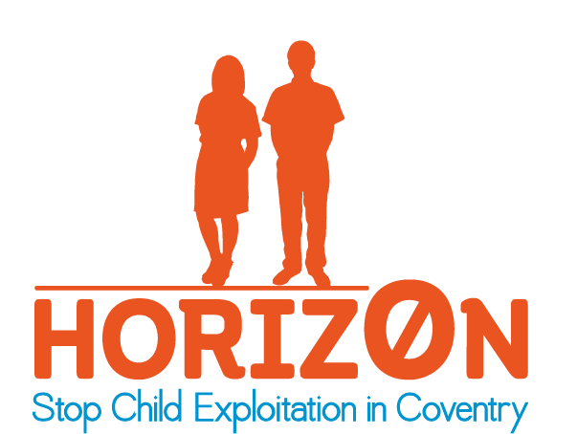
What is Child Criminal Exploitation?
Child Criminal Exploitation is a type of child abuse where children are manipulated and coerced into committing crimes. There are many forms of criminal exploitation including the supply and movement of drugs, offences in relation to firearms, knives and other weapons, violent assaults and cuckooing where criminals forcibly take control over an individual’s home.
Child Criminal Exploitation is often linked to gang activity and children usually consider their involvement in gangs and crimes as consensual and a choice, they do not recognise that they are being exploited.

What can Child Criminal Exploitation look like?
Criminal gangs use different methods of recruitment and exploitation including drug debts, bribes, befriending, threats and violent assaults. Once a child is exploited into a gang the dangers they may face include:
- threats, blackmail and violence
- being arrested
- theirs, family and friends safety threatened
- emotional abuse
- substance and alcohol misuse
- being forced to commit crimes
- risk of physical harm, rape and sexual abuse
- significant negative impact on education and future employment
- risk of being killed or severely injured
- not being able to leave or cut off ties with the gang due to fear of repercussions to self, family or friends
- Plugging (the concealment of drugs inside body cavities)
Any child can be targeted by exploiters regardless of their age, gender, background, socio-economic status, religion or culture. However, exploiters often target children who have unmet needs.

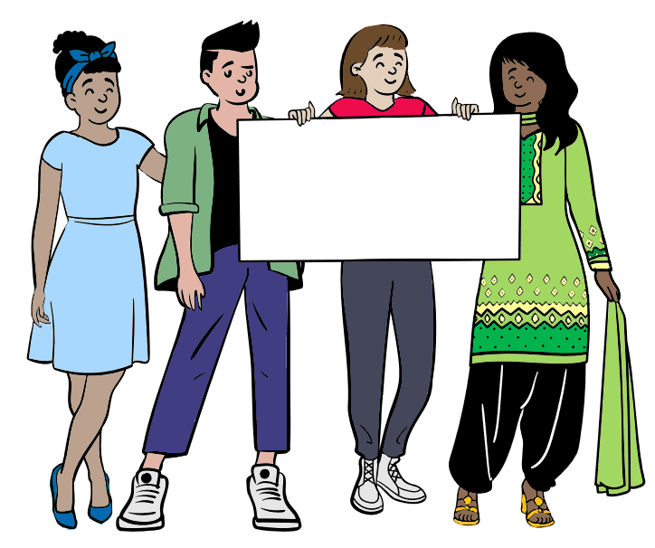

One Minute Guide
Child Criminal Exploitation
June 2026

STOP CHILD EXPLOITATION!

What to do if you think it’s happening
If you have a concern that a child may require support or be at risk of harm a referral to The Children & Family Initial Response Service should be made using the Request For Support form: Request for Support’
You may wish contact The Children & Family Initial Response Service on 024 7678 8555. If the child is at immediate risk of significant harm call the police on 999. To discuss a non-emergency matter with the Police call 101.
Out of office hours please call the Emergency Duty Team on
024 7683 2222.
For more information about Child Exploitation see our website
Where there are concerns that children are being criminally exploited, they should be referred to the National Referral Mechanism (NRM) as potential victims of modern slavery / human trafficking.

Indicators of Child Criminal Exploitation
Some signs that a child is being criminally exploited may include:
- Going missing from home or school
- Suddenly having lots of money, new possessions, new clothes or trainers that they cannot account for
- Receiving more calls/texts than usual
- Being very protective of their mobile phone or having multiple phones or SIM cards
- Using new language, words or hand signs
- Changing their appearance, e.g. dressing in a particular way or style, or use of particular colours
- Changes in behaviour e.g. being scared, aggressive, distant or angry
- Talking about an individual or group who have a lot of influence over them
- Hanging around with individuals or groups that are older than them and breaking ties with old friends
- Dropping out of positive activities and hobbies
- Unexplained physical injuries and/or refusal to seek medical treatment
- Travelling alone to places far from home or being found by services out of area
- Unexplained bus or train tickets
- Carrying drugs, large amounts of money or weapons
- Self-harming and substance misuse issues

Key Contacts and Further Information
Coventry Safeguarding Children’s Partnership
Horizon – Coventry
Fearless
St Giles

