Binley Cycleway Section 7 – Stage 1 Road Safety Audit – Designer’s Response

This technical note is a designer’s response to the independent Stage 1 Road Safety Audit undertaken by Joel Logue and Caron Archer of the Traffic Management and Road Safety Team, Coventry City Council. The audit took place around the 4th January 2024.
This designer’s response has been prepared by Peter Howarth MSc BSc (hons) FCIHT.

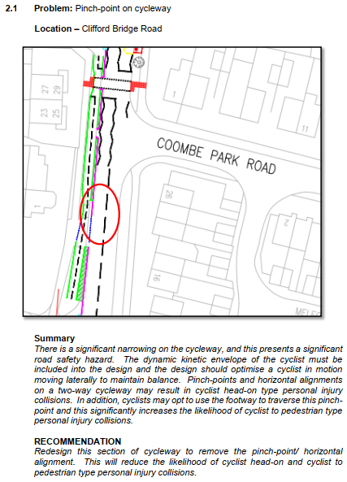
Designer’s Response
This area will be carefully considered at detailed design stage, particularly the vertical and horizontal alignment along with the width of the cycleway at its narrowest point. Comments and concerns regarding the dynamic kinetic envelop of users of the highway will be fully considered and accommodated as part of this process.
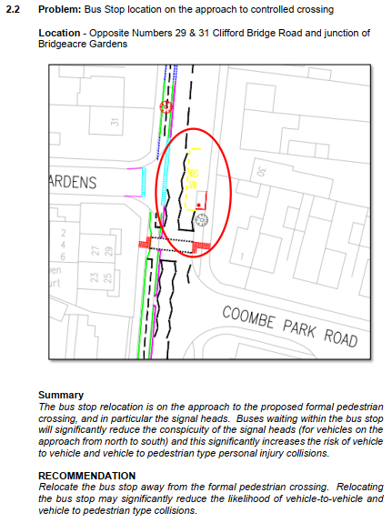
Designer’s Response
During the detailed design, full attention and consideration will be given to the conspicuity of the traffic signal heads. The likelihood of motorists overtaking a bus within the controlled crossing zone for an infrequent and minimally used bus stop is very low. Far side and possibly tall additional signal heads are likely to be provided, or measures to prevent overtaking.

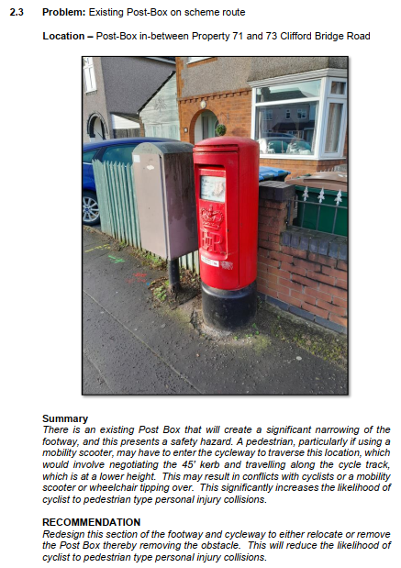

Designer’s Response
Measures will be taken during the detailed design to ensure safe and appropriate passage is enabled along the footway. This may involve marginal realignment of the kerb between the footway and cycleway, should there not sufficient width, or a reduction/ removal of the level difference.
The shallow kerbs are designed to enable pedestrians and people using a mobility aid to easily access the cycleway from the footway, should this ever be necessary.

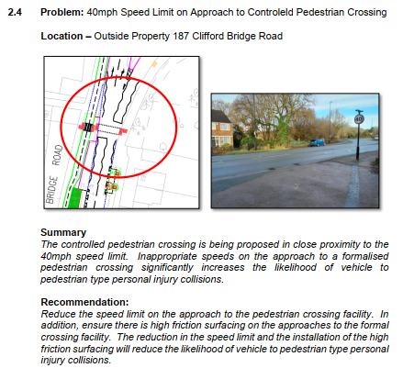

Designer’s Response
The speed limit on the approach is currently being reviewed and is likely to be lowered as part of or in co-ordination with the implementation of the scheme. Appropriate skid resistance will be provided on the carriageway approaches to the crossing, although this is likely to be through a high spec asphalt rather than the application of a dressing material.

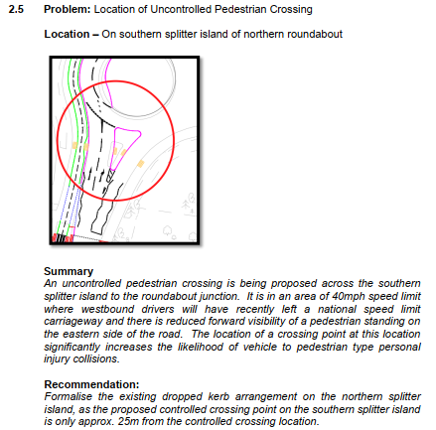
Designer’s Response
This uncontrolled pedestrian crossing point will be removed from the proposals and pedestrians will be guided to use the Puffin Crossing instead. The speed limit will also be lowered which may enable this facility to be included in the future should a demand be generated.

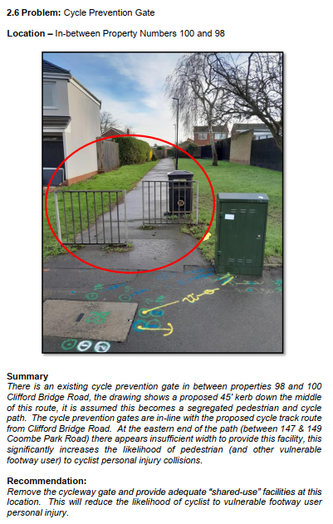
Designer’s Response
The pedestrian fencing will be removed as part of the scheme and at detailed design stage, the cycleway will tie-in appropriately.

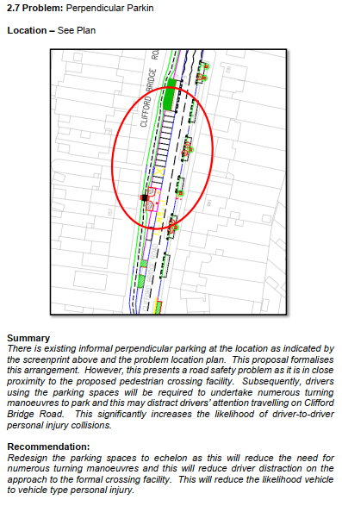
Designer’s Response
The proposed design replicates the existing parking situation, although formalises it with road markings to maximise the number of spaces available to residents. Further consideration will be given during the detailed design process to optically narrow the traffic lanes with road markings such as hatching, dragon teeth or rumble strips, alongside advanced warning signage.

