Coventry
Protocol for Addressing Adult Modern Slavery

Coventry Modern Slavery Partnership, working collaboratively to prepare professionals and the public to pursue perpetrators of exploitation, prevent modern slavery offences, and protect survivors of exploitation

Contents
1. Executive Summary 4
1.1. Protocol on a Page 4
1.2. Aim 5
1.3. Objectives of Protocol 5
1.4. Principles of Protocol 5
1.4.1. Coventry Modern Slavery Partnership Values 5
1.4.2. A Public Health Approach to Modern Slavery 5
1.4.3. A Community-Centred Approach to Modern Slavery 5
1.4.4. Person-Centred Approach to Modern Slavery 6
1.4.5. One Coventry Approach 6
1.5. The Impact of this Protocol on Survivors of Modern Slavery 6
2. Modern Slavery Overview 8
2.1. Definition of Modern Slavery 8
2.2. Key Legislation & Statutory Guidance 8
2.2.1. Modern Slavery Act 2015 8
2.2.2. Modern Slavery Statutory Guidance 9
2.2.3. Nationality and Borders Act 2022 9
2.2.4. Care Act 2014 9
2.2.5. Crime & Disorder Act 1998 9
2.2.6. Localism Act 2011 10
2.2.7. Equality Act 2010 10
2.2.8. Housing Act 1996 10
2.2.9. Homelessness Reduction Act 2017 10
2.2.10. Homelessness Code of Guidance 2018 11
3. Strategy 12
3.1. Strategic Vision 12
3.1.1. Strategic Priorities 12
3.2. Pursue 13
3.3. Prevent 15
3.4. Protect 17
3.5. Prepare 19
4. Pathways 22
4.1. Initial Identification & Safeguarding Pathway 23
4.2. Referral to the National Referral Mechanism Pathway 25
4.2.1. Pre-NRM Pathway 25
4.2.2. During NRM Pathway 26
4.2.3. Post NRM Pathway 27
4.3. Access to Specialist Support 28
4.4. Access to Skills & Employment 29
4.5. Access to Housing Pathway 30
4.6. Adult Social Care Pathway 31
4.7. Health Pathway 32
4.8. Transition to Adulthood Pathway 33
4.9. Trading Standards Pathway 34
5. Monitoring & Evaluation 35
6. Glossary 36
Appendix 1. Contributors 42
Appendix 2. Further Reading 43

1. Executive Summary

Protocol on a Page
Coventry Modern Slavery Protocol Summary
This Protocol sets out the strategic vision for the Coventry Modern Slavery Partnership and the operational pathways that support this vision.

Approaches

Values

Strategy

Pathways

Aim
The Coventry Modern Slavery Protocol sets out the strategic vision for the Coventry Modern Slavery Partnership and the operational pathways that support this vision.

Objectives of Protocol
- To present Coventry Modern Slavery Partnership’s strategic approach to preventing, combatting, and addressing modern slavery via the UK Government’s 4 P approach to modern slavery.
- To present the operational processes for responding to modern slavery in Coventry via the creation of survivor support pathways.
- To establish the ongoing monitoring and evaluation mechanisms for the strategy and pathways.

Principles of Protocol

Coventry Modern Slavery Partnership Values
- Collaboration: We will work together, championing best practice and supporting the collective fight against exploitation.
- Compassion: We will place survivors’ needs at the heart of our approach, acting with kindness, fairness, and respect.
- Integrity: We will follow through on our commitments, adhering to our principles, and being transparent about our progress.
- Safety: We will prioritise the safety of our communities at all times, ensuring that exploitation is not tolerated in Coventry.

A Public Health Approach to Modern Slavery
The public health approach to modern slavery involves a comprehensive and multidisciplinary approach to prevent, detect, respond to, and support individuals affected by this crime. It recognises that modern slavery is not just a legal or criminal justice issue, but a public health concern that requires action across multiple sectors, including law enforcement, health, social services, education, and community engagement. (Source: Addressing Modern Slavery: A Public Health Approach for Local Authorities)

A Community-Centred Approach to Modern Slavery
The community-centred approach to modern slavery involves localising our approach to directly address the needs of communities in Coventry. It recognises the importance of mobilising assets within our communities to encourage equity amongst our residents and empower individuals to contribute to the fight against modern slavery. Community-centred approaches focus on co-design with those with lived experience of modern slavery, reducing barriers to accessing services, and building social capital.

Person-Centred Approach to Modern Slavery
The person-centred approach to modern slavery places the needs and experiences of those subjected to modern slavery at the heart of its response. It places emphasis on the impact of trauma on survivors, dispels the concept of the ‘perfect victim’, advocates for survivors to be in control of their recovery plan, and encourages professionals to communicate effectively to build trust with the survivors they support. This protocol was co-created with people with lived experience of modern slavery.

One Coventry Approach
The One Coventry Approach describes how the Council works and collaborates with its partners and communities to ensure that Coventry residents get the very best that the city can offer. The Coventry Modern Slavery Protocol aligns with the One Coventry priority of improving outcomes and tackling inequalities within our communities, and as the founding organisation of the Coventry Modern Slavery Partnership embodies Coventry City Council’s role as a partner, enabler, and leader.
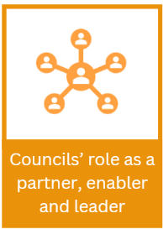
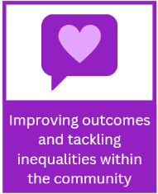
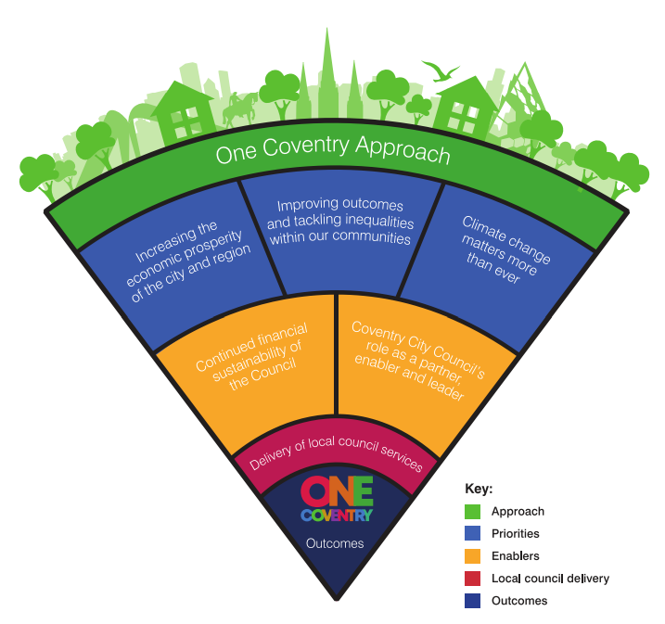

The Impact of this Protocol on Survivors of Modern Slavery
The below journey map illustrates the impact that professionals’ actions have on the lives of people facing exploitation. In red you can see what happens when professionals don’t raise their concerns, blame survivors, and criminalise them for what have been forced to do as part of their exploitation. In green you can see the positive impact of raising concerns, sharing information, and taking a survivor-centred approach. Sam and Holly’s story is based on the real-life experiences of survivors of modern slavery in Coventry. 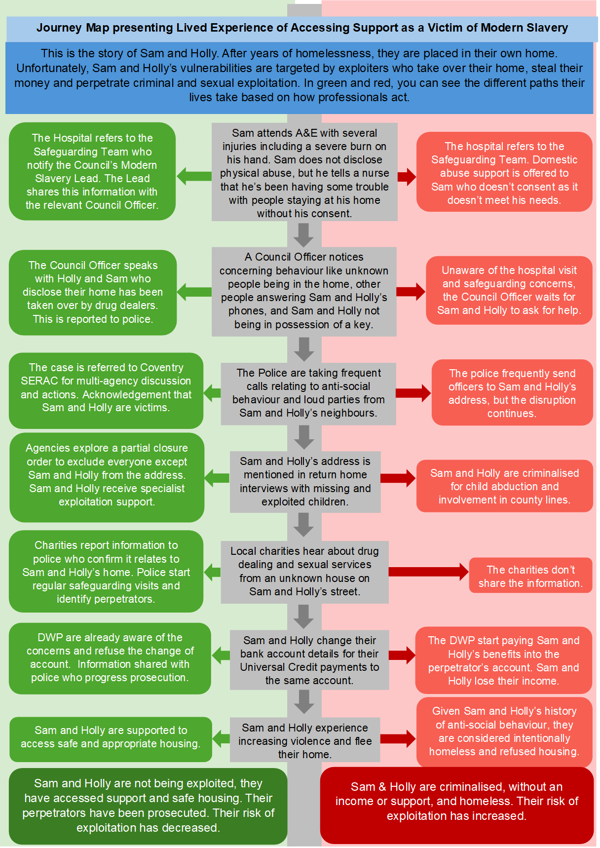

Modern Slavery Overview

Definition of Modern Slavery
Modern slavery is an umbrella term which encompasses all forms of slavery, human trafficking, and exploitation.
In all forms of modern slavery an exploiter uses means of control such as the threat or use of force, coercion, abduction, fraud, deception, or an abuse of power or vulnerability to exploit another person for personal, financial, or commercial gain.
This exploitation may include sexual exploitation, forced labour, domestic servitude, forced criminality, slavery, financial exploitation, or removal of organs.
People who are subjected to modern slavery can be children or adults, of any gender, from all backgrounds, countries, and communities.
To learn more about modern slavery, please visit our webpages.
At the end of this document there is a glossary to help you understand any new terms you come across.

Key Legislation & Statutory Guidance

Modern Slavery Act 2015
The Modern Slavery Act is the main domestic legislation which determines the UK’s response to modern slavery, its main provisions include:
- Under section 52 of the Act, specified first responders have a statutory duty to notify the Home Office of potential survivors of modern slavery. All suspected child survivors should be referred into the National Referral Mechanism (NRM), as well as adults who give their consent. In cases where consent isn’t given, a Duty to Notify (DtN) referral should be made.
- Clarity of existing modern slavery and human trafficking offences and increase of maximum sentences for these offences from 14 years to life imprisonment.
- The introduction of slavery and trafficking prevention orders and slavery and trafficking risk orders – which can be used to disrupt activities by modern slavery perpetrators.
- The creation of the role of the UK Independent Anti-Slavery Commissioner and placed a duty on authorities, including councils, to cooperate with the role.
- The introduction of support and protection for survivors, including a defence for survivors of slavery or trafficking who commit an offence and measures on the presumption of age of child survivors of modern slavery.
- The introduction of the role of independent child trafficking advocates, now referred to as independent child trafficking guardians.
- The requirement for certain businesses to produce and publish a modern slavery statement, setting out what they are doing to tackle modern slavery and trafficking in their supply chains.

Modern Slavery Statutory Guidance
The Modern Slavery Statutory Guidance is published under section 49(1) of the Modern Slavery Act 2015 which requires the Secretary of State to issue guidance to public authorities about:
(a) The sorts of things which indicate that a person may be a survivor of slavery or human trafficking.
(b) Arrangements for providing assistance and support to persons who there are reasonable grounds to believe are survivors of slavery or human trafficking.
(c) Arrangements for determining whether there are reasonable grounds to believe that a person is a survivor of slavery or human trafficking’.

Nationality and Borders Act 2022
The Nationality and Borders Act 2022 introduced a wide range of measures relating to modern slavery. Section 61 of the Act decreased the minimum entitlement to survivor support from 45 days to 30 days. Section 63 of the Act disqualifies survivors who are considered to be a threat to public order or have claimed to be a survivor in bad faith from receiving protection. Section 65 of the Act narrows access to temporary leave to remain for survivors of slavery or human trafficking.

Care Act 2014
The Act gives local authorities a duty under to provide care and support to adults at risk of various types of abuse, including modern slavery. Local authorities should carry out an assessment to determine whether an adult has eligible needs for any adult who appears to have a need for care and support. A person will have eligible needs if they meet all of the following: they have care and support needs as a result of a physical or a mental condition, because of those needs, they cannot achieve two or more of the outcomes specified and as a result, there is a significant impact on their wellbeing. Outcomes of relevance to survivors of modern slavery might include “being able to make use of the adult’s home safely”, “developing and maintaining family or other personal relationships” and “accessing and engaging in work, training, education or volunteering”.

Crime & Disorder Act 1998
The Crime and Disorder Act 1988 gives local authorities the ability to pursue those perpetrating modern slavery offences.

Localism Act 2011
Section 1 of the Localism Act, 2011 gives local authorities a broad residual power to “do anything that individuals may generally do.” This includes for the benefit of persons resident or present in its area. This may be of relevance where a survivor of modern slavery does not meet the meet eligibility criteria under the Care Act 2014. Best practice would be for a Human Rights Assessment to be undertaken with a view to providing the survivor with support or assistance under this provision to avoid a breach of his or her human rights.

Equality Act 2010
Section 149 of the Equality Act 2010 requires public bodies to have due regard to the need to ‘advance equality of opportunity’ including to the need ‘take steps to meet the needs of persons who share a relevant protected characteristic that are different from the needs of persons who do not share it’. Hence, survivors of modern slavery who have needs arising from relevant protected characteristics (such as, age, disability, gender reassignment, pregnancy and maternity, race, religion or belief, sex, sexual orientation) may need to be treated more favourably in terms of the provision of accommodation or services than other persons not suffering from this protected characteristic.

Housing Act 1996
The Housing Act 1996 provides for local authorities to make enquiries of a person who is homeless or at risk of homelessness pursuant to Section 184 Housing Act 1996. Survivors of modern slavery experience many barriers to accessing accommodation under homelessness provisions. For example, survivors can be told that they are not considered to be in priority need. However, when assessing priority need local authorities should consider the unique vulnerabilities of survivors of modern slavery, especially the risk of further exploitation and trafficking, noting that Article 4 of the European Convention on Human Rights prohibits slavery. This should be considered by decision makers when considering whether they are significantly more vulnerable than an ordinary person facing homelessness. Under s206 of the Act, any accommodation provided must be ‘suitable’. This is particularly relevant for survivors of modern slavery who have very specific accommodation needs arising from their experiences including ‘gender specific’ needs.

Homelessness Reduction Act 2017
The Homelessness Reduction Act 2017 supplements and amends the Housing Act 1996, adding new duties to local authorities to prevent and relieve homelessness. These new duties apply to all eligible applicants (i.e. based on immigration status) and are blind to intentionality and priority need. The prevention duty is also blind to local connection. The new ‘relief’ duty does not require the local housing authority to provide accommodation in all cases, but the local authority must help the applicant to find suitable accommodation. The Act also lays out a duty on public authorities to refer consenting individuals to the local authority for support preventing or relieving homelessness.

Homelessness Code of Guidance 2018
The Homelessness Code of Guidance 2018 provides guidance about how local authorities should provide assistance and accommodation to those who are homeless or at risk of homelessness. Chapter 25 provides guidance in relation to meeting the housing needs of survivors of modern slavery, including:
- Identification of modern slavery survivors.
- Accommodation enquiries and applications.
- Suitability of accommodation.
(Source: Council Guide to Tackling Modern Slavery)

Strategy

3.1. Strategic Vision
The strategic vision of the Coventry Modern Slavery Partnership is to work collaboratively to prepare all professionals and public working and residing in Coventry to pursue perpetrators of exploitation, prevent modern slavery offences, and protect survivors of exploitation.

Strategic Priorities
This strategy is Coventry’s local adaptation of the UK government’s ‘4 P Approach to Modern Slavery’ which aims to reduce the prevalence of modern slavery in the UK by prioritising four components: prosecuting and disrupting individuals and groups responsible for modern slavery (Pursue); preventing people from engaging in modern slavery crime (Prevent); strengthening safeguards against modern slavery by protecting vulnerable people from exploitation and increasing awareness and resilience against this crime (Protect); and reducing the harm caused by modern slavery through improved survivor identification and enhanced support and protection (Prepare). (Source: Modern Slavery Strategy).

  - Pursue
How we will disrupt individuals and groups responsible for modern slavery.
Goal | What does this look like? | Who is likely to do this work? | What will success look like?
Working in partnership | Multi-agency working to use all available avenues to disrupt and prosecute perpetrators of exploitation.  Continued commitment, evaluation, and development to the Coventry Slavery and Exploitation Risk Assessment Conference (SERAC) where cases of modern slavery can be discussed and actioned by a multi-agency panel of knowledgeable professionals. | Local Authority Regulatory Services.  Police.  Gangmasters and Labour Abuse Authority (GLAA).  Home Office.  Department for Work and Pensions (DWP). | Services:  Good outcomes in pursuing perpetrators of exploitation and disrupting the business of modern slavery.  Positive feedback about SERAC.  Survivors:  I believe agencies around me are working together to help me feel brave and secure enough to contribute to the criminal justice process.
Gathering Intelligence & Sharing Information | Training our staff about when and how they should share information, covering the consideration of confidentiality and the different avenues of reporting information.  Equipping our frontline staff with the skills and sensitivity necessary to empower survivors to report their exploiters and participate in the justice process.  Monitoring and sharing emerging trends and themes linked to modern slavery.  Support for new, innovative methods of ensuring rigorous data gathering, including academic research and policies that strengthen our ability to understand exploitation in our region. | Safeguarding Leads.  Frontline teams likely to encounter exploitation.  Local Authority Modern Slavery Lead.  Service Commissioners.  Survivor support services.  Offender management services.  Modern slavery ambassadors.  Local Authority Regulatory Services. | Services:  Increased reporting.  Increased survivor participation in the criminal justice process.  Better understanding of Coventry’s modern slavery profile.  New: with the right people at the right time, with my best interests in mind whilst protecting my right to confidentiality.  Survivors:  I believe the agencies around me will be transparent about how they use and share the information I tell them.
Using Legislation to Tackle Exploitation | We will leverage housing, licensing, and trading standards legislation. We will inspect and regulate rental properties to ensure they are not being used for exploitative purposes. We will monitor, oversee and regulate businesses to prevent them from engaging in or facilitating modern slavery. | Local Authority Regulatory Services. | Services:  Increased civil and criminal justice outcomes for perpetrators of exploitation.  Survivors:  I believe agencies will attempt to hold traffickers to account and that there ways for me to get justice.

  - Prevent
How we will prevent people from being subjected to or perpetrating modern slavery.
Goal | What does this look like? | Who is likely to do this work? | What will success look like?
Improving Life for At-Risk Communities | Applying the push and pull factors of exploitation to identify at-risk communities in Coventry.  Providing targeted awareness-raising campaigns to educate individuals, communities and businesses who may be at increased risk of exploitation.  Delivering interventions to improve at-risk communities’ wider determinants of health. | Local Authority Modern Slavery Lead.  Services working with at-risk communities.  Public Health services.  Employability support services.  Safeguarding Leads.  Modern slavery ambassadors. | Services:  Increased reporting from members of the public.  Fewer survivors and perpetrators of exploitation.  Increased safe employment opportunities.  Survivors:  I have access to services that are relatable, and survivor led.
Early Intervention at the First Signs of Vulnerability | Survivor support and perpetrator disruption options at first signs of modern slavery risk.  Prevention of escalation of exploitation and further harm towards survivors. | Police  Survivor support services.  Offender management services.  Safeguarding Leads.  Modern slavery ambassadors. | Services:  Fewer survivors being re-trafficked.  Fewer survivors trapped in long periods of exploitation.  Survivors:  Professionals acted to get me out of exploitation and into the right support.
Implementing Safe Human Resources & Procurement Practices | Organisations in Coventry implementing a zero-tolerance approach towards exploitation within their supply chains and workforce.  Practicing safe recruitment processes, publishing modern slavery statements, and publicising whistle-blowing systems. | Businesses and organisations who procure products, services and/or employ staff. | Services:  Increased reporting from businesses.  Increased accordance with employment legislation.  Increased focus on sustainable and ethical products and services.  Survivors:  I feel valued and safe in my workplace.

  - Protect
How we will protect survivors of modern slavery.
Goal | What does this look like? | Who is likely to do this work? | What will success look like?
Holistic Support for Survivors Throughout their Recovery | Local survivor support pathways that reflect the varied services required to ensure holistic, long-term, survivor-centred support.  Encouraging growth and innovation in survivor support services.  Ability to identify and rectify gaps in service provision by listening to survivors accessing our services and local support providers. | Local Authority Modern Slavery Lead.  Survivor support services.  Service Commissioners.  Frontline teams offering services to survivors.  Safeguarding Leads.  Modern slavery ambassadors. | Services: More survivors accessing support.  Better outcomes for survivors.  Positive feedback from survivors about the support they have accessed.  Survivors:  I was able to access services that gave me the support nec essary to help me move forward from my exploitation.
Multi-Agency Case Management | Meeting the needs of survivors by working collaboratively as a city to coordinate comprehensive safeguarding, support, and protection for survivors.  Continued commitment, evaluation, and development to the Coventry Slavery and Exploitation Risk Assessment Conference (SERAC) where cases of modern slavery can be discussed and actioned by a multi-agency panel of knowledgeable professionals. | Frontline teams offering services to survivors.  Local Authority Modern Slavery Lead.  Survivor support services.  Safeguarding Leads.  Modern slavery ambassadors. | Services:  Increased knowledge amongst professionals of service offer across the city.  Survivors accessing the right support at the right time.  Positive feedback about SERAC.  Survivors:  I believe agencies around me are working together to safeguard me from further harm and provide me with appropriate support.
Fulfilling our Legal Responsibilities to Survivors | Ensuring staff working in statutory services have the training and resources needed to be able to complete their legal duties in accordance with best practise guidance. This may include, but is not limited to:  First Responder agencies submitting Duty to Notify (DtN) and National Referral Mechanism (NRM) referrals under the Modern Slavery Act 2015.  Housing authorities providing appropriate housing and homelessness support in accordance with Homelessness Reduction Act 2017 and the Housing Act 1996.  Adult Social Services providing appropriate care and support under the Care Act 2014. | First Responder agencies under the Modern Slavery Act 2015.  Statutory agencies involved in the disruption of exploitation and support of survivors. | Services:  Increased NRM and DtN referrals.  Increased accordance with legislation.  Survivors:  I believe the services around me understand and comply with their legal duties to survivors of modern slavery.

  - Prepare
How we will prepare professionals and the public to better identify and support survivors of modern slavery.
Goal | What does this look like? | Who is likely to do this work? | What will success look like?
Delivering High Quality Training & Awareness Campaigns | Providing data-led training which focuses on the real-time trends, patterns, and needs in Coventry to upskill our staff on recognising exploitation, following proper reporting procedures, and providing trauma-informed support. We will give particular focus to NRM training for frontline professionals who may act as First Responders.  Adopting a community approach to addressing exploitation by educating the public about the signs of modern slavery, how to report suspicions, and where to seek help for survivors, with a particular focus on communities vulnerable to exploitation.  Consulting with those with lived experience of modern slavery to ensure our training is grounded in the realities of survivors of exploitation. | Local Authority Modern Slavery Lead.  Organisations that provide specialist modern slavery training.  Frontline teams likely to encounter exploitation.  Community organisations.  Lived Experience Consultants.  Safeguarding Leads.  Modern slavery ambassadors. | Services:  A high number of frontline teams trained.  Positive feedback about training provided.  Increased reporting.  Survivors:  I believe that professionals and the public are properly trained to identify, recognise and report exploitation.
Encouraging Organisations & Communities to Appoint Modern Slavery Ambassadors | Encouraging organisations and communities to appoint ‘Modern Slavery Ambassadors’ who can act as points of contact for guidance and escalation regarding modern slavery concerns.  Providing training opportunities and knowledge sharing sessions to promote continuous learning amongst Modern slavery ambassadors. | Local Authority Modern Slavery Lead.  Community Groups.  Frontline teams likely to encounter exploitation.  Safeguarding Leads.  Modern slavery ambassadors. | Services: Increase in organisations and teams with a designated Modern Slavery Champion.  Positive feedback from organisations and teams with a Modern Slavery Champion.  Survivors:  I believe there are professionals who are knowledgeable about exploitation in the services I use.
Amplifying Best Practice & Committing to Continual Improvement | Use of the Coventry Modern Slavery Partnership, to offer a platform to organisations combatting modern slavery, encourage joint projects, and share examples of exceptional work to enable continual learning from best practice.  We will provide ongoing training and reflection opportunities to staff to ensure organisational knowledge remains up to date.  We will offer support systems to enable staff to manage the psychological impacts of dealing with modern slavery cases.  Giving emphasis to the lived experience of survivors of modern slavery and encouraging all organisations to use lived experience inputs in their service design. | All services involved in addressing modern slavery in Coventry. | Services: Positive feedback about the Coventry Modern Slavery Partnership.  Effective monitoring and evaluation mechanisms.  Increased use of the lived experience of survivors in service design.  Survivors:  I was able to use my lived experience to contribute to the services I have used, to highlight necessary changes and make improvements for other survivors.

Pathways
To deliver our strategy, the Coventry Modern Slavery Partnership have developed operational pathways to guide frontline professionals through the practicalities of modern slavery case management.
There are nine pathways in this protocol, which are explained further below.
The General Pathway consists of:
- The Initial Identification & Safeguarding Pathway
- The NRM Pathway (including Pre-NRM, During-NRM & Post-NRM)
- Access to Specialist Support
- Access to Skills and Employment
- Access to Housing Pathway
The General Pathway should be used by any professional apart from the following organisations who have their own operational pathways:
- Coventry City Council Adult Social Care
- National Health Service (NHS).
- Coventry City Council Childrens Social Care (for transition to adulthood cases)
- Coventry City Council Trading Standards

Initial Identification & Safeguarding Pathway
This pathway should be followed by all agencies in all cases of modern slavery concerns.
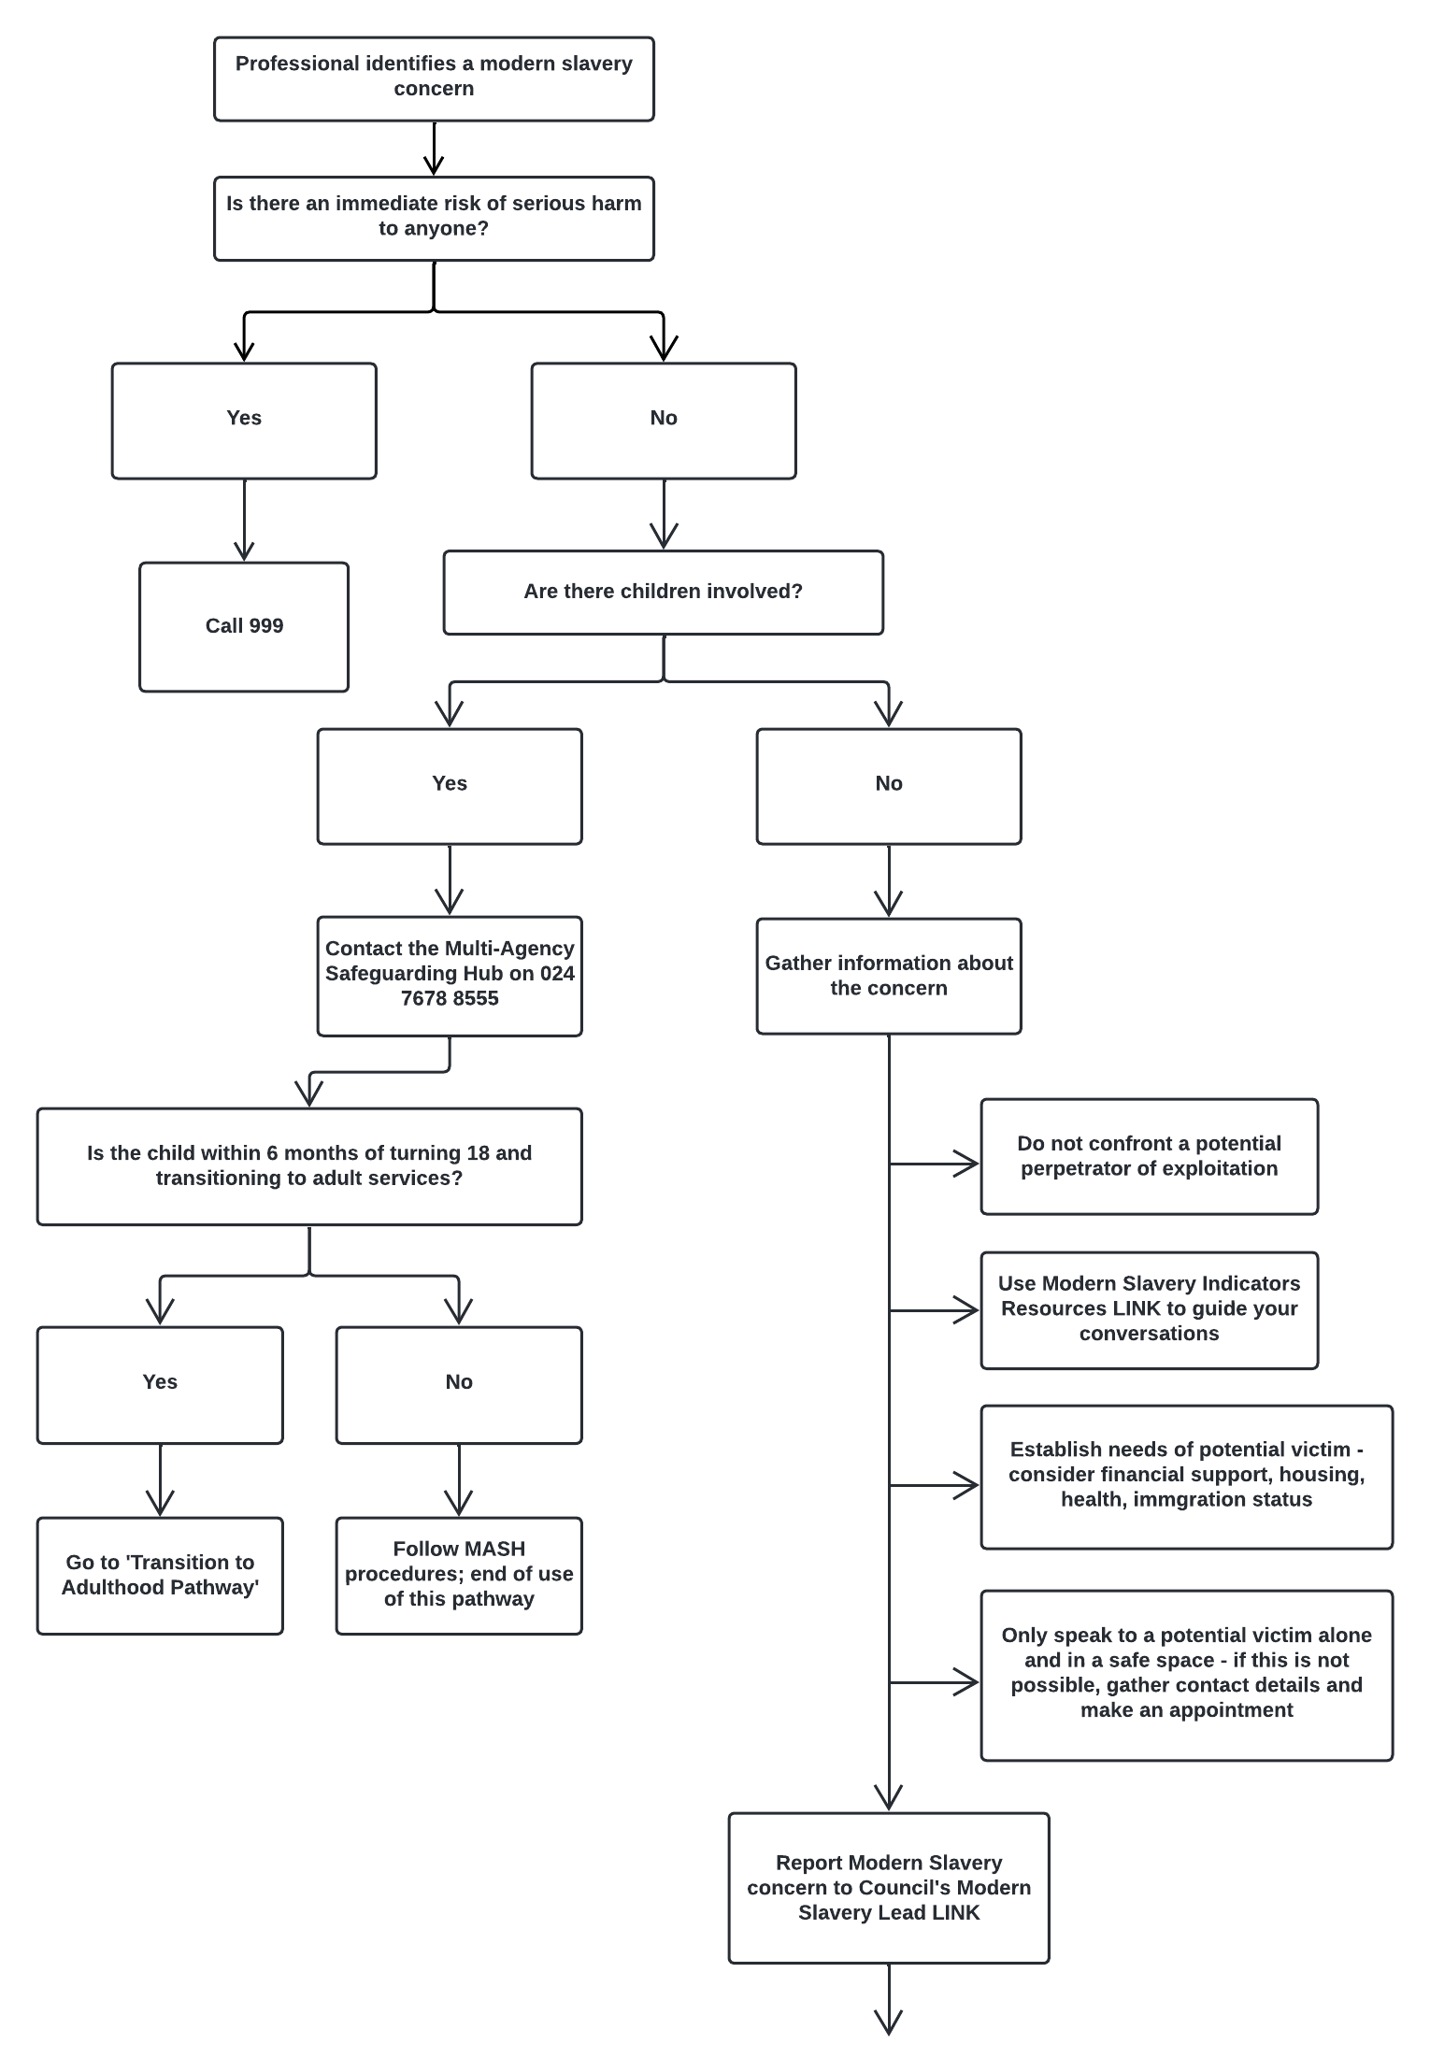
Report Modern Slavery concern to the Council’s Modern Slavery Lead

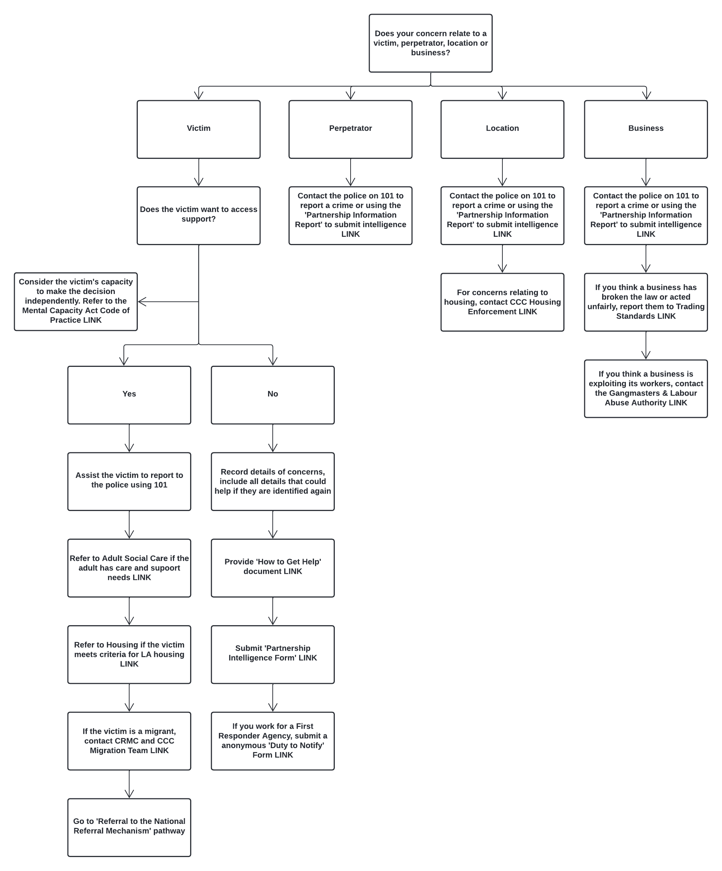
Consider the survivor’s capacity to make the decision independently. Refer to the Mental Capacity Act Code of Practice
An ‘adult at risk’ is an individual who has needs for care and support, is experiencing or at risk of abuse or neglect, and is unable to protect themselves.
Refer to Housing if the survivor meets criteria for LA housing
Refer to Adult Social Care if the individual is an ‘adult at risk’
Contact the police on 101 to report a crime or submit a Force Intelligence Bureau (FIB) form
If the survivor is a migrant, contact CRMC and CCC Migration Team
If you work for a First responder Agency, submit an anonymous ‘Duty to Notify’ Form
Submit a Force Intelligence Bureau (FIB) form
Contact the police on 101 to report a crime or submit a Force Intelligence Bureau (FIB) form
Contact the police on 101 to report a crime or submit a Force Intelligence Bureau (FIB) form
If you think a business is exploiting its workers, contact the Gangmasters & Labour Abuse Authority
If you think a business has broken the law or acted unfairly, report them to Trading Standards
For concerns relating to housing, contact CCC Housing Enforcement

Referral to the National Referral Mechanism Pathway

Pre-NRM Pathway
This pathway should be followed by all agencies in all cases of modern slavery concerns.
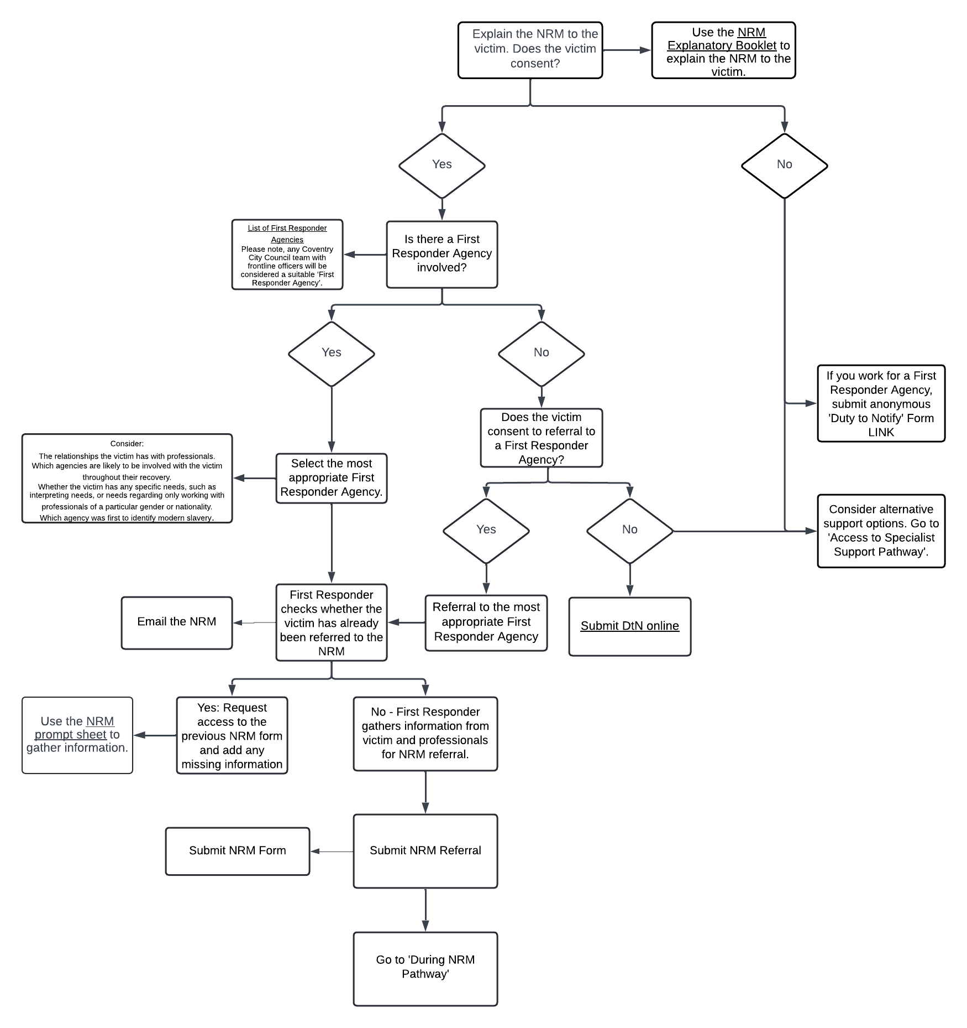
If you work for a First Responder Agency, Submit anonymous DtN Online
Consider: The relationships the survivor has with professionals. Which agencies are likely to be involved with the survivor throughout their recovery. Whether the survivor has any specific needs, such as interpreting, or needs regarding only working with professionals of a particular gender or nationality. Which agency was first to identify modern slavery.
Use the NRM Explanatory Booklet to explain the NRM to the survivor.
Email the NRM
Submit NRM Form
Use the NRM Prompt Sheet to gather information.
List of First Responder Agencies
Please notes any Coventry City Council team with frontline officers will be considered a suitable ‘First Responder Agency’.

During NRM Pathway
This pathway should be followed by first responder agencies in cases already referred to the National Referral Mechanism.
Contact CCC’s Modern Slavery Lead
Email or call 0800 808 3733 the Salvation Army.
Use the NRM Explanatory Booklet to explain the survivor’s support entitlements
Email or call 0800 808 3733 the Salvation Army.
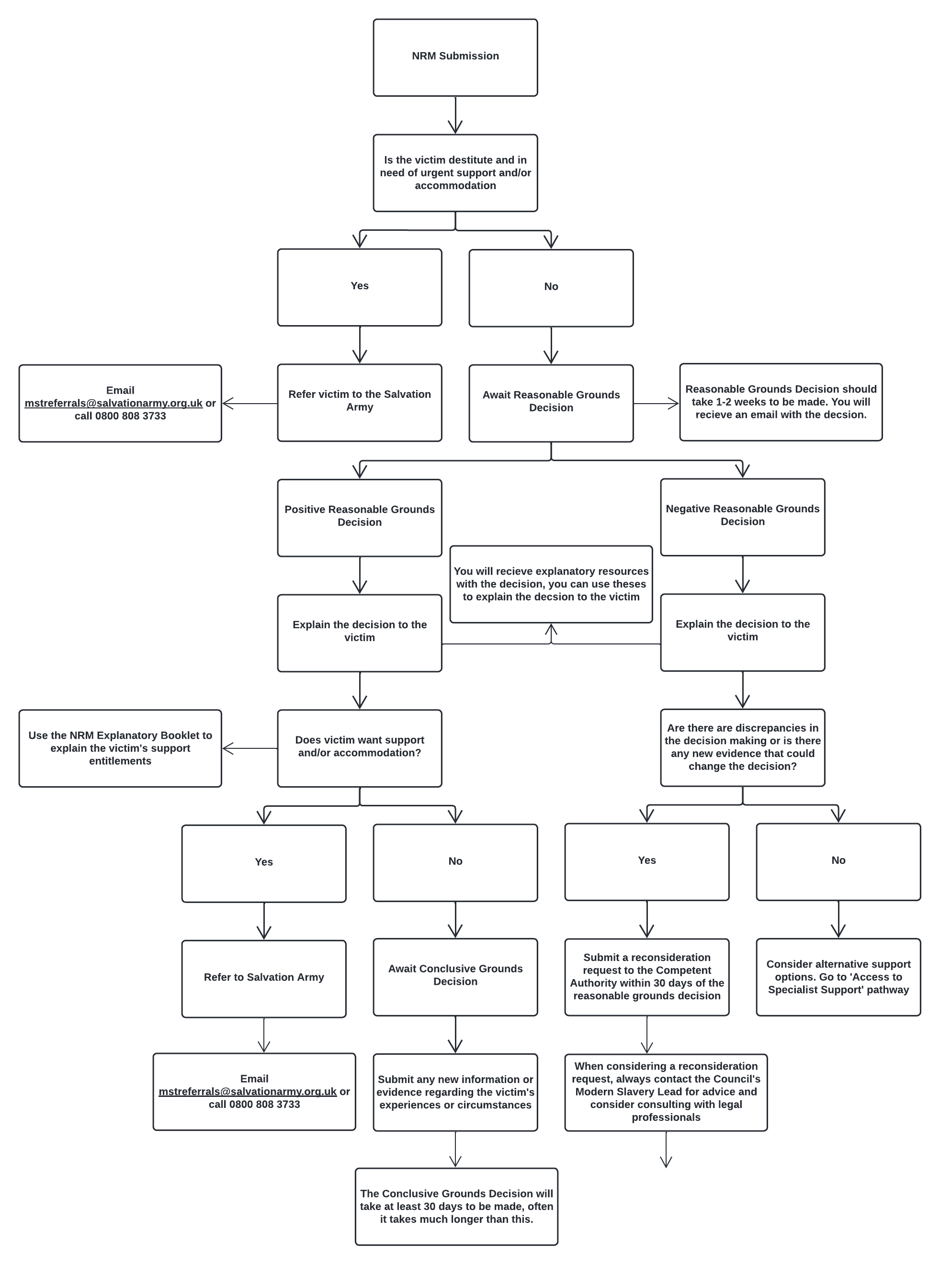

Post NRM Pathway
This pathway should be followed by first responder agencies in cases where a conclusive grounds decision has been made in the National Referral Mechanism.
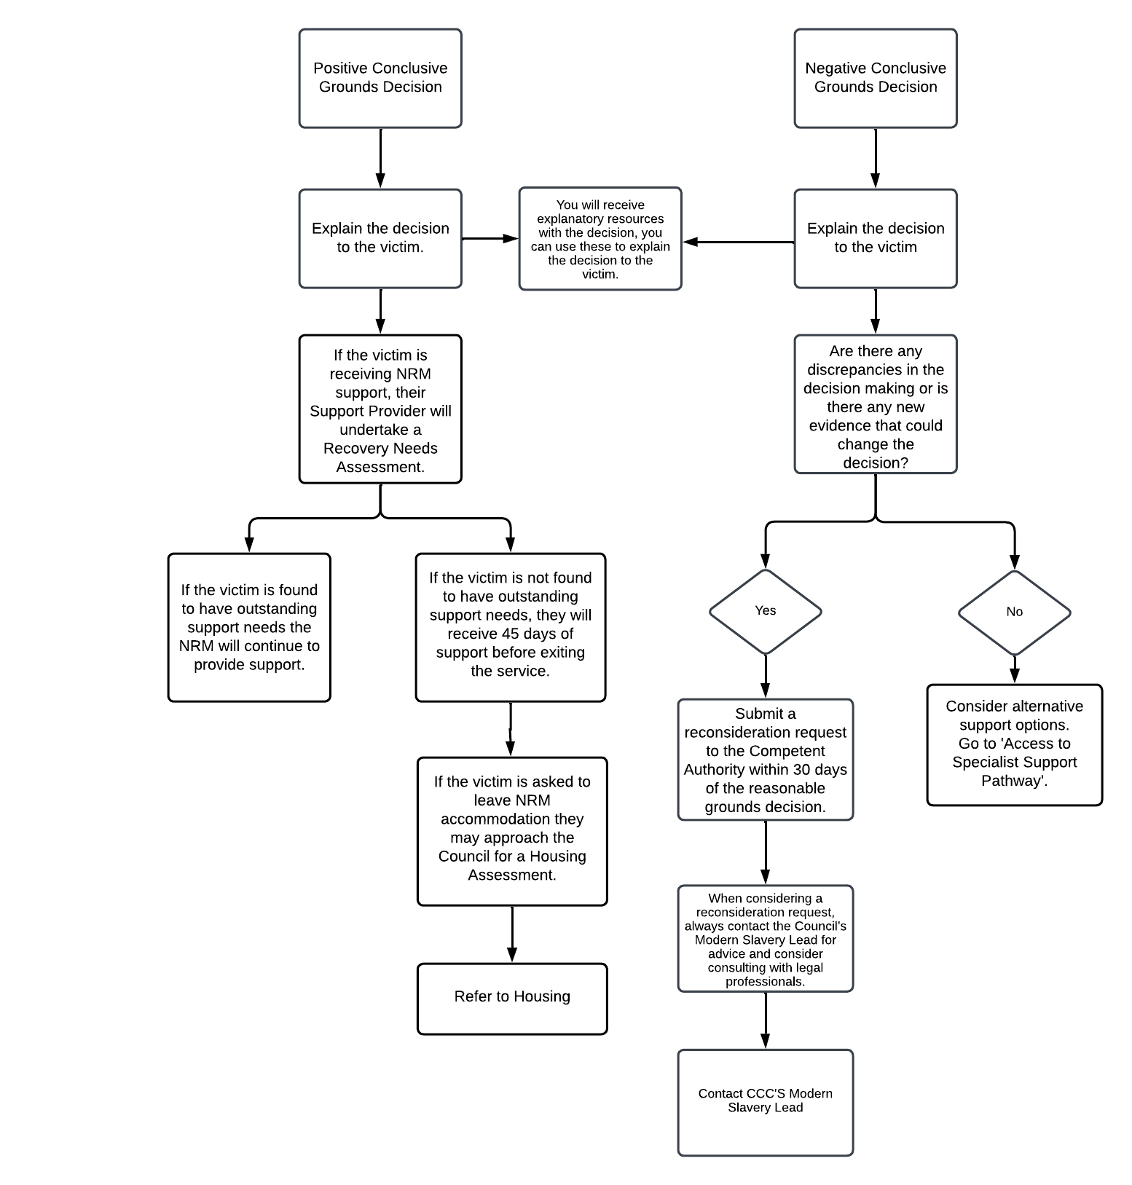
Home Office consideration for a grant of Leave to Remain of up to 30 months for foreign Positive CG survivors with no existing leave to remain.
Contact CCC’s Modern Slavery Lead
Refer to Housing

Access to Specialist Support
Female Survivors
All Survivors
Male Survivors
This table should be used by all agencies helping survivors to access support.
Support | Are they currently in the NRM?  (Consider contacting the NRM as survivor might not be aware) |  | Negative RG and/or CG Decision | Positive RG and/or CG Decision
Support | Yes | No | Negative RG and/or CG Decision | Positive RG and/or CG Decision
NRM Support via Modern Slavery Survivor Care Contract  Referrals via The Salvation Army. Support delivered by Black Country Women’s Aid & Migrant Help.  Specialist outreach support and safe accommodation to survivors and dependents. Range of support including financial, access to health services, emotional wellbeing and access to legal services. | 
West Midlands Anti Slavery Network
Independent Modern Slavery Advocates provide outreach support to survivors at any stage of their recovery.
Adavu
Casework support for survivors of modern slavery to rebuild lives pre and post NRM.
Hope for Justice
Delivers a national independent advocacy service including specialist socio and legal advocacy
Hope at Home
Provides accommodation, gym memberships, therapy sessions, bus passes.
Sophie Hayes Foundation
Provides education, skills development, and community support to survivors across their recovery.
Kairos Women Working Together
Provides holistic, trauma informed, long term support and advocacy for women who are subject to or at risk of sexual exploitation; including women who face multiple disadvantages and have ‘complex’ unmet needs
Medaille Trust’s Moving on Project
Provides survivors with long-term outreach support, referral to NRM, and ABE interviews.
Black Country Women’s Aid’s Sexual Exploitation and Community Engagement Project
Proactively identifies and provides initial support to adult female survivors of sexual exploitation

Access to Skills & Employment
This table should be used by all agencies helping survivors to access support.
Adult Education Service - www.coventry.gov.uk/adulted
Most courses are free if:
- You were born before 31/08/2005.
- You have been living in the UK legally for at least the last 3 years.
- You have an EU/EAA or Swiss citizen, have Settled Status and have lived continuously in the EEA, Switzerland, Gibraltar, or the UK for at least the last 3 years.
- You are a refugee.
- You have discretionary leave to remain.
- You are in the UK on one of the Ukrainian or Afghan schemes.
- You are an Asylum seeker and have been living in the UK while waiting for my claim to be decided for more than 6 months.
Maths
English
Digital Skills
English Language support – incl. English for Speakers Of Other Languages (where eligible)
Learning for Life
Learning for Work

Job Shop
Available to all Coventry residents
Support includes:
- 1 to 1 Job Coaching.
- Practical Support.
- Direct vacancies from our employer network.
- Exciting events to meet directly with local employers and training providers.
- Careers Advice.
- Money Advice.
- Barrier Breaking Support.
- Health and Wellbeing Support.

Access to Housing Pathway
This pathway should be used by all agencies helping survivors to access accommodation.
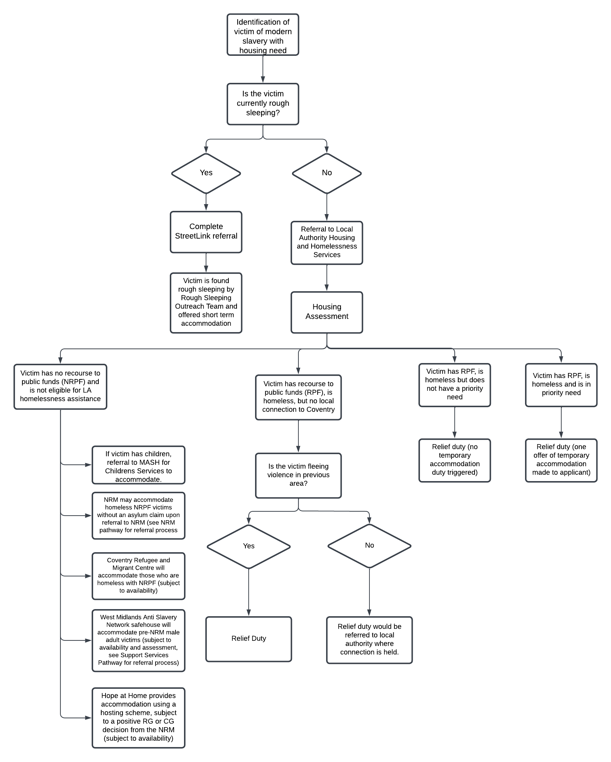
Would the person be at risk of violence if they returned to their previous area?

Adult Social Care Pathway
This pathway should be followed by staff working in Adult Social Services.
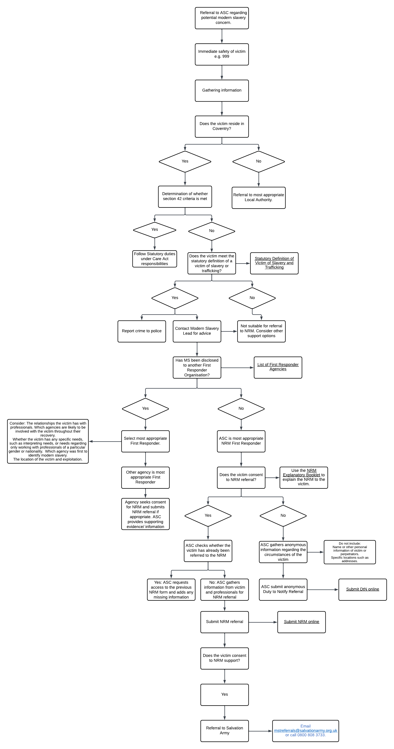
Submit NRM online
Contact CCC’s Modern Slavery Lead
Email the NRM
List of First Responder Agencies
Consider: The relationships the survivor has with professionals. Which agencies are likely to be involved with the survivor through their recovery. Whether the survivor has any specific needs, such as interpreting needs, or needs regarding only working with professionals of a particular gender or nationality, Which agency was first to identify modern slavery. The location of the survivor and exploitation
Statutory Definition of Survivor of Slavery and Trafficking
Use the NRM Explanatory Booklet to explain the NRM to the survivor.
Email or call 0800 808 3733 the Salvation Army.
Submit DtN online

Health Pathway
This pathway should be used by staff working in health services.

Transition to Adulthood Pathway
This pathway should be used by Children’s Services for cases where a child survivor is turning 18 years old and transitioning to adult services.
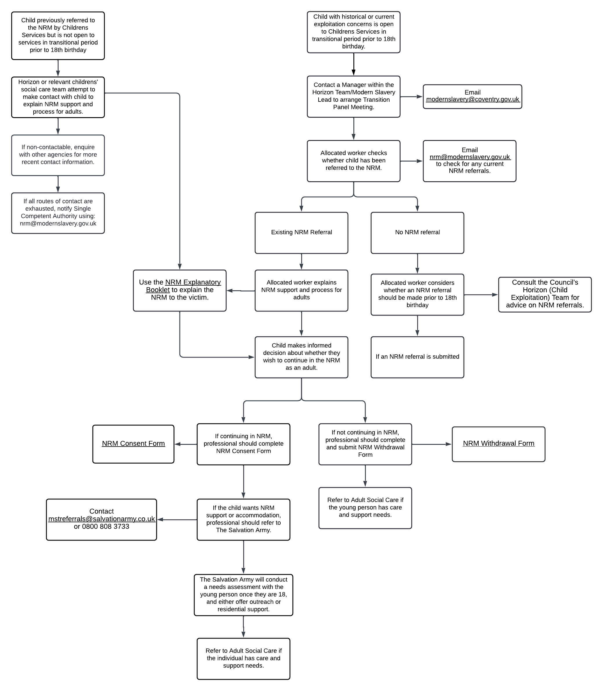
Horizon or relevant children’s services team attempt to make contact with child to explain NRM support and process for adults.
Contact mstreferrals@salvationarmy.co.uk or 0800 808 3733.

Use the NRM Explanatory Booklet to explain the NRM to the survivor.
NRM Withdrawal Form

NRM Consent Form

Trading Standards Pathway
This pathway should be used by Trading Standards staff for any modern slavery concern.
Use the NRM Explanatory Booklet to explain the NRM to the survivor.

Monitoring & Evaluation
The Coventry Modern Slavery Partnership will meet on a quarterly basis to review progress against the 4 P Strategy and Pathways. The Coventry Modern Slavery Partnership is a sub-group of the Harm and Abuse Reduction Partnership (HARP) and will report into the Community Safety Board on a quarterly basis.
The Coventry Modern Slavery Partnership will publish an annual action plan setting out smart objectives with performance indicators to meet the strategic priorities. At the end of each year, the Partnership will produce an annual report to highlight the work completed to fulfil the objectives.
The pathways will be disseminated via training. The Council’s Modern Slavery Lead will ensure the pathways are in use via the monitoring of cases of modern slavery. Issues of non-compliance with the pathways will be escalated to the Coventry Modern Slavery Partnership and relevant operational groups as needed.

Glossary
4 P approach to modern slavery: The UK Government's strategy which aims to reduce the prevalence of modern slavery in the UK by prioritising four components: prosecuting and disrupting individuals and groups responsible for modern slavery (Pursue); preventing people from engaging in modern slavery crime (Prevent); strengthening safeguards against modern slavery by protecting vulnerable people from exploitation and increasing awareness and resilience against this crime (Protect); and reducing the harm caused by modern slavery through improved survivor identification and enhanced support and protection (Prepare). 5
Abduction: the act of making a person go somewhere with you using pressure, threats or violence. 8
Bad faith: An individual may be considered to have claimed to be a survivor of modern slavery in bad faith where they, or someone acting on their behalf, have knowingly made a dishonest statement in relation to being a survivor of modern slavery. 9
Best practice: professional procedures that are accepted as being most effective. 5
Coercion: the use of force or intimidation to obtain compliance. 8
Deception: the act of causing someone to accept as true or valid what is false or invalid. 8
Duty to Notify (DtN): is the duty placed on public authorities in England and Wales by section 52 of the Modern Slavery Act 2015 to notify the Secretary of State when encountering a potential survivor of Modern Slavery. In practice, this is discharged by informing the Home Office. 8
European Convention on Human Rights: The Convention protects the right to: life, freedom and security, respect for private and family life, freedom of expression, freedom of thought, conscience and religion, vote in and stand for election, a fair trial in civil and criminal matters, property and peaceful enjoyment of possessions.The Convention prohibits: the death penalty, torture or inhuman or degrading treatment or punishment, slavery and forced labour, arbitrary and unlawful detention, discrimination in the enjoyment of the rights and freedoms secured by the Convention, deportation of a state’s own nationals or denying them entry and the collective deportation of foreigners. 10
Exploitation: Exploitation occurs when an exploiter uses means of control such as the threat or use of force, coercion, abduction, fraud, deception, or an abuse of power or vulnerability to use another person for personal, financial, or commercial gain. Exploitation may include sexual exploitation, forced labour, domestic servitude, forced criminality, slavery, financial exploitation, or removal of organs. 5
First responders: referrals to the NRM can only be made by authorised agencies known as First Responders. First Responders are responsible for identifying potential survivors, gathering information and referring them to the NRM or, in the case of adults, notifying the Home Office if someone does not consent to being referred. 8
Fraud: is any activity that relies on deception in order to achieve a gain. Fraud becomes a crime when it is a knowing misrepresentation of the truth. 8
Gender specific needs: survivors may need access to single sex support and accommodation due to previous trauma associated with a particular gender. 10
Harm and Abuse Reduction Partnership (HARP): HARP brings together agencies that work with survivors of crime to better understand who in the city is being harmed and how services can work together to improve services and decrease the risk of abuse. 33
Holistic support: support which treats the whole of someone and not just a part. 17
Human trafficking: the recruitment, transportation, transfer, harbouring or receipt of people through force, fraud or deception, with the aim of exploiting them for profit. 8

Immigration Enforcement Competent Authority (‘IECA’): is one of the competent authorities that is responsible for making Reasonable Grounds decisions and Conclusive Grounds decisions regarding individuals in the following groups: All adult Foreign National Offenders (FNOs) detained in an Immigration Removal Centre. All adult FNOs in prison where a decision to deport has been made. All adult FNOs in prison where a decision has yet to be made on deportation. Non-detained adult FNOs where action to pursue cases towards deportation is taken in the community. All individuals detained in an Immigration Removal Centre (IRC) managed by the National Returns Command (NRC), including those in the Detained Asylum Casework (DAC) process. All individuals in the Third Country Unit (TCU)/inadmissible process irrespective of whether detained or non-detained.
Independent Child Trafficking Guardians (ICTGs): The ICTG service provides somebody who can speak up on behalf of, and act in the best interests of, the child. The ICTG service model provides two discrete services to children who have been trafficked; ICTG Direct Worker to support children for whom there is no one with parental responsibility for them in the UK and ICTG Regional Practice Co-ordinator whose role is to focus on children who do have a figure with parental responsibility for them in the UK. 8
Lived Experience Consultants: A lived experience consultant is skilled with the ability to share wisdom and insights they have gained from walking their particular path in life. They are commissioned to provide input on the impact of an organisation's work on people who have similar experiences to their own. 19
Lived experience: Personal knowledge about the world gained through direct, first-hand involvement in events rather than through representations constructed by other people. 5
Modern Slavery Lead: A role within Coventry City Council with responsibility for developing and implementing the Council's approach to adult exploitation through various operational and strategic responsibilities. 33
Modern slavery statement: Certain commercial organisations must publish an annual statement setting out the steps they take to prevent modern slavery in their business and their supply chains. This is a requirement under section 54 (Transparency in Supply Chains) of the Modern Slavery Act 2015. 9
Modern slavery: an umbrella term which encompasses all forms of slavery, human trafficking, and exploitation. In all forms of modern slavery an exploiter uses means of control such as the threat or use of force, coercion, abduction, fraud, deception, or an abuse of power or vulnerability to exploit another person for personal, financial, or commercial gain. This exploitation may include sexual exploitation, forced labour, domestic servitude, forced criminality, slavery, financial exploitation, or removal of organs. People who are subjected to modern slavery can be children or adults, of any gender, from all backgrounds, countries, and communities. 5
National Referral Mechanism (NRM): refers to the UK’s framework for identifying and referring potential survivors of modern slavery and ensuring they receive the appropriate support. Consent is required for an adult to be referred to the NRM. If an adult does not consent to enter the NRM, a DtN referral should be completed using the same online process. Adults in England and Wales who are recognised as a potential survivor of modern slavery through the NRM have access to specialist tailored support for a period of at least 30 days while their case is considered. 8
Perfect victim: is a myth which dictates that victims should be weak or vulnerable and involved in a respectable activity at the time of victimisation. 6
Police and Crime Board (PCB): Otherwise known as the Community Safety Board, the Police and Crime Board is a requirement within the Crime & Disorder Act 1998. A number of agencies were given “Responsible Authority” status that places a statutory duty on them to work together and do all they reasonably can to prevent, detect and reduce crime and nuisance and prevent re-offending. These agencies must work with local businesses and communities to improve the safety f the communities they live and work in. 33
Priority need: Housing authorities have duties to try and prevent or relieve homelessness for all applicants who are eligible for assistance and are homeless or threatened with homelessness, irrespective of whether or not they may have a priority need for accommodation. If a housing authority is unable to prevent an applicant from becoming homeless, or to help them to secure accommodation within the ‘relief’ stage, they are required to reach a decision as to whether the applicant has a priority need for accommodation. Examples of categories of priority need are pregnancy, dependent children, domestic abuse, physical or mental disability, time in care as a child, risk of violence. 10
Public health: public health contributes to reducing the causes of ill-health and improving people's health and wellbeing through: health protection, and health services. 5
Re-trafficked: Re-trafficking refers to when a survivor of trafficking has been trafficked and/or exploited on more than one occasion. 15

Single Competent Authority (SCA): refers to one of the UK’s decision- making bodies that is responsible for making Reasonable Grounds decisions and Conclusive Grounds decisions regarding individuals not in the groups covered by the IECA.
Slavery and Exploitation Risk Assessment Conference (SERAC): The purpose of the SERAC is to establish a forum - where suspected or known cases of exploitation/slavery/trafficking can be discussed, in confidence, with an open exchange of information so that a multi-agency plan of action can be developed. The aim of this is to increase effectiveness and co-operation between agencies to result in better service provision, greater protection for survivors and better outcomes and safeguarding interventions for individuals who have been exploited. 13
Slavery and Trafficking Prevention Orders: STPOs are aimed at those convicted, cautioned, who received a reprimand or final warning in respect of a slavery or human trafficking offence, but can not be put on trial in the usual way because they are not fit to plead/stand trial. The Court may impose a wide range of restrictions on individuals depending on the nature of the case, as long as these are necessary to prevent harm associated with slavery or trafficking offences. The Orders are designed so that law enforcement bodies and the Courts can respond flexibly to the risks posed by an individual of committing future modern slavery offences. 8
Slavery and Trafficking Risk Orders: STROs are aimed at individuals who have not been convicted of a slavery or human trafficking offence but there is a risk of them committing these offences in the future. The Court may impose a wide range of restrictions on individuals depending on the nature of the case, as long as these are necessary to prevent harm associated with slavery or trafficking offences. The Orders are designed so that law enforcement bodies and the Courts can respond flexibly to the risks posed by an individual of committing future modern slavery offences. 8
Social capital: the networks of relationships among people who live and work in a particular society, enabling that society to function effectively. 5
Supply chains: A supply chain is a network of individuals and companies that are involved in creating a product and delivering it to the consumer. 16
Survivor: someone who has been subjected to modern slavery. Often used to describe someone who has left exploitation. Often interchaneable with the term victim. Some people prefer this term to victim as it is perceived as a more empowering word. 5
Temporary leave to remain for survivors of slavery or human trafficking: A survivor with a positive conclusive grounds decision and no existing right to remain in the UK is automatically considered for permission to stay. Leave is given based on the survivor needing to recieve medical treatment, contribute to a criminal justice process or apply for compensation in the UK. VTS leave does not provide a route to settlement, although longer periods of stay might be considered under the VTS Guidance. 9
The push and pull factors of exploitation: these factors are what increases someone's risk of being targeted by exploiters. Push factors include: war and conflict, lack of job opportunities and lack of support network. Pull factors include: economic and social stability, the promise of a better life, a sense of belonging. 15
Threat to public order: applies when the competent authority is satisfied that the individual is a threat to public order and that disqualification from NRM support is appropriate considering the individual recovery needs of the person. 9
Transition to adulthood: The transition to adulthood is a process that brings childhood to an end and turns the individual into a young adult at the age of 18. This process is characterised by the acquisition of new roles for young people, roles linked to the development of personal autonomy that culminate in their emotional and functional independence. 21
Trauma-informed support: Trauma-informed support acknowledges the widespread impact of trauma on an individual’s neurological, biological, psychological and social development. Trauma informed support aims to help the individual to understand paths for recovery, and actively avoid re-traumatisation through multi-agency interventions. 19
UK Independent Anti-Slavery Commissioner: The Commissioner’s role is independent from Government and is to ‘encourage good practice sharing’ amongst all those with a role to play in tackling every aspect of modern slavery and human trafficking in the UK. The Modern Slavery Act also places a duty on public authorities to co-operate with the Commissioner, share data with their office and comply with requests. The legislation is clear that the Commissioner has no responsibility for or powers over individual cases. 8
Wider determinants of health: a range of social, economic and environmental factors which impact on people’s health. They’re also known as social determinants. These factors are influenced by the local, national and international distribution of power and resources which shape the conditions of daily life. They determine the extent to which different individuals have the physical, social and personal resources to: identify and achieve goals, meet their needs, and deal with changes to their circumstances. 15

Glossary Sources:
Council of Europe – What are our Rights and Liberties
Department of Health and Social Care (12.2024) – Wider Determinants of Health
Independent Anti-Slavery Commissioner – About
UK Home Office (04.2017) - Guidance on Slavery and Trafficking Prevention Orders and Slavery and Trafficking Risk Orders under Part 2 of the Modern Slavery Act 2015
UK Home Office (08.10.2024) - Modern Slavery: statutory guidance for England and Wales (under s49 of the Modern Slavery Act 2015) and non-statutory guidance for Scotland and Northern Ireland
UK Home Office (20.10.2024) – National Referral Mechanism Guidance: Adult (England and Wales)
UK Ministry of Housing, Communities and Local Government (12.12.2024) - Homelessness code of guidance for local authorities

Appendix 1. Contributors
This document was developed by the Modern Slavery Protocol Task and Finish Group. The group was chaired by Hebe Lawson, Modern Slavery Lead at Coventry City Council, and comprised of the following member organisations:

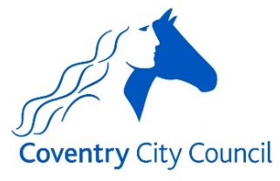






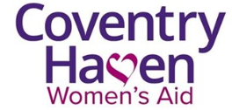
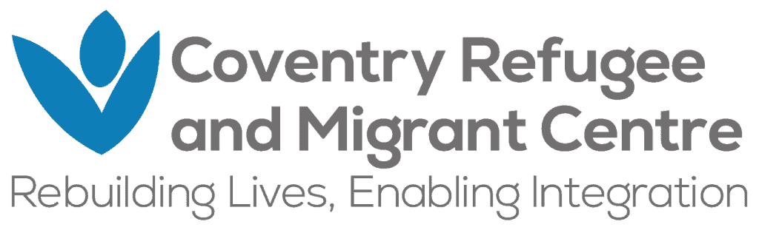


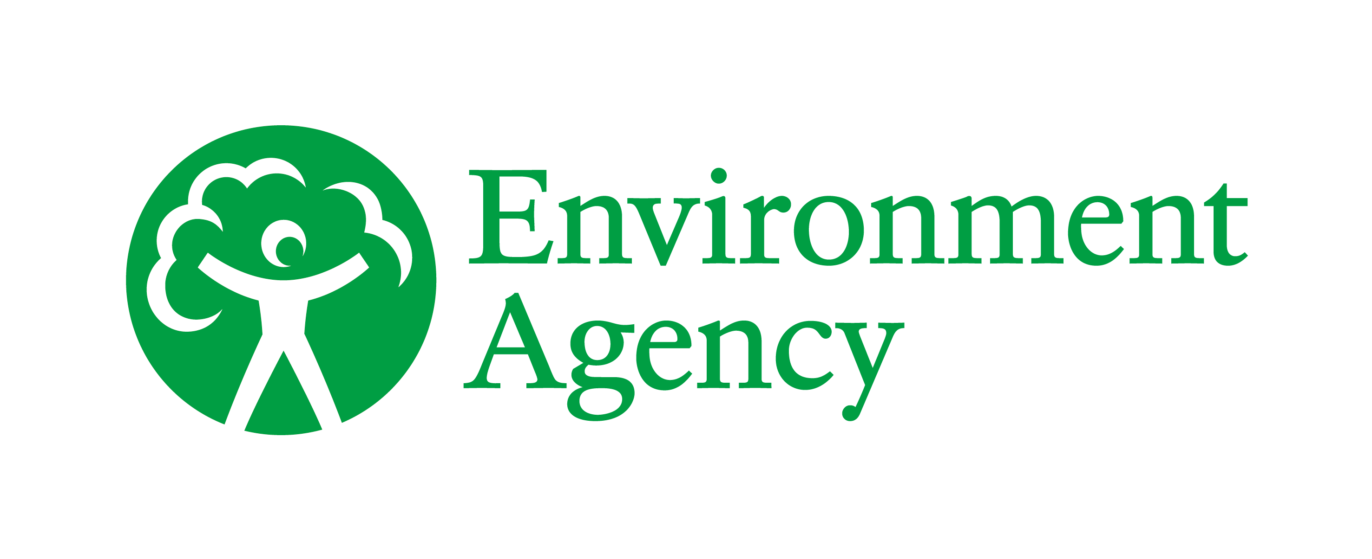

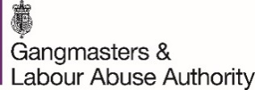
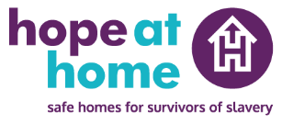

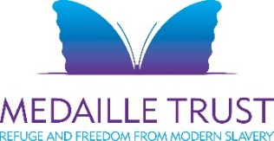
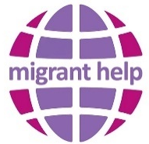

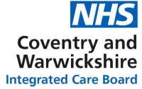



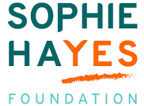




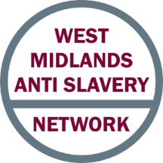

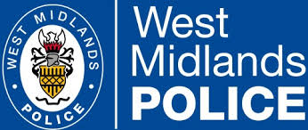
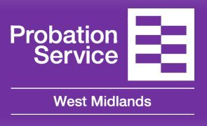Thank you to the following organisations who reviewed this document: Birmingham City Council
Boroughs of Westminster, Kensington, and Chelsea
Human Trafficking Foundation
Oxford City Council

Appendix 2. Further Reading

West Midlands Adult Safeguarding Policy & Procedures
Mental Capacity Code of Practice

