How to sign the declaration form
If you do not have the latest version of Microsoft Word which allows digital signatures, you will need to download, print, sign with ink and scan the document for uploading.
If you are applying on behalf of the proposed licence holder, you will need to email or post them the document for signing before returning it to you for uploading.
YOUR APPLICATION WILL NOT BE COMPLETE IF:
- You do not upload all pages of the declarations
- The applicant and the proposed licence holder don't sign all the necessary declarations
- The applicant and the proposed licence holder sign separate declaration forms

Declaration form Signing:
- Download the correct declaration form that you are required to sign as part of your HMO Licence Application.
HMO Declarations (S254) – This is the declaration form you need to sign if you are applying for a new Additional / Mandatory HMO Application.
HMO Declarations (S254) - Renewal – This is the declaration form you need to sign if you are applying for a Renewal Additional / Mandatory HMO Application.
HMO Declarations (S257) – This is the declaration form you need to sign if you are applying for a new s257 HMO Application. S257 refers to a property converted into a block of self-contained flats, also known as a Section 257 HMO. This means the building:
- Consists of only self-contained flats
- Was converted before 1 June 1992 and did not and still does not comply with the 1991 Building Regulations.
- Or, was converted on or after 1 June 1992 and did not and still does not comply with the Building Regulations that existed at the time of the conversion.
- Less than two-thirds of the flats are owner-occupied
- The building is occupied by three or more people, from two or more households
HMO Declarations (S257) - Renewal – This is the declaration form you need to sign if you are applying for a s257 Renewal HMO Application.

Ensure you have added the details of any Manager, Owner or Mortgage Provider on your Online Application Form and informed them that you have submitted an HMO Application.

- Go to Declaration 5. Add the address of the HMO and write your name. If you are applying as a company we still require the individual completing the declaration to print their name. Then you are ready to sign the document.

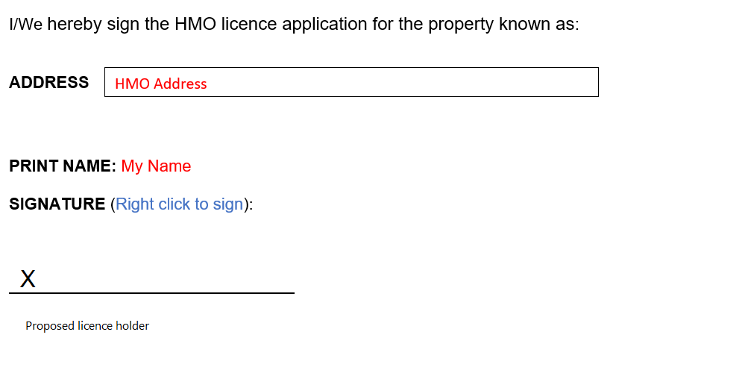

- Right click on the ‘X’ and then on the pop up click on ‘sign’

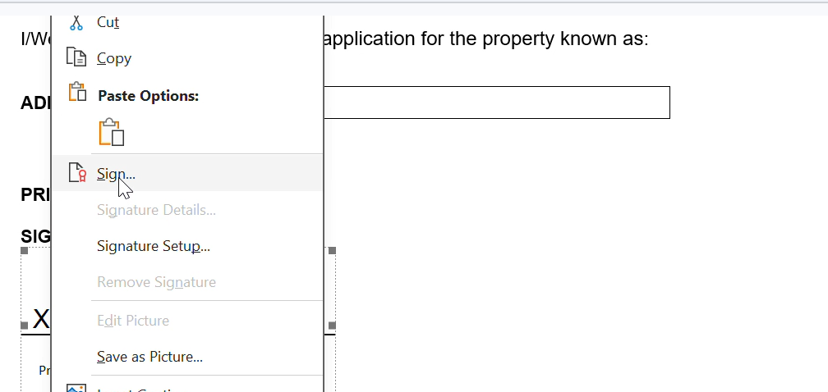

A new window will pop up. Add your signature and then press sign.
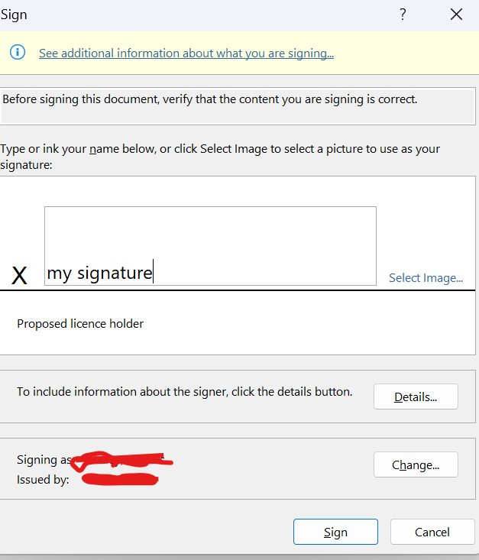
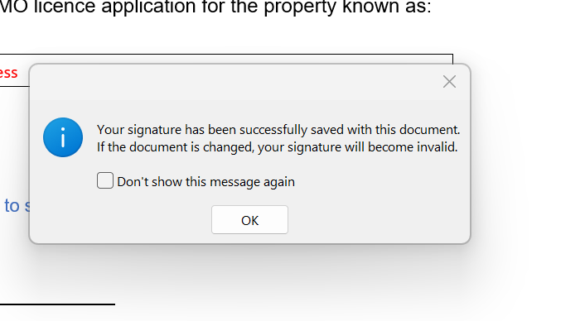
Press ‘OK’. Your signature has now been added, and you can upload this document to your HMO Application submission or send it to HMO@coventry.gov.uk
Do not make any changes to the document at this point as this will invalid the signature and you will have to sign it again.

