Secondary Unit 10 Lesson 2 Journey Worksheet

- The word journey around the world. Take a look at this picture. What do you notice? Can you add words to the image?
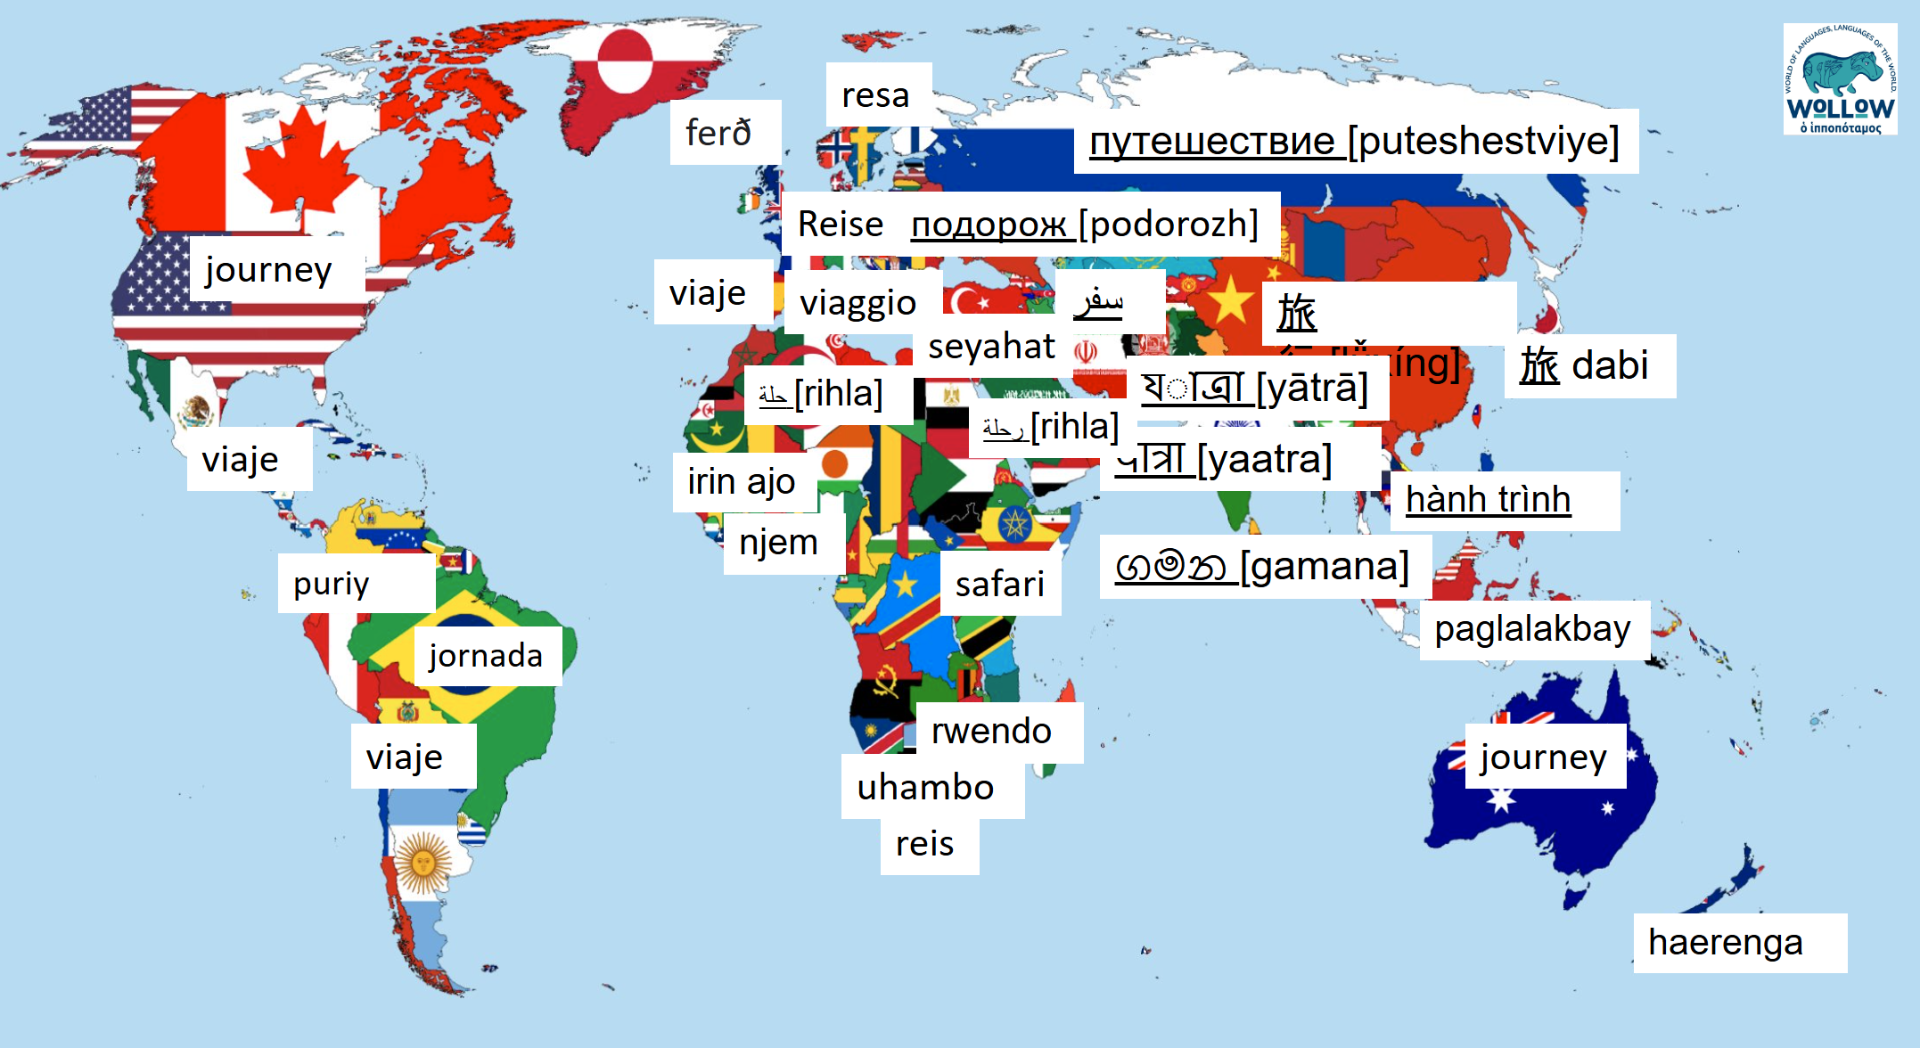

- Quiz time!
- Have you ever been on a journey? Where did you go?​
- What modes of transport can you use for a journey?​
- Why do people go on journeys?​
- Can you name different types of journey? (e.g. educational)​
- What might you pack for a journey?​
- How do you prepare for a journey?​
- What challenges might people face on a journey?​
- How has technology changed the way people go on journeys?
- What happens when you go on a journey? Is it just a physical thing or can it be more emotional or spiritual? What can you add to the word wheel?

