8 December 2025

School Admissions Team
Council House,
Earl Street,
Coventry, CV1 5RR

Dear Sir/Madam

Admissions Policy 2027 Entry

As required by the Admissions Code, Rugby High School has published its proposed admissions policy for 2027 entry and has initiated a consultation period which will run from 10 December 2025 to 22nd January 2026.

Please would you bring this admission consultation to the attention of the relevant schools, academies, nurseries, governors and parents within the areas covered by the priority circle in Northamptonshire, by displaying these arrangements on the County Council’s website.

Copies of the policy and the catchment area map can also be viewed on the school website at www.rugbyhighschool.co.uk under Parents/Admissions.

If anyone wishes to comment on this policy, they should write to Mrs J Jarman, Governance Professional, at the school address before the deadline of midday on 22nd January 2026.

Yours sincerely
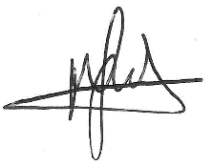
Mark Grady
Headteacher

