Overview:
Cuckooing or home invasion is a form of criminal exploitation where individuals or groups take over the home of a vulnerable person to use the property for illegal activities, such as drug dealing, storing weapons or cash, or sex work. Cuckooing is a form of modern slavery.

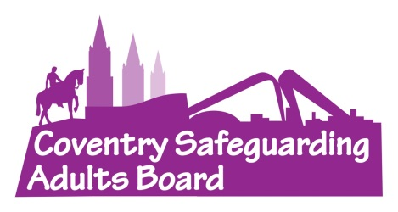
Impact:
Cuckooing has a huge impact on our communities.
Not only does cuckooing cause physical and mental harm to the people involved, but it also facilitates the production and distribution of harmful substances and provides locations for sexual exploitation.
All of this creates more victims of abuse and causes distress to local residents who are subjected to anti-social behaviour and noise.
Warning Signs:
- An increase in people coming and going from a property
- New vehicles outside the property
- An increase in litter, clothing or bedding around the property.
- Signs of drug use.
- Property falling into disrepair.
- Increase in disturbances.
Find more warning signs on the Council’s website

One Minute Guide
Cuckooing
September 2025

What can you do?
- Call the police on 101 or 999
- Consider a referral into Adult Social Care
- Refer to the Council’s Modern Slavery Lead

Support Services:
The National Referral Mechanism (NRM) is a government programme to identify and support survivors of modern slavery.
Potential victims of cuckooing can be referred to the NRM to receive specialist assistance by local authorities, police and other specialist agencies.
Charitable services can also provide support to survivors of Modern Slavery and survivors may also be entitled to Local Authority Support e.g. Housing or Adult Social Care.
For more information, please access the Modern Slavery Protocol

Types of Cuckooing:
Cuckooing can take many forms. Survivors of the exploitation may be expected to:
- Allow access to their home for illegal activities (e.g., drug dealing, storage of weapons or drugs).
- Run errands or deliver illegal items on behalf of perpetrators.
- Clean up or hide evidence of exploitation within their home.
- Lie to professionals, friends and family members about what is happening in the home.
- Limit their use of their home or move out completely.
- Ask for permission to use their facilities (e.g. the bathroom, kitchen or television).
- Follow demands under fear of violence or threat of violence.
- Follow demands due to owing money to the person who has cuckooed the property.

Prevalence:
In 2024, cases of cuckooing or home invasion made up 28% of all criminal exploitation concerns for adults

