Overview:
County lines are criminal gangs or organised networks who exploit people to traffic illegal drugs from one region to another. Simply put, it is when someone is forced to deal drugs through debt bondage, threats, or abuse. It is a form of criminal exploitation & modern slavery. County lines are typically associated with children, but they are also one of the most common types of criminal exploitation for adults in Coventry.

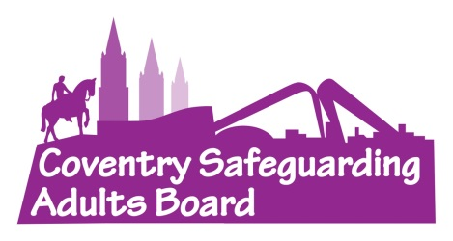
Impact:
County lines have a huge impact on our communities.
Not only do they cause physical and mental harm to the people involved, but they also facilitate the distribution of harmful substances, sexual exploitation and cuckooing.
All of this creates more victims of abuse and causes distress to local residents who may feel unsafe in their communities if they suspect there is drug dealing nearby.

Warning Signs:
- Increased drug use / being found with large amounts of drugs.
- Being secretive about who they are talking to / where they are going.
- Unexplained money, phone(s), clothes or jewellery.
- Increasingly disruptive or aggressive behaviour.
- Using sexual, drug-related or violent language they typically wouldn’t.
Find more warning signs on the Council’s website

One Minute Guide
County Lines
November 2025

What can you do?
- Call the police on 101 or 999
- Consider a referral into Adult Social Care
- Refer to the Council’s Modern Slavery Lead

Definition:
County lines is a term for a form of criminal exploitation where organised crime networks export illegal drugs, normally from urban areas into smaller towns and rural areas.
These groups use children and vulnerable adults to move and sell the drugs, often relying on violence, threats and manipulation. The "line" itself refers to the mobile phone number used to take drug orders.
County lines exploitation can take many forms. Survivors of the exploitation may be expected to:
- Package, sell, or transport illegal drugs.
- Organise travel for people transporting drugs.
- Drive drugs to specific people or locations.
- Provide accommodation for other people involved in the county line.
County lines link to other crimes such as cuckooing (home invasions) or forced cannabis cultivation.
Support Services:
The National Referral Mechanism (NRM) is a government programme to identify and support survivors of modern slavery.
Potential victims of county lines can be referred to the NRM to receive specialist assistance by local authorities, police and other specialist agencies.
Charitable services can also provide support to survivors of Modern Slavery and survivors may also be entitled to Local Authority Support e.g. Housing or Adult Social Care.
For more information, please access the Modern Slavery Protocol

Prevalence:
In 2024, cases of county lines or forced drug dealing made up 40% of all criminal exploitation concerns for adults.

