County Lines
Government guidance on Criminal Exploitation of children and vulnerable adults depicts county lines as ‘a term used to describe gangs and organised criminal networks involved in exporting illegal drugs into one or more importing areas within the UK, using dedicated mobile phone lines or other form of “deal line”.’ It is said that they are more likely to ‘exploit children and vulnerable adults’ to ‘move and store the drugs and money and they will often use coercion, intimidation, violence (including sexual violence) and weapons.’ It is crucial to understand that although the children may not see themselves as victims, they are not able to consent to exploitation.

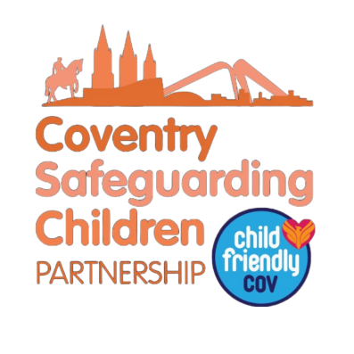
Signs to look out for
What to do if I spot the signs?

Government guidance on Criminal Exploitation of children and vulnerable adults depicts county lines as ‘a term used to describe gangs and organised criminal networks involved in exporting illegal drugs into one or more importing areas within the UK, using dedicated mobile phone lines or other form of “deal line”.’ It is said that they are more likely to ‘exploit children and vulnerable adults’ to ‘move and store the drugs and money and they will often use coercion, intimidation, violence (including sexual violence) and weapons.’

One Minute Guide
Child Exploitation – County Lines
June 2026

Where is this a problem?

County lines is considered to be a national issue; therefore, it can be said to be an issue everywhere. Coventry is known to have many young people entrenched into county lines. The local authority as well as organisations such as Horizon are involved in monitoring, recognising, and also preventing individuals being pulled into county lines.
If you believe a child is actively involved in county lines, please contact the police on 101 or 999 in an emergency.






Reporting county lines activity
If you have a concern that a child may require support or be at risk of harm a referral to The Children & Family Initial Response Service should be made using the Request For Support form: Request for Support’
You may wish contact The Children & Family Initial Response Service on
024 7678 8555. If you witness a crime or act of county lines in person you should contact the police by calling 999 as soon as possible.
Who is targeted?
As professionals it’s important to remember that exploitation is a form of child abuse, and the boundaries may at first seem unclear when intervening with and supporting exploited children. The young people may be viewed at first glance as perpetrators or criminals but it’s vital to recognize that they are usually victims as well.
Gangs often target and groom individuals they feel to be more vulnerable, such as those with learning disabilities or looked after children, however any child could be susceptible to county lines. The groups involved within county lines are mostly using young people aged 14-17, but a child can be involved from as young as seven years old and there is seemingly not a maximum age limit. It is far more common for young people and children to be criminally exploited than vulnerable adults. Individuals from all ethnicities, ages and genders can be entrenched in county lines.

These statistics show that county lines as a topic is a concern of many people within the UK, ranging from parents to professionals and policing authorities. The levels of violence and intimidation used against the young people by the gangs has increased so it is crucial to be aware of the signs of county lines.

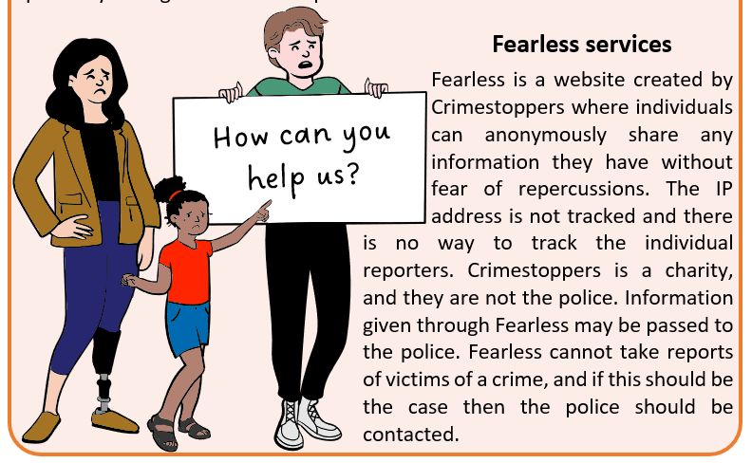

County lines statistics for the UK

Key Contacts and Further Information
Coventry Safeguarding Children Partnership Serious Violence Strategy 2018
Criminal Exploitation of children and vulnerable adults: County Lines guidance 2018
Fearless anonymous reporting

