What is CAPVA?
Child and Adolescent to Parent Violence and Abuse (CAPVA) is characterised by a pattern of harmful behaviour(s). While there is currently no legal definition, CAPVA refers to the dynamic between a child or adolescent who repeatedly engages in violent or otherwise abusive behaviour towards their parent or carer.
Abusive behaviour may include physical violence, emotional or psychological abuse, verbal abuse, economic or material abuse, sexual abuse and coercive control.

What does CAPVA look like?
CAPVA is often accompanied by stigma, shame and guilt which contributes to it being a ‘hidden’ form of family abuse.
There are, however, factors that could indicate why a family may be at risk for CAPVA:
- Family history/current experience of domestic abuse
- Child/adolescent is being abused
- Substance misuse
- Mental health problems
- Learning difficulties, disability or medical conditions affecting the brain of the child
- Child’s development
- Parenting or family environment
- Media/social media
- Peers, community and wider society
CAPVA is a highly gendered form of abuse, in which mothers/maternal carers are significantly more likely to experience harm from their children.
What does the law say?
While it is not explicitly defined by law, CAPVA can be recognised as a form of domestic abuse that is distinct from intimate partner abuse. CAPVA may also be considered as a form of bullying.
Under the Domestic Abuse Act 2021, behaviour is considered abusive if any of the following take place:
- Physical or sexual abuse
- Violent/threatening behaviour
- Controlling/coercive behaviour
- Economic abuse
- Psychological/emotional abuse
The definition of abuse laid out in The Domestic Abuse Act 2021 applies only to those aged 16 or over, but it is important to note that CAPVA can be carried out by children younger than 16.
It is widely accepted that CAPVA can include children and young people aged 8 – 18.


One Minute Guide
CAPVA: Child and Adolescent to Parent Violence and Abuse

Impacts on the parent/caregiver
Parents/caregivers may experience physical injury and endure the emotional/psychological effects of violence.
Encountering poor mental health outcomes due to extended periods of feeling helpless and ashamed, where they may feel they have ‘failed’ as parents/carers.
They may feel restricted in their home or try to avoid the home entirely to avoid violence and abuse.
Material and financial consequences due to destruction of property during violent episodes may also create further stress and financial anxiety.

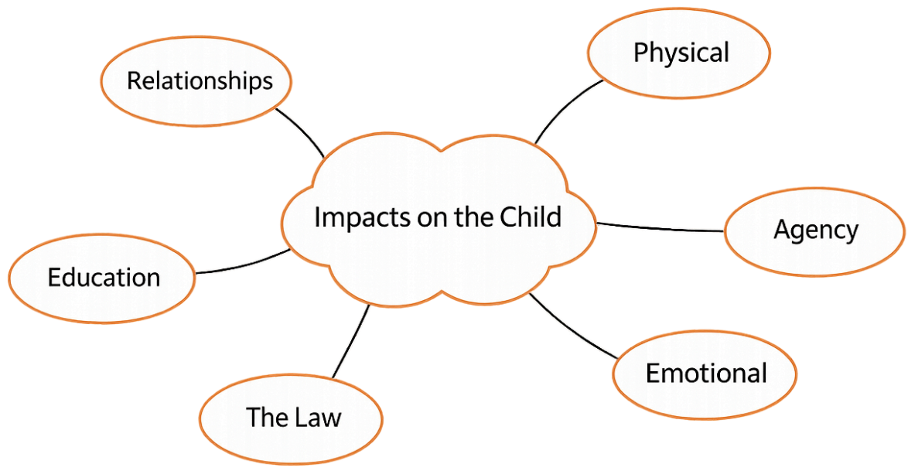
Injuries from hitting parents, walls or objects. Violent behaviour from the parent/caregiver through retaliation, self-defence or restraint may also cause injury to the child. Increased self-destructive behaviour.
Relationships with parents/siblings broken down, or loss of relationships due to separation. Reduced social contact with friends/peers.

Lacking freedom due to being grounded/denied entry into the home. Moved out/no longer living at home.

Absence from school, or aggressive behaviour in school leading to suspension/exclusion. Reducing life chances and opportunities.

Low self-esteem, feelings of guilt and shame. Poor mental health and feelings of stress, anxiety or depression. May be experiencing trauma from past or ongoing abuse they may be exposed to/experiencing themselves.

Legal consequences because of violence and abuse, such as being arrested or subject to legal orders.
Impacts on siblings
Siblings in the household may experience physical injury from direct violence from their sibling, or through indirect violence when trying to intervene. Belongings may also be damaged during violent episodes.
Emotional health can be affected as a result of distress from witnessing violence and abuse, which may cause siblings to avoid the home.
CAPVA can place strain on sibling relationships leading to damaged or even lost relationships where siblings have been separated.
What should I do?
Identify all children in the household and establish their safety when attending a CAPVA incident. If there are safety concerns, referrals should be made to Children’s Social Care.
Consider the family context. Offer early intervention for children/young people showing signs of being at risk for violent/abusive behaviour.
Wraparound safeguarding responses should be considered alongside a criminal justice response. The young person should take responsibility for their behaviour, although parents will likely wish to maintain the parent-child relationship and not criminalise their child.
A referral should be made to the Local Authority, where Children’s Social Care will then decide on the type of response required to meet the needs of the child. Children’s Services should work in collaboration with Adult Social Care to form a tailored response to the child and parent/carer.
Responses to CAPVA should be understanding and respectful. A collaborative multi-agency response is crucial to providing a tailored response that meets the child’s needs.

Key Contacts and Further Information
- Coventry Safeguarding Adult Board
- Child or Adolescent to Parent Violence and Abuse
- Information guide: adolescent to parent violence
- Directory | Respect Young People's Service

