Central Building & Welding Academy
14-16 Pathway
Course Outline & Proposal
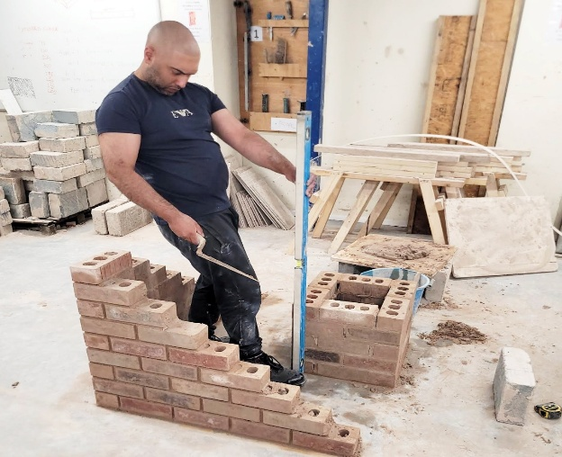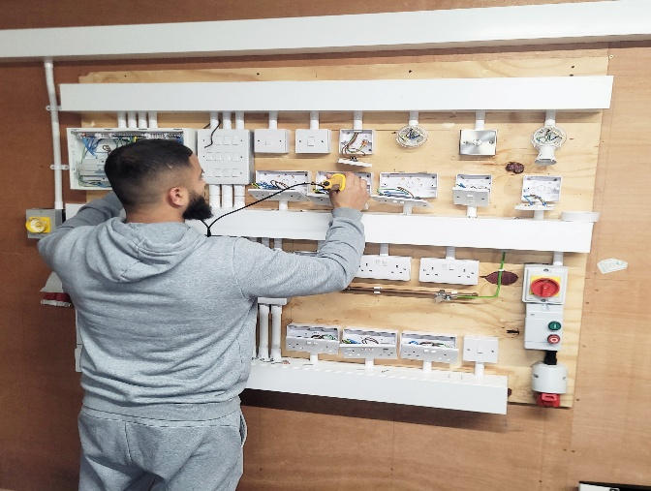
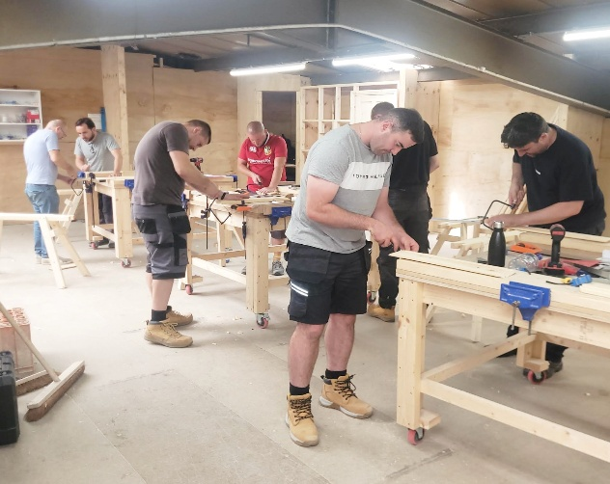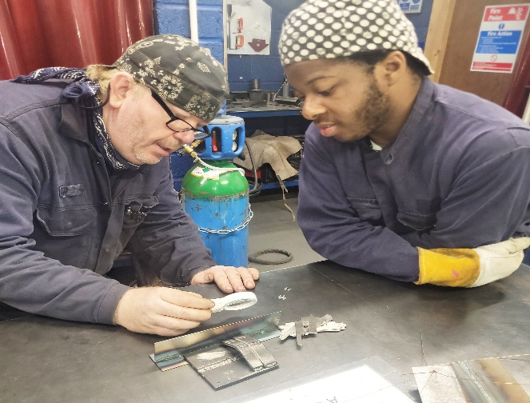

Submitted to: | Coventry Alternative Provision
Submitted By: | David Winterburn (Director)
Submission Date: | TBA

Mission Statement
Our Mission
To support and empower adults and young people by removing barriers and providing a safe and functional learning environment. We strive to provide highly skilled tutors that act with integrity and strive to deliver impactful training for all learners. We are highly motivated to upskill all learners and produce highly trained, competent tradespeople to bridge the skills gap in the construction industry.

Our Vision is to promote an innovative, inclusive and accessible learning environment where learners are continually supported by dedicate professionals: To develop the skills necessary to have exciting and rewarding careers within the construction industry.

Our Trademarks
Role Models– We always present high moral standards, acting as role models for our learners’, we maintain high standards and strive for excellence at all times. We take pride in our work, and work to our full potential displaying integrity with everything we do.
Ownership- We take personal responsibility for everything we do, including any issue or challenges we encounter; we own it until it is resolved and seek help and guidance when we need it.
Leading by example-Lifelong learners – to be able to keep up with new methods of working and best practices in teaching and industry, we regularly evaluate our performance and have the passion and desire complete the training that will drive quality in our delivery and provide truly exceptional programmes of learning.

- Labour Market Information
The construction sector contributes almost £100 billion to the UK economy each year and it is predicted that this figure will continue to grow. In 2026, the industry will need to recruit an additional 217,000 new workers just to meet demand. That’s the forecast from the Construction Skills Network (CSN) 2021-25, published by CITB today.
According to the CSN, most Literacy regions will experience an increase in construction workers by 2026, with East Midlands (1.7%) and West Midlands (1.4%) forecast to lead demand. Scotland (1.4%) and Wales (0.7%) are also predicted to fare well. The only region forecast to see a slight decline in workforce is the Northeast (-0.1%). Major projects such as HS2 are driving growth in some regions, and infrastructure (5.2%) and private housing (6.7%) should see the healthiest pace of expansion by 2026. We also expect a growing contribution to come from repair, maintenance and improvement work, as retrofitting existing buildings to meet net zero emissions targets becomes more important.
- Provider Overview & Intent
CBWA delivers specialist, vocational training for young people as part of our alternative provision offer. Our curriculum enables learners to re-engage with education, rebuild confidence and develop the practical skills, behaviours and independence required for successful progression. We combine specialist vocational teaching with integrated therapeutic and pastoral support to remove barriers to learning and secure measurable progress. Young people remain central to all decision-making, and excellence is never compromised.
CBWA are a Tier 1 provider, and we specialises in delivering construction trade skills, providing learners with hands-on, industry-aligned training that reflects local labour market needs. Our training bespoke training facility and programme of delivery will support young people with the foundations required for post-16 vocational routes, apprenticeships and employment within the construction sector.
CBWA intend to provide a safe, inclusive and nurturing learning environment where young people can be supported to build their confidence and re-engage in education. CBWA intend to promote healthy lifestyles and social development and provide our young people with committed, passionate and understanding staff that can provide them with the training opportunities to support them to reach their full potential. CBWA also intend to provide support and guidance with transition planning and ensure each young person has a specified destination once they have completed their current qualifications.

- Communication & Collaboration
CBWA staff work in lockstep with local authorises, schools, parents, carers and other relevant stakeholders to ensure that we provide a wrap-around service that aligns with the individual needs of the young people in our care. CBWA staff are in regular contact with the CAP team, parents and carers and everything is done to ensure our young people attend regularly and thrive on courses. Termly reviews are completed to communicate progress to all relevant stakeholders with regards to learning, behaviour and attitudes. Parent and learner voice are also an integral part of our intent to maintain strong two- way communication links with our stakeholders.
- Safeguarding
Safeguarding is a priority at CBWA, and we have a designated safeguarding lead (DSL) and two Deputy Designated safeguarding leads (DDSL) also. CPOMS is used for recording and monitoring safeguarding concerns. All learners have a dedicated risk assessment in place. All staff receive safeguarding training annually. DSL & DDSL undertake safeguarding training to align with their specific roles and responsibilities. All CBWA staff also have enhanced DBS check, and a single central record is kept to in accordance with our contractual and statutory requirements.
Position | Name | Safeguarding Role
Director | David Winterburn | Designated Safeguarding Lead
Centre Manager | Richard Howes | Deputy Designated safeguarding leads
Tutor (pre-16) | John Little | Deputy Designated safeguarding leads
Reporting Safeguarding Incidents
CBWA staff also use the vital online platforms such as CLM and CPOMS to ensure we have effective and robust channels of communication with our stakeholders. Updates on these systems supports us to communicate effectively in areas such as safeguarding, attendance, behaviour, progress.
Reporting Non-Attendance
Non-attendance reported on CLM and CPOMs to alert all parties of attendance concerns and also to schedule attendance reviews. Academy staff also contact parents and careers by phone and email to report non-attendance. CBWA liaise with local authority and school staff to inform them of any unplanned absences.
Online Safety
This course is delivered face-face and does not involve remote learning. Learners may have access to industry and training related video recordings for educational purposes. Learners are supervised at these times and do not have control of the devices being used. Personal mobile devices are securely stored in lockers prior to lessons starting to ensure safety and

- Programme Overview
This qualification has been designed to provide learners with basic skills and knowledge in multiple areas of construction. The 6219 can provide learners with an exceptional understanding of each area of study and learners can use this as a precursor to different stand-alone level 1 courses or our level 2 diploma in maintenance operations.
The 6219 really does provide the perfect Lense for learners to view the different specialist areas of the building trade and this culminates in our learners being able to make informed decisions about their future careers.
The 6219 diploma covers multiple areas of training and combined with our functional skills delivery it enhances the cultural capital of each of our learners.

6219 Guided learning hours
This qualification comprises 360-370 guided learning hours and each learner must achieve thirty-seven credits to pass this qualification. Each unit is between 2-4 credits. There is one compulsory unit with unit 101 Introduction to Health and Safety in the Construction Industry (3 credits).

Provider | CBWA
Programme Title | 6219 C&G
Target Audience | 14–16-year-old
Delivery Model | Face to face
Group size | 12
School Role | TBD
Duration | Academic year
Location | Unit 1, Bayton Road Industrial Estate, Exhall Coventry CV7 9NH
Academic year | September 2026-July 2027

- Programme Pathways
CBWA provides our young people with structured skills-based training in the 14-16 academy. CBWA delivers training in small groups with a ratio of one member of teaching staff to six learners. This high teacher-to-learner ratio enables our staff to provide high levels of individual support, and this culminates in ever increasing levels of engagement from our learners. Parent evening May-July

CBWA Pathways
14-16 academy
Post 16 L1 academy
Coventry College L1 & Level 2 Construction skills
Post 16 L2 academy
Qualifications
CBWA deliver the 6219 Level qualification, and this introduces several different trades that are constantly in high demand with employers.
Functional Skills
Functional skills are embedded into each of the elements of this course and learners will be completing numeracy and literacy training relevant to the specific unit towards which they are working. Learners commence their training by working on the CBWA do not currently provide stand-alone functional skills qualifications in our 14-16 academy, however, as a growing provider we are willing to explore opportunities to broaden our curriculum to meet the needs of our stakeholders. See examples of functional skills delivery below.

Unit 005

Functional Skills Mapped to Bricklaying Outcomes
Set out the corner | Numeracy | Measure brick lengths, calculate gauge
Lay bricks to line and level | Numeracy + Literacy | Interpret instructions, check plumb/level
Follow sequence of work | Literacy | Read method statements
Prepare materials | Numeracy | Calculate mortar ratios
Maintain quality | Literacy | Read HSE guidance, complete PPE list

Careers Guidance & Transition Planning
CEIAG is embedded in our curriculum, and we have a weekly theme set out in our scheme of work. This aspect of our curriculum will provide learners with the information and guidance to make informed decisions by the end of the academic year. See below for breakdown of key CEIAG themes in our curriculum for term one.
Week 1 | What is LMI? | Week  2 | Local Construction Jobs in Coventry & West Midlands
Week  3 | Skills Shortages in Construction | Week  4 | Pay & Progression in Construction
Week  5 | Apprenticeship Demand | Week  6 | Employer Expectations
Week  7 | Green Skills & Future Construction Trends | Week  8 | SEND-Friendly LMI Project
Week  9 | Construction Pathways (Level 1–3) | Week  10 | Self-Assessment: My Strengths vs Job Requirements
Week  11 | LMI in the Workshop | Week  12 | Employer Encounter Preparation

Transition Planning
CBWA provides termly one - one careers guidance sessions. These sessions are completed by our knowledgeable staff who can provide highly impactful insights into the construction industry and draw from their own lived experiences in trades. Transition planning is a key aspect of our curriculum and CBWA supports young people to identify and secure placements either through our post sixteen academy if learners have an EHCP or alternatively through our pathway with Coventry College. Parents/career evenings will be available from May 2027, and parents will be able to attend the academy to discuss next steps. The link CBWA has with Coventry College also provides an excellent soft landing into mainstream education for our learners and this compliments our in-house career pathway.
To ensure the move from CBWA to Coventry College is as frictionless as possible CBWA staff support our learners with interviews and introduction meetings.
Employer Engagement
Employer engagement enables our young people to gain a greater understanding of the opportunities that exist within the construction industry. Our young people can meet and talk with employers either through external or internally hosted employments events. In recent months CBWA have collaborated with British Gypsum who are part of the Saint Gobain Group. British Gypsum manufacture and sell many of the leading plastering and rendering related products to national outlets across the UK and abroad. British Gypsum also work in collaboration with training providers such as CBWA and they support medium and large- scale building contractors and subsequently have extensive employer links in the construction industry. CBWA are developing access routes to these potential employers and intend to leverage our professional relationship to develop employment links. CBWA also welcome guest speakers from British Gypsum to deliver talks on employment opportunities in the construction industry.

- Wellbeing & Mentoring
Learner wellbeing is central to everything we do at CBWA, and this plays a significant role in our day-to-day delivery. Whilst our staff pride themselves on teaching skills-based training they also spend a significant amount of time working with individual learners to develop their social skills. This one-to-one support and mentoring will enable young people to develop the people skills they require to function optimally in their personal life, training or working environment.
See brief outline below:
Term 1
- Consent
- Sexual Health
- SDI’s
- Contraception
- Pregnancy
Term 2
- Toxic masculinity/misogyny
- Violence against girls
- Pornography
- Personal safety in public spaces
Term 3
- Internet safety
- Mental health in construction
- Physical health
CBWA staff also spend considerable amount of time coaching and mentoring our learners on training and work-related expectations. This will include customer service, work ethic, the importance of timekeeping, planning and preparation, other topics that will enable our learners to thrive in the workplace and enhance their cultural capital.
CBWA staff how decades of collective experience working in alternative provision settings and we provide differentiation in our teaching and planning to support a wide range of needs.

- School Partnership

All young people that attend the 14-16 academy at CBWA must be enrolled with a school throughout the duration of the academic year. The CBWA curriculum is designed to run alongside and compliment the school curriculum and not to replace it.

- Termly Progress Reviews
All young people on roll at CBWA receive a termly progress review which is documented and uploaded on CLM. The progress reviews provide an Insite into the day-to-day performance of each learner and they are available to relevant stakeholders.

- Attendance
- Termly progress
- What’s Going Well? (WWW)
- Areas for improvement
- Engagement and Behaviour
- Individual targets
- Other relevant

- EHCP & Non EHCP Learners
If a learner has an EHCP CBWA staff will review the document and based on the information provided we will invite learners into the academy for an introduction meeting. Following the meeting a final review will take place, and a decision will be made as to whether needs can be met. Once a learner with an EHCP has been enrolled staff will use the information to identify specific needs and align training to meet their needs.

Achievement & Outcomes
Outcomes are measured against the starting points of each learner. For instance, it is our expectation that each enrolled learner will complete the stage of the qualification towards which they are working. Unfortunately, this will not always be the case, and some learners may not achieve a qualification due to issues outside of the academies or the learners’ control. If there has been improvement in other areas of the learner’s performance such as time - keeping, behaviour, engagement, communication, self-confidence CBWA will consider this to be a tangible success even though it will not be reflected in the qualification.

Outcome | KPI
Attendance | 90% across the academic year
Engagement | Consistently engages
Numeracy & Literacy | Completion of all resource lists, health and safety assessments, exam answers, completion of CV
CEIAG & Transitions | All post-sixteen learners have a planned destination
Wellbeing | Improved: communication skills, self-confidence, engagement in activities preparation and planning
Transition ready | All learners have a plan to move onto work or post sixteen training

Quality Framework
CBWA will ensure that the academy is prepared and forthcoming for each of the CAP quality reviews. Data sharing and collaboration on all matters that pertain to the quality assurance frameworks will be shared and where necessary action points will be reviewed, and a quality improvement plan will be implemented to ensure CBWA are aligning their quality processes with CAP.

- Onboarding Process

CAP Learners
Process From Onboarding to Transition planning
Order | Activity | Action | Person Responsible | Timeline
1 | Complete Initial Screening | Receive EHCP and read and gain understanding of learner’s background, safeguarding & academic history. Complete initial screening document. | Richard Howes (RH)  John Little (RH)  Richard Figgit (RF) | Pre- introduction meeting
2 | Complete  Induction Meeting | Face to face or meeting to be completed to provide information about the specific training option at CBWA and complete a Centre tour and meet and greet with teaching and support staff. Complete Introduction record. | RH  JL  RF | Within 15 days of receiving consultation
3 | Complete learner risk assessments | Risk assessment to be completed using the information gained from EHCP and introductory meeting | RH-post 16  Pre- 16 Main provider to complete | September 2026/ or prior to start date.
4 | Summary of Learner Needs | Provide teachers and support workers with summary of needs, including SEND | RH | September  2026
4 | ILP | To start prior to first session and include SEND needs. Teacher to add SMART targets (minimum 1 per month). | JL  HCV  GS  DB | September 2026
5 | Support Plan | To be completed at least once per term. First plan to be completed within first two weeks of the 1st term learners start attending | RF | September 2026
6 | Baseline Assessment Status | FS tutor to complete BKSB for literacy and numeracy.  Pastoral support and or teacher to complete wellness assessment. | RF  JL  GS  DB | September 2026
7 | Student Voice | Students to complete monthly student voice documents that is enclosed in their ILP’s | Students | Before last study day of each month September 26-July 27
8 | Parent Voice/Carer | Parents receive termly Parent Voice document to give feedback on their opinions | Parent/Carer | End of each term
9 | Progress Reviews | Teachers complete the termly CBWA review document identifying what’s going well and areas that require improvement. Achievement to be included and progress with trades training and function skills | JL  DB  GS  RF | Termly
10 | Transition/Next Steps/  Employability | To be weaved into delivery in line with functional skills & CV writing, job searching techniques and mock interviews to commence in term 3.  Pathways to employment term 3 (internships) | RF | September 26 -July 27  April-July 2027
11 | Achievement tracking | To be completed in line with progress reviews and at the end of the final term. | RH | July 2027
12 | Safeguarding Handover | Safeguarding details/EHCP to be handed over to new provider on request. Use CBWA | RH | July 2027 or on withdrawal

- What is included in our offer

- X2 teaching staff per cohort of twelve learners
- Integrated CEIAG
- Transition planning
- Employability skills
- Termly progress reviews
- Enrollment on the C&G 6219 Basic Skills in Construction
- Internal & external pathway planning with CBWA & Coventry college
- Safeguarding process
- Annual outcomes to CAP
- EHCP delivery

