Selective Mutism Family Groups

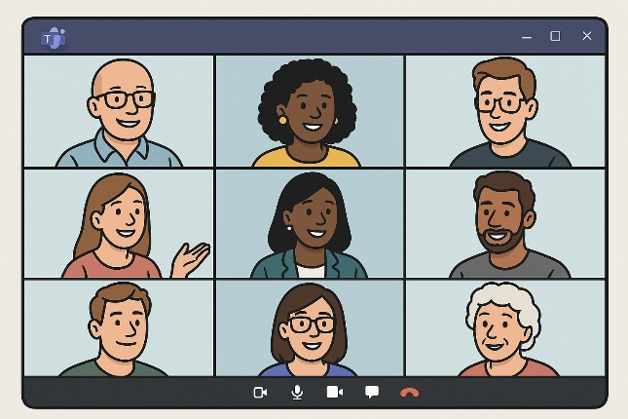

Parents and carers are warmly invited to attend our Selective Mutism Family Group, a remote session delivered via Microsoft Teams, designed specifically for Coventry families of children and young people with Selective Mutism. These sessions are for adults only and are not suitable for children or young people to attend.

The group is jointly facilitated by practitioners from Coventry Educational Psychology Service and the Children’s Speech and Language Therapy Service.

Sessions offer a safe and supportive space to talk about Selective Mutism and to share ideas and lived experiences.

This is not a therapy session. There is no pressure to speak, and participants are welcome to join in whatever way feels comfortable. You can contribute to discussions, use the chat function, or simply listen with your camera and microphone turned off.

How to book onto a session (held online via Microsoft Teams):
Sessions typically run twice per term. To view session dates and book a place, please visit: https://bookwhen.com/parent-carer-training-sessions.

We look forward to welcoming you.

